AI-AUGMENTED ENGINEERING DYNAMICS: A CONVERSATIONAL APPROACH  ME345 ENGINEERING DYNAMICS · CHAPTER 1 / PART 1  Engineering Homework  From Motion to Measurement  Particle Kinematics → Graphs → Tracker → Validate  Suggested Assessment · 10 points  target effort ≈ 35–45 minutes · type all answers and paste all Tracker evidence directly into this document |   Figure: AI First Engineering (AIFE) course logo
Taner Onsay, Ph.D. · © 2026 AI First Engineering ·

AI use is allowed and encouraged — as an assistant. But the measurements, graph readings, and Tracker evidence must be YOUR OWN work — not an AI transcript. You remain responsible for every measurement, interpretation, verification, and final engineering judgment. Assessment rewards evidence + reasoning + validation, not polished prose.

THE ENGINEERING WORKFLOW — from motion to measurement
IDEALIZE / MODEL → ANALYZE → MEASURE → VALIDATE → REPORT
the ME345 course loop: OBSERVE → IDEALIZE → MODEL → SOLVE / ANALYZE → VALIDATE → REPORT
In this homework you will exercise the whole Chapter 1 / Part 1 toolkit: decide when a particle model is appropriate, work with signed position, displacement, and velocity on a coordinate axis, read motion from an s(t) graph, and then measure a real falling motion from video with Tracker and judge whether the ideal free-fall model survives contact with your evidence. No new physical experiment is required — the videos are provided.

Time guide: Part A ≈ 6 min · Part B ≈ 7 min · Part C ≈ 8 min · Part D ≈ 15–18 min · Part E ≈ 4 min. These times are approximate and are provided to indicate the intended scope of each part.

PART A · Particle Model & Coordinate System (1.5 points · ≈ 6 min)
A particle has mass but negligible size and shape — for the motion being studied. A particle is an engineering MODEL, not necessarily a small object: whether it is appropriate depends on the engineering question being asked.
A1 — Same Automobile, Two Questions. Consider the SAME automobile in two engineering situations. For each question, state whether the particle model is APPROPRIATE or INSUFFICIENT, and justify your choice in one sentence.
1. “Where will the automobile be five seconds from now?”
Particle model: APPROPRIATE ☐ INSUFFICIENT ☐
WHY (one sentence):
2. “Will the automobile roll over during this maneuver?”
Particle model: APPROPRIATE ☐ INSUFFICIENT ☐
WHY (one sentence):
A2 — Signs on the Ruler. An engineer studying vehicles on a straight test road places the origin s = 0 at a timing gate and chooses positive s to point east. At one instant, a vehicle is 40 m WEST of the gate and driving EAST at 12 m/s.
1. State the sign of the vehicle’s position s and the sign of its velocity v at this instant (include the values with units).
2. In one or two sentences: why does a negative position NOT force the velocity to be negative? Who chose where s = 0 is and which direction is positive?
ANSWER A2:

PART B · Position, Displacement, Distance & Velocity (1.5 points · ≈ 7 min)
A particle moves along a straight line. It starts at s₁ = +15 m, travels in the positive direction to s₂ = +65 m, then reverses direction and stops at s₃ = −25 m. The complete trip takes 20 s.
B1 — Compute. Determine each quantity for the complete trip. Report signs (where applicable) and units.
1. Final position: s_final = ____________ m
2. Displacement: Δs = ____________ m
3. Total distance traveled: s_T = ____________ m
4. Average velocity (complete trip): v_avg = ____________ m/s
B2 — Concept. In one or two sentences: for THIS motion, why is the total distance traveled NOT equal to |displacement|?
ANSWER B2:

PART C · Read the Motion — s(t), v(t), a(t) (2 points · ≈ 8 min)
The graph below shows position s(t) for a particle moving along a straight line. The motion is divided into four labeled intervals: O–A, A–B, B–C, and C–D. Remember the central Chapter 1 / Part 1 idea: instantaneous velocity is the SLOPE of the position–time graph, and acceleration is the slope of the velocity–time graph.
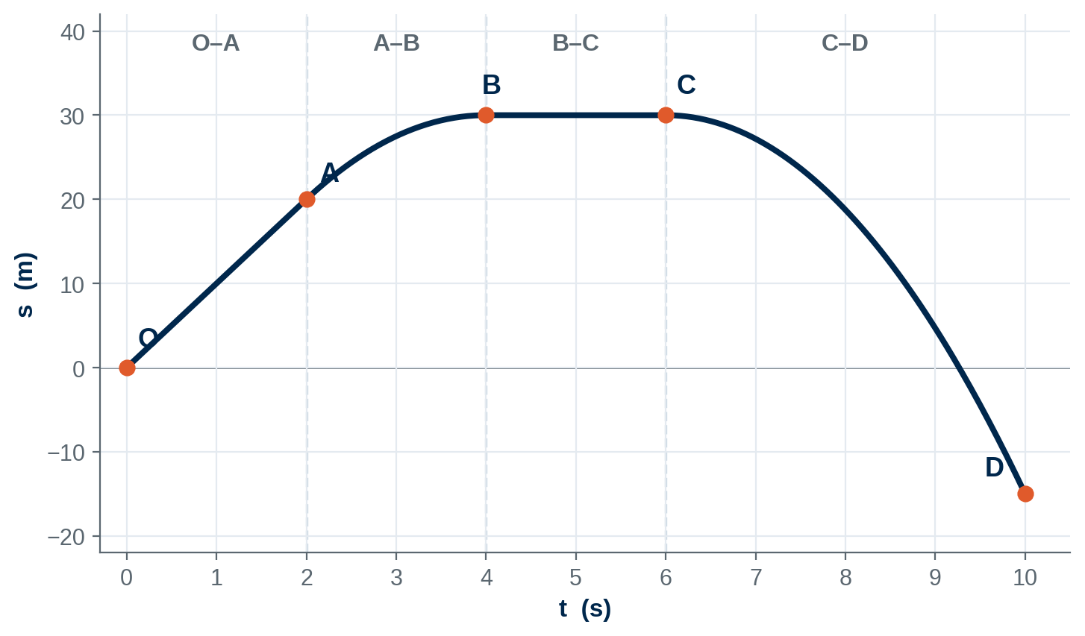
Figure C1 — position–time graph, s(t), for Part C.
C1 — Read the Motion From s(t). Use the slope of s(t), and how that slope changes with time, to complete the table. Remember:
v = ds/dt → velocity is the SLOPE of s(t)
a = dv/dt → acceleration tells how that slope CHANGES with time
Interval | Sign of v (+ / − / 0) | Is v constant or changing? | Sign of a (+ / − / 0) | Speeding up / slowing down / neither
O–A
A–B
B–C
C–D

C2 — Greatest Speed. Where on the plotted motion is |v| greatest? Explain using the magnitude of the slope of s(t). Identify the location and justify from the slope — do not calculate a numerical velocity from the drawing.
ANSWER C2:
C3 — Generalize the Sign Rule. From your answers for intervals A–B and C–D in the table above, complete the following engineering rule:
When v and a have the SAME sign, the particle is ____________________
When v and a have OPPOSITE signs, the particle is ____________________
Which interval in Figure C1 provides an example of v < 0 and a < 0? What is happening to the particle’s speed there?
ANSWER C3:
C4 — The Misconception. A classmate claims: “Negative acceleration always means the particle is slowing down.” Using interval C–D as your evidence, explain in one or two sentences why this claim is wrong.
ANSWER C4:

PART D · Video Challenge — From Motion to Data (3 points · ≈ 15–18 min)
FOUR BALLS — ONE HEIGHT
Four balls are released individually, from rest, from the same height: h = 73 in = 1854 mm = 1.854 m. Eight instructor-provided videos are posted in the Chapter 1 VIDEO FILES section of the AI First Engineering Learning Platform — for each ball, one regular-speed video (≈ 30 fps) and one slow-motion video (≈ 120 fps).
[ https://www.aifirstengineering.org/learn/ai-augmented-engineering-dynamics
Scroll down to Chapter 1- Video Files]
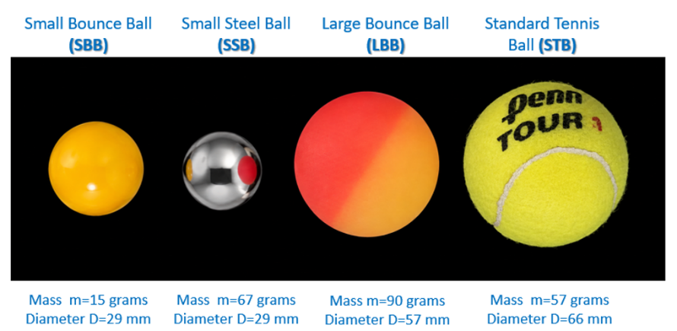

Ball | Description | Mass (g) | Diameter (mm)
SBB | Small Bounce Ball | 15 | 29
SSB | Small Steel Ball | 67 | 29
LBB | Large Bounce Ball | 90 | 57
STB | Standard Tennis Ball | 57 | 66
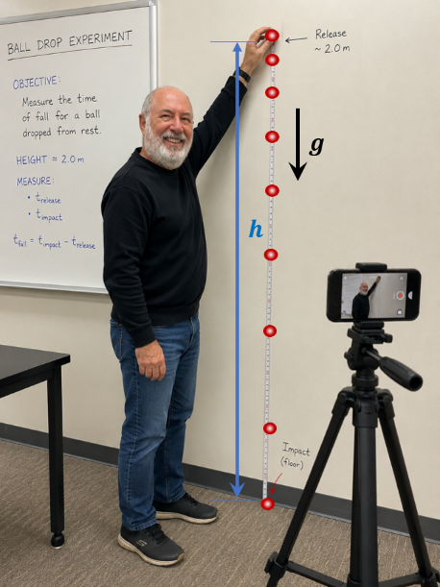
D1 — Commit to a Prediction. Answer BEFORE watching any video.
1. According to the ideal particle / free-fall model, should the four fall times be the same or different? Give a brief physical/modeling explanation (1–2 sentences).
2. Calculate the ideal fall time using t = √( 2h / g ) with h = 1.854 m and g = 9.81 m/s².
Ideal fall time: t_ideal = ____________ s
3. Why do mass and diameter not affect the prediction of THIS model? (Hint: look at what appears — and what does not appear — in the equation.)
ANSWER D1:
D2 — Observe the 30-fps Videos. Watch the four regular-speed (≈ 30 fps) videos — visual observation only, no measurement yet.
1. Based only on visual observation of the regular-speed videos, can you confidently determine whether the four fall times are different? (1 sentence)
2. Is visual observation alone sufficient evidence for an engineering conclusion? Explain briefly. (1–2 sentences)
ANSWER D2:
D3 — Tracker Analysis (120-fps videos · SBB and SSB only). Detailed Tracker analysis is required for only TWO balls: SBB (Small Bounce Ball) and SSB (Small Steel Ball). This pairing is deliberate — SBB and SSB have the same nominal diameter (29 mm) but substantially different masses (15 g versus 67 g). Holding gross diameter approximately constant provides a controlled comparison for examining whether the measured motion shows an apparent mass-related difference.
Drop-height reference: Both balls were released from the same nominal height, h = 73 in = 1.854 m. Use this known drop height for the ideal free-fall model comparison. Spatial calibration in Tracker is not required for determining the release-to-impact fall time.
For EACH of the two balls, using its 120-fps slow-motion video:
1. Import/open the provided 120-fps video in Tracker.
2. Establish an appropriate coordinate system — the origin and positive direction are YOUR choice; state them.
3. Spatial calibration is not required for determining the release-to-impact fall time. If you wish to display position in physical units, you may set the Tracker scale using an appropriate known-length reference visible in the video.
4. Track the ball through the fall.
5. Obtain position-versus-time data, s(t) or y(t).
6. Determine the measured fall time (release to impact).
7. Paste your Tracker evidence into the boxes below.
Minimum acceptable evidence: the tracked path AND the position–time data or plot from which your fall time was read. The evidence must show that YOU performed the analysis.

PASTE TRACKER EVIDENCE FOR SBB (120-fps VIDEO) HERE
(tracked path + position–time data/plot — click here and paste — Ctrl+V / Cmd+V)

PASTE TRACKER EVIDENCE FOR SSB (120-fps VIDEO) HERE
(tracked path + position–time data/plot — click here and paste — Ctrl+V / Cmd+V)

D3 — Results Table. Complete the comparison table from your Tracker measurements:
Ball | Mass (g) | Diameter (mm) | Ideal Fall Time (s) | Tracker Fall Time (s) | Difference (s)
SBB | 15 | 29
SSB | 67 | 29

Video frame rate used: ______ fps · How you chose the release and impact frames:
D4 — 30 fps vs. 120 fps: Temporal Resolution. The regular-speed videos were recorded at ≈ 30 fps; the slow-motion videos at ≈ 120 fps. Use Δt ≈ 1 / frame rate.
1. Approximate duration represented by ONE frame:
At 30 fps: Δt ≈ ____________ s
At 120 fps: Δt ≈ ____________ s
2. Which video provides better temporal resolution, and by what factor?
3. Suppose two measured fall times differ by only about 0.01 s. Could you confidently distinguish that difference using the 30-fps videos? What about the 120-fps videos? Explain using the frame-time resolution.
ANSWER D4:
THE PRINCIPLE — A difference you cannot resolve is not evidence. Compare every measured difference against the timing resolution of the video that produced it.

PART E · Engineer Decides — Model Validation + AI (1 point · ≈ 4 min)
E1 — Model Validation. Based on your Tracker measurements AND the temporal resolution of the videos: does your experimental evidence support the simple particle/free-fall model for SBB and SSB at the resolution of this experiment? Answer in 2–3 sentences supported by your numbers (measured times, ideal time, frame-time resolution). Either conclusion can earn full credit if your evidence supports it.
ANSWER E1:
E2 — AI Engineering Companion. Give a capable AI assistant a question such as:
“The ideal free-fall model predicts the same fall time for these two balls. What physical effects could cause small differences in their measured fall times?”

Do NOT paste the AI transcript. Instead, report the following:
1. ONE physically plausible AI-generated explanation. (1 sentence)
2. Does YOUR experimental evidence support that explanation? (1 sentence)
3. At the measurement resolution available, does the effect appear large enough to matter? (1 sentence)
ANSWER E2:
PHYSICALLY POSSIBLE ≠ SUPPORTED BY EVIDENCE ≠ LARGE ENOUGH TO MATTER. AI generates possibilities. Engineers use evidence to decide which possibilities are credible. The final decision belongs to the student engineer.

SUBMIT · Evidence Checklist & Human Review (≈ 2 min)
Submit ONE completed Word document — this file — containing all of the following:
- Part A particle-model decisions and coordinate/sign reasoning (A1, A2)
- Part B numerical results with signs and units + distance-vs-displacement reasoning (B1, B2)
- Part C completed slope table and graph interpretations (C1–C4)
- Tracker evidence for SBB — Part D3
- Tracker evidence for SSB — Part D3
- Completed SBB/SSB comparison table — Part D3
- 30-fps versus 120-fps resolution calculations and reasoning — Part D4
- Model-validation judgment supported by quantitative evidence — Part E1
- AI Engineering Companion response evaluation — Part E2
- Human review statement signed and dated (below)

SUBMIT ONE COMPLETED HOMEWORK DOCUMENT
Keep all required answers and Tracker evidence in this document rather than as separate Tracker, video, or image files. If this homework is being used as part of a course, follow your instructor’s submission and file-naming requirements.

HUMAN REVIEW: (Parts A–E: 9 points · Human Review / Completeness: 1 point · Total: 10 points)
“I reviewed the calculations, graph interpretations, Tracker evidence, measurements, AI-assisted analysis, and engineering conclusions in this submission and confirm that they represent the work I performed and reviewed.”
Human reviewed and approved: __________________________
Student name: __________________________ Date: ____________
AI assists. Humans observe. Humans verify. Humans decide. Humans approve.

Suggested Assessment Rubric — 10 points
Used by the instructor and, where applicable, by an AI grading agent. All required evidence must appear inside this document — the grader will not open separate Tracker, video, or image files.
Criterion | What full credit looks like | Pts
Particle model + coordinate/sign reasoning | Both automobile questions classified correctly with question-driven justification; A2 resolves s < 0 with v > 0 correctly — origin and positive direction are the engineer’s choice, and the sign of position does not determine the sign of velocity. | 1.5
Position / displacement / distance / average velocity | s_final = −25 m; Δs = −40 m; s_T = 140 m; v_avg = −2.0 m/s over 20 s — signs and units correct; distance ≠ |displacement| explained by the direction reversal. | 1.5
s(t), v(t), a(t) graphical and sign interpretation | Sign of v from the slope AND sign of a from the changing slope correct for all four intervals; constant vs. changing velocity identified; speeding up / slowing down via the v–a sign relationship; greatest |v| located at D from the magnitude of the slope; “negative acceleration = slowing down” misconception refuted using C–D. Do not double-penalize one conceptual error across columns. | 2
Video/Tracker analysis + experimental evidence | Ideal t = 0.615 s computed from t = √(2h/g); genuine Tracker evidence pasted for BOTH SBB and SSB (tracked path + position–time data); comparison table complete with plausible measured times and differences. | 2
30/120-fps measurement-resolution reasoning | Frame times ≈ 0.033 s (30 fps) and ≈ 0.008 s (120 fps); factor ≈ 4; correctly concludes a 0.01-s difference cannot be resolved at 30 fps and is marginal (≈ one frame) at 120 fps. | 1
Model validation + AI critical evaluation | Verdict explicitly compares measured differences with frame-time resolution; AI hypothesis evaluated against the student’s own evidence — physically possible ≠ supported by evidence ≠ large enough to matter. | 1
Human review / completeness | All checklist items present; answers concise; human-review statement signed and dated. | 1
 | TOTAL | 10

