ME 345 ENGINEERING DYNAMICS  CHAPTER 1 / PART 1 — KINEMATICS  Self-Assessment  Can I Observe It, Model It, Analyze It, and Validate It?  Ungraded · for your own learning · work at your own pace |   Figure: AI First Engineering (AIFE) course logo

Taner Onsay, Ph.D. © 2026 AI First Engineering

AI TUTOR MODE — read this first
You do not need to complete every question in one sitting. Start with each group. If you can confidently solve the first questions independently, sample the remaining questions. Spend more time in groups where you need AI or human help. Try each question yourself first. If you become stuck, AI may be used as a tutor — not as an answer machine. Instead of asking for the answer, try:
“Do not solve this for me. Ask me one question or give me one small hint at a time.”
The purpose of this self-assessment is to determine what YOU understand — not what your AI can answer. This is the course workflow in action: Observe › Idealize › Model › Solve / Analyze › Validate › Report.

After each group, rate yourself with the four checkboxes. Your pattern of ratings — not a score — is the output: it tells you exactly what to review, practice, or bring to office hours before Part 2.

GROUP 1 · Explain It — Think Like a Dynamicist
1. When Is a Car Just a Particle?
An engineer is studying a car traveling along a straight test road. For each engineering question below, decide whether treating the entire car as a particle is reasonable. Explain your reasoning.
A. How long does the car take to travel 100 m?
B. How much does the car body pitch forward during hard braking?
C. What is the position of the car along the road as a function of time?
Then complete: “An object can reasonably be modeled as a particle when __________.”

2. Same Physical Location — Different Position?
Two engineering teams record the motion of the same autonomous delivery robot along the same straight hallway. Team A puts s = 0 at the west door and defines east as positive. Team B puts s = 0 at the center of the hallway and defines west as positive. At one instant, the teams report different numerical values of s.
Can both teams be correct? Explain what is physically real and what depends upon the chosen coordinate system.

3. Position, Displacement, or Distance?
A warehouse inspection robot begins at s = +8 m. It moves to s = +32 m, reverses direction, and stops at s = −4 m.
A. Sketch the motion on a number line.
B. Determine its final position.
C. Determine its displacement.
D. Determine its total distance traveled.
E. Explain why displacement and distance give different information about exactly the same trip.

4. Can Something Move and Have Zero Displacement?
A small autonomous vehicle leaves its charging station, performs a test maneuver, and eventually returns to exactly the same location. Is it possible for the vehicle to have:
– zero displacement?
– nonzero distance traveled?
– zero average velocity?
– nonzero average speed?
Explain each answer in words before using equations.

RATE YOURSELF on this group before moving on:
- I can do this independently.
- I can do this with a small AI hint.
- I need substantial AI help.
- I still need human/instructor help.

GROUP 2 · Read the Motion — Can You See Motion in a Graph?
5. Four Position–Time Graphs
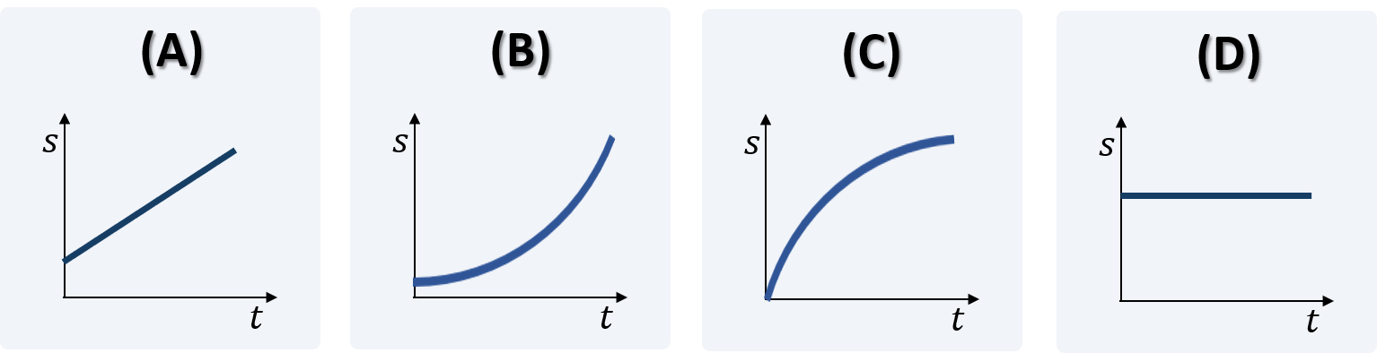
The four position–time graphs below represent four different particle motions. For each particle determine:
1. Is v positive, negative, or zero?
2. Is its speed increasing, decreasing, or constant?
3. Is a positive, negative, or zero — where that can be determined?
Do not calculate. Reason from graph shape and slope.

6. The Robot Is Moving Left — and Getting Faster
A robot moves in the negative s-direction while its speed continually increases.
A. What sign must v have?
B. What sign must a have?
C. Sketch a plausible s(t) curve.
D. Sketch a plausible v(t) curve.
Explain why negative acceleration does NOT necessarily mean slowing down.

7. Freeze the Animation
Watch the video Rectilinear-Particle-Motion-1 in https://www.aifirstengineering.org/learn/ai-augmented-engineering-dynamics
Scroll down to Chapter 1 → Video Files - open/download Rectilinear-Particle-Motion-1.
Without numerical calculation, identify the sign of v and a during each interval. Then sketch the qualitative shape of s(t).

8. Tell Me the Story of This Graph
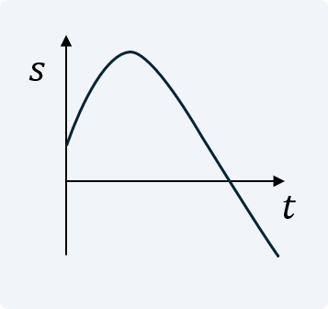
Write a short physical story that could produce this graph. Identify and mark different points on the graph with a circle and letter o-A, o-B, o-C. Then determine:
– the initial direction of motion,
– when the particle stops,
– when it reverses direction,
– whether crossing s = 0 means the particle stops.

9. Average or Instantaneous?
A hallway robot’s data logger records only two entries: s = 2 m at t = 1 s, and s = 8 m at t = 3 s.
A. Compute the robot’s average velocity over this interval.
B. A teammate concludes: “So the robot’s velocity at t = 2 s was 3 m/s.” Is that conclusion justified? Explain.
C. Sketch two different s(t) curves that pass through both recorded points but have clearly different velocities at t = 2 s.
D. What would the data logger need to record for the average velocity to become a good estimate of the instantaneous velocity?

RATE YOURSELF on this group before moving on:
- I can do this independently.
- I can do this with a small AI hint.
- I need substantial AI help.
- I still need human/instructor help.

GROUP 3 · Do It — s(t) → v(t) → a(t)
Work by hand. The derivative is the only tool you need — integration is not used in Part 1.
10. An Automated Camera Dolly
A camera dolly used to film a vehicle test moves along a straight rail. Its position is modeled by
s(t) = 2 + 3t + 0.50t² , where s is in meters and t is in seconds.
A. Before differentiating, predict: Does the dolly ever stop or reverse direction for t ≥ 0? Explain how you know.
B. Determine v(t).
C. Determine a(t).
D. Evaluate s, v, and a at t = 4 s.
E. Describe in words what the dolly is doing at that instant. Was your prediction correct?

11. Mathematics First — Then Physics
An inspection robot has position s(t) = 12 − 4t + t² (s in meters, t in seconds).
Determine v(t) and a(t). Determine the instant at which the robot is momentarily at rest. At that instant, is its acceleration also zero? Explain why or why not.

12. Don’t Touch the Calculator Yet
A particle has s(t) = 5 − 2t − 0.75t². Before calculating anything, predict:
– the initial direction of motion;
– whether it initially speeds up or slows down.
Now calculate v(t) and a(t). Was your prediction correct? Finally, sketch what an animation of this motion would look like.

13. Same Equation — Different Coordinate System
An engineer describes the motion of a test cart using s(t) = 1 + 4t + t². A second engineer chooses the same origin but reverses the positive coordinate direction.
Without re-deriving everything from scratch, predict how the second engineer’s s(t), v(t), and a(t) will differ. Which physical characteristics of the motion must remain unchanged?

RATE YOURSELF on this group before moving on:
- I can do this independently.
- I can do this with a small AI hint.
- I need substantial AI help.
- I still need human/instructor help.

GROUP 4 · Visualize It — Can You See the Mathematics?
14. Match the Three Views
[COMING SOON — VIDEO ACTIVITY
Continue to Question 15]

15. Which Frame Sequence Is Consistent?
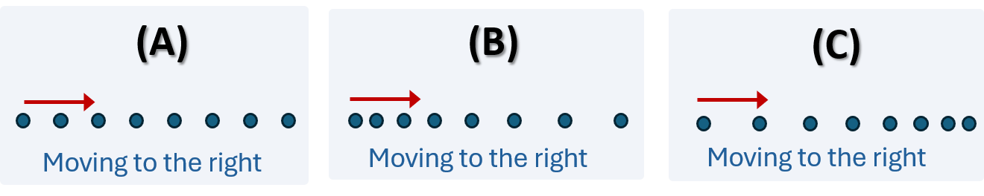
Dots representing a vehicle’s position at equal time intervals every 0.5 s.
For each sequence A, B, C:
1. What is happening to speed?
2. Sketch the qualitative s(t).
3. What can you say about the relationship between v and a?

16. Can These Three Graphs Belong Together?
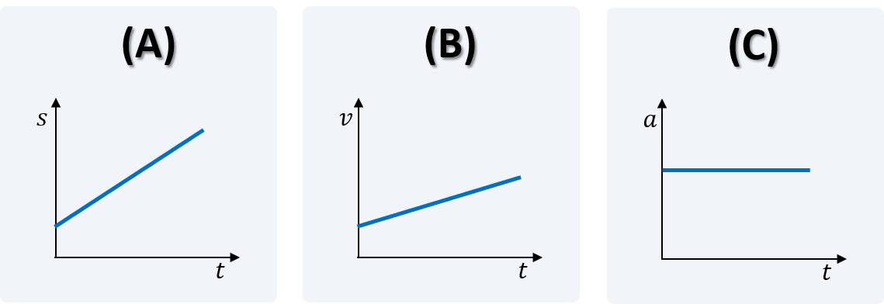
An AI supposedly produces these three plots describing one experiment. The plots are beautifully formatted. Are they mutually consistent? Identify exactly which derivative relationship fails. Then change only ONE graph so that all three become physically and mathematically consistent.

17. Draw the Motion Before Seeing It
A vehicle starts to the left of the origin, moves toward +s, speeds up, passes the origin, and later continues moving in the same direction at approximately constant speed.
Sketch a plausible s(t). On the same time scale, sketch v(t). Describe what an animation generated from your graphs should look like.

RATE YOURSELF on this group before moving on:
- I can do this independently.
- I can do this with a small AI hint.
- I need substantial AI help.
- I still need human/instructor help.

GROUP 5 · Observe & Validate — From Real Motion to Engineering Data
18. The Roadside Video
[COMING SOON — VIDEO ACTIVITY
Continue to Question 19]

19. Position Data from Video
A Tracker-style analysis gives:
t (s) | s (m)
0 | 0.0
1 | 2.1
2 | 4.0
3 | 6.2
4 | 8.1
5 | 10.2

A. What type of motion does the data suggest?
B. Estimate the average velocity over the entire interval.
C. Would the s(t) plot look more like a straight line or a curved line?
D. Why should real experimental points NOT be expected to lie perfectly on an ideal mathematical curve?

20. Now the Spacing Changes
A second vehicle produces:
t (s) | s (m)
0 | 0.0
1 | 0.8
2 | 2.1
3 | 4.0
4 | 6.6
5 | 9.9

Before calculating, inspect the changes in position. Is the vehicle:
– approximately constant speed,
– speeding up,
– slowing down?
What evidence supports your answer? Sketch the expected s(t) curve.
Now estimate the vehicle’s velocity at t = 3 s using the available measurements.
A. Which neighboring data points did you use?
B. Is your result an instantaneous velocity, or an estimate based on an average velocity over a finite interval?
C. What change in the MEASUREMENT PROCESS would allow the estimate to approach the true instantaneous velocity more closely?
D. If an AI gives you a numerical value for v at t = 3 s, what should it tell you about its method and limitations before you trust the result?

21. The Ball Drop
Watch the video Chp1-Lab1-LBB-iPhone-SlowMo-Slowed-Down-0.25x.mp4 (note that the original was recorded at 120fps). Go to
https://www.aifirstengineering.org/learn/ai-augmented-engineering-dynamics
Scroll down to Chapter 1 → Video Files and open/download Chp1-Lab1-LBB-iPhone-SlowMo-Slowed-Down-0.25x.mp4
Immediately before release, the ball is stationary. Choose a vertical coordinate system and explicitly state which direction you define as positive. Predict the signs of v and a:
– immediately before release,
– shortly after release,
– later during the fall.
– estimate the velocity and acceleration immediately before impact with the ground.
Would another engineer choosing the opposite positive direction obtain different signs? Would the two engineers disagree about the physical motion? Explain.

Challenge: The original 120-fps iPhone recording is available as Chp1-Lab1-LBB-iPhone-SlowMo-Original-120fps.MOV in the same Chapter 1 → Video Files section. Use Tracker to analyze the original video. The ball is dropped from a height of 73 in. Compare your predicted velocity/sign behavior with the measured v(t) obtained from the ball-drop footage. Did the measured motion agree with your prediction? If not, determine whether the disagreement comes from your physical reasoning, coordinate convention, measurement uncertainty, or data processing.

RATE YOURSELF on this group before moving on:
- I can do this independently.
- I can do this with a small AI hint.
- I need substantial AI help.
- I still need human/instructor help.

GROUP 6 · Break the AI — Judge the Machine
22. AI Says: “Negative Acceleration Means Deceleration”
An AI assistant reports: “The vehicle has a = −3 m/s². Therefore, the vehicle is decelerating.”
Classify the statement: Correct / Sometimes Correct / Incorrect.
Construct two physical situations with a = −3 m/s²: one in which the vehicle is slowing down, and one in which it is speeding up. What additional information did the AI need before making its claim?

23. The AI Derivative Audit
An AI is given s(t) = 3 + 2t + t² and generates: v(t) = 2 + t, a(t) = 1.
Do not simply redo the entire problem. Perform a DERIVATIVE AUDIT. Identify the error and explain how a human engineer could detect it quickly. Then state the correct v(t) and a(t).

24. The AI Watches the Video
You upload a five-second vehicle video to an AI system. It replies: “The car accelerates at exactly 2.37 m/s².” You provided no scale marker, no known distance, and no frame-rate information.
Should you trust the numerical acceleration? Explain what information is missing. Distinguish between what the AI might reasonably infer qualitatively, and what it cannot yet establish quantitatively.

25. Three AIs, Three Answers
You ask three AI systems whether a particle with v = −6 m/s and a = −2 m/s² is speeding up.
– AI-A: “Slowing down, because acceleration is negative.”
– AI-B: “Speeding up, because velocity and acceleration have the same sign.”
– AI-C: “Impossible to determine, because velocity is negative.”
Which response is best? Do not stop at selecting one. Explain the physics well enough that you could convince the other two AI systems.

26. The AI Animates It Wrong
[COMING SOON — VIDEO ACTIVITY
Continue to Question 27]

RATE YOURSELF on this group before moving on:
- I can do this independently.
- I can do this with a small AI hint.
- I need substantial AI help.
- I still need human/instructor help.

GROUP 7 · Transfer — New Object, Same Kinematics
27. Rocket → Car → Bicycle → Ball
Consider:
– a rocket rising vertically,
– a car moving along a straight road,
– a bicycle traveling along the same road,
– a ball falling vertically.
For each, identify an engineering question for which the object could reasonably be modeled as a particle. Then explain what all four problems have in common mathematically even though the physical objects are dramatically different.

28. Design the Motion
You are programming a small autonomous cart for a demonstration. Requirements:
1. Start at s = 0.
2. Initially move in the +s direction.
3. Speed up.
4. Later slow down.
5. Momentarily stop.
6. Reverse direction.
You do NOT need to find an equation. Sketch a physically plausible s(t). Beneath it, sketch the corresponding v(t). Mark the instant of reversal on both graphs.
CHALLENGE: What must be true about the slope of s(t) at that instant?

29. You Are the Engineer
[COMING SOON — VIDEO ACTIVITY
Continue with your self-assessment reflection.]

RATE YOURSELF on this group before moving on:
- I can do this independently.
- I can do this with a small AI hint.
- I need substantial AI help.
- I still need human/instructor help.

Reading your ratings. Mostly “independently” → you own the Part 1 foundations; move forward. “Small AI hint” clustered in one area → that is your review target; retry those questions later without AI. “Substantial AI help” → return to the corresponding lecture section and retry the questions. Any “human/instructor help” → bring those exact questions to class, office hours, or your instructor — that is what they are for.
THE GOAL IS NOT 29 CORRECT ANSWERS.
The goal is to know: “What can I explain, visualize, calculate, and validate without outsourcing my thinking?”
AI assists. The engineer observes, models, validates, decides, and approves.

