AI-AUGMENTED ENGINEERING DYNAMICS: A CONVERSATIONAL APPROACH  ME345 ENGINEERING DYNAMICS · CHAPTER 2 / PARTS 1–3  Engineering Homework  From Curved Paths to Projectiles  Bicycle Wheel → Tracker → Projectile Model → Predict → Validate  Suggested Assessment · 10 points  target effort ≈ 60–75 minutes · type all answers and paste all Tracker evidence directly into this document |   Figure: AI First Engineering (AIFE) course logo
Taner Onsay, Ph.D. · © 2026 AI First Engineering ·

AI use is allowed and encouraged — as an assistant. AI may help you with the Tracker workflow, check an equation, help you read a plot, debug a calculation, or challenge your reasoning. But the Tracker measurements, the physical interpretation, the model-versus-experiment validation, and the final engineering judgment must be YOUR OWN work — not an AI transcript. Assessment rewards evidence + reasoning + validation, not polished prose.

THE ENGINEERING WORKFLOW — from real motion to a validated model
SEE → THINK → MODEL → SOLVE → VALIDATE
the ME345 course loop: OBSERVE → IDEALIZE → MODEL → SOLVE / ANALYZE → VALIDATE → REPORT
Chapter 1 asked what a particle does on a straight line. Chapter 2 / Parts 1–3 let the path curve: velocity and acceleration become vectors, fixed x–y axes turn one motion into two component descriptions, and the projectile model becomes Cartesian kinematics with a_x = 0 and a_y = −g. In this homework you will measure two real motions with Tracker — a bead on a bicycle wheel and a ball leaving a table — and follow the full chain: physical video → Tracker measurement → motion data → mathematical model → engineering prediction → comparison with experiment → physical interpretation. No new physical experiment is required — the four videos are provided.

Time guide: Part A ≈ 20 min · Part B ≈ 20 min · Part C ≈ 15 min · Part D ≈ 5 min · Part E ≈ 5 min. These times are approximate and are provided to indicate the intended scope of each part.

FOUR VIDEOS — ONE INVESTIGATION
Only these four instructor-recorded videos are required (Chapter 2 VIDEO FILES section of the AI First Engineering Learning Platform); use the ≈ 120-fps versions for all Tracker work.
VIDEO 1 Bicycle wheel — bead at approximately steady speed — 120 fps · file: [Bicycle-Wheel-SteadySpeed3-120fps.MOV]
VIDEO 2 Bicycle wheel — bead slowing down (brake applied) — 120 fps · file: [Bicycle-Wheel-BrakeApplied-1.MOV]
VIDEO 3 LBB (Large Bounce Ball) — vertical drop from the runway-exit height — 120 fps · file: [LBB-1st-Speed.MOV]
VIDEO 4 LBB (SAME ball) — horizontal launch at the HIGHER of the two available launch speeds — 120 fps · file: [LBB-3rd-Speed.MOV]
Known dimensions for Tracker calibration: bead-path radius on the wheel r = 12 in = 0.305 m (spindle center to bead center) · ball release height above the floor h = 55 in = 1.397m.
[ https://www.aifirstengineering.org/learn/ai-augmented-engineering-dynamics
Scroll down to Chapter 2 - Video Files]

PART A · Bicycle Wheel — Speed, Direction, and Acceleration (2.5 points · ≈ 20 min)
A ½-in silver bead is attached near the rim of a bicycle front wheel mounted on a stand; the bead moves on a circle of radius r = 12 in = 0.305 m about the spindle. Video 1 shows the wheel turning at approximately constant angular speed; in Video 2 a rubber friction element presses lightly against the hub and the wheel slows gradually. The particle is the bead. The central question of Chapter 2 / Part 1 is the one you will now settle with data: constant speed — is that zero acceleration?
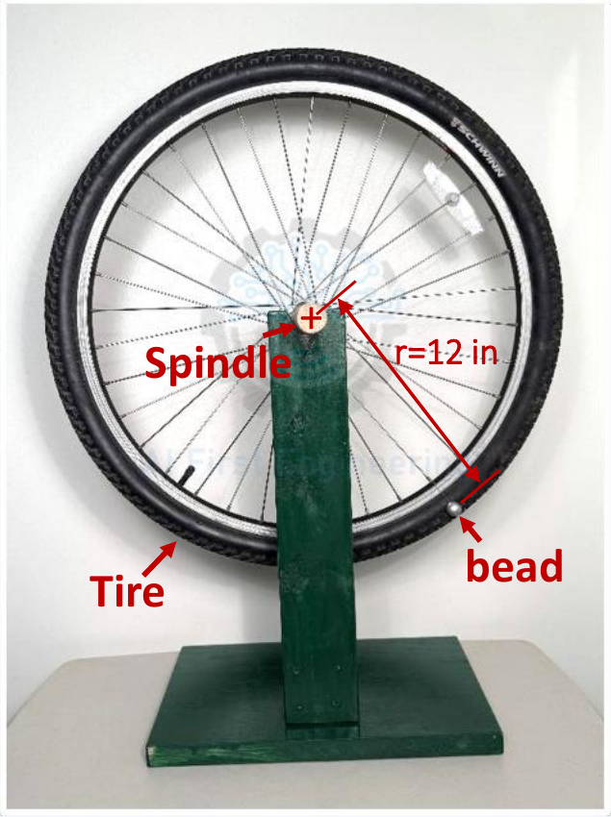
Figure A1 — bicycle-wheel apparatus: spindle, tire, and the bead at r ≈ 12 in from the spindle center.
A1 — Commit to a Prediction. Answer BEFORE opening Tracker. For the STEADY-SPEED wheel (Video 1):
1. Watch the Video: Is the bead's speed constant? Is the bead's velocity constant? (One sentence each — be precise about the difference.)
2. Is the bead accelerating? If yes, in which direction does the acceleration vector point? Commit in one sentence.
3. With the origin at the spindle center and x horizontal / y vertical, sketch or describe the shape you expect for x(t) and for y(t) over two revolutions. What should the amplitude of each be, in meters?
ANSWER A1:
A2 — Tracker Measurement: Steady-Speed Wheel (Video 1). Set the origin at the spindle center (x horizontal, y up), calibrate the scale in tracker with the bead-path radius (or using tracker calibration stick-you can us the full diameter 24in of the path-see lecture slides), and track the bead for at least two full revolutions. Display the x(t) and y(t) plots. Then:
1. Read the period T (time for one revolution – (s/rev) ) from successive peaks of x(t) or y(t) — use more than one revolution and average.
2. Read the amplitude of x(t) and of y(t). Both should be ≈ r — this is a built-in check of your calibration and origin. State them.
3. Compute the angular rate ω = 2π / T, the bead speed v = ω r, and the acceleration magnitude a = ω² r (the Part 2 result a = −ω² r for the steady bead, now with numbers).
4. Pick ONE instant (one row of the Tracker data table) and record x, y, v_x, and v_y at that instant. Check that x·v_x + y·v_y ≈ 0 and that √(v_x² + v_y²) ≈ ω r. What does the first check say about the direction of the velocity vector relative to the radius?
Required evidence (ONE screenshot): the Tracker main window showing the tracked bead path with your axes and calibration stick, and the x(t) and y(t) plots.
PASTE TRACKER EVIDENCE FOR THE STEADY-SPEED WHEEL (VIDEO 1) HERE
(tracked path + axes + calibration + x(t) and y(t) plots — click here and paste — Ctrl+V / Cmd+V)

A2 — Results Table.
T (s) | x amplitude (m) | y amplitude (m) | ω = 2π/T (rad/s)

v = ωr (m/s) | a = ω²r (m/s²) | t of chosen row (s) | x, y (m) | v_x, v_y (m/s) | x·v_x + y·v_y

Direction of the acceleration vector at that instant (from the Part 1 construction — toward what point?):
A3 — Tracker Measurement: Slowing Wheel (Video 2). Same origin, axes, and calibration. Track the bead from the moment braking begins for at least two full revolutions.
Display x(t) (or y(t)). Then:
1. Compare the x(t) plot with the steady case: what changes and what stays the same? (Think: spacing of the peaks vs. height of the peaks.)
2. Read the period from the FIRST pair of successive peaks (T_early) and from the LAST pair you tracked (T_late). Compute v_early = 2πr / T_early and v_late = 2πr / T_late.
3. Is the direction of the velocity vector still changing while the wheel slows? Is the speed changing? So how many contributions to the acceleration are there now, and roughly which way does the total acceleration vector point relative to the path (use the Part 1 picture: inward, backward, or a combination)?
Required evidence (ONE screenshot): tracked path plus the x(t) or y(t) plot for the slowing wheel, with the two peak pairs you used visible.
PASTE TRACKER EVIDENCE FOR THE SLOWING WHEEL (VIDEO 2) HERE
(tracked path + x(t) or y(t) plot showing the peaks you read — click here and paste — Ctrl+V / Cmd+V)

T_early (s) | v_early (m/s) | T_late (s) | v_late (m/s)

ANSWER A3 (items 1 and 3):
A4 — Position, Velocity, Speed, Acceleration: Sort Them Out. Complete the table for the bead. Use YES / NO, and a short phrase for the direction rows. Base every entry on what you measured or constructed above, not on memory.
Quantity (for the bead) | Steady-speed wheel (Video 1) | Slowing wheel (Video 2)
Distance from the spindle |r| constant?
Speed |v| constant?
Velocity vector v constant?
Acceleration vector a zero?
Direction of a relative to the path
Which is changing: speed, direction, or both?

A5 — The Claim. A classmate says: “The bead on the steady wheel moves at constant speed, so its acceleration is zero — Tracker even shows a flat speed plot.” Using your A2 numbers (ω, r, a = ω²r) and the Δv construction from Part 1, explain in two or three sentences why the claim is wrong, and state what IS constant.
ANSWER A5:
CONSTANT SPEED ≠ CONSTANT VELOCITY. Acceleration is the rate of change of the velocity VECTOR. A change in direction alone needs an acceleration — and on a circle at steady speed that acceleration is ω²r, pointing at the center.

PART B · Does Horizontal Motion Change Falling? (2.5 points · ≈ 20 min)
ONE BALL — TWO WAYS TO LEAVE THE TABLE
The Large Bounce Ball (LBB: 90 g, 57 mm) is released twice from the same height above the floor, h = 55 in = 1.397m. once from rest (Video 3, vertical drop, v₀ ≈ 0) and once rolled along the V-slot runway so that it leaves the table edge with a horizontal velocity (Video 4, the higher-speed launch). The camera views the flight plane from the side; a vertical tape measure beside the flight and a horizontal tape along the floor are visible for calibration.
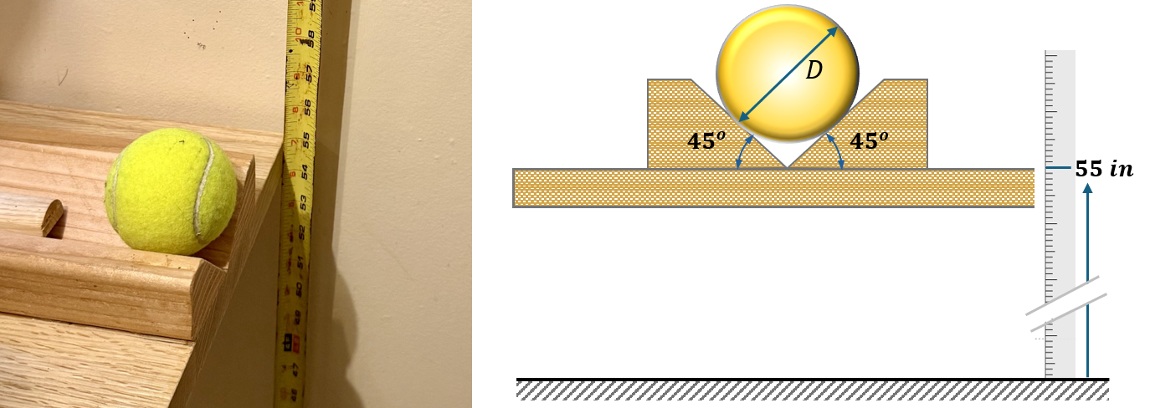
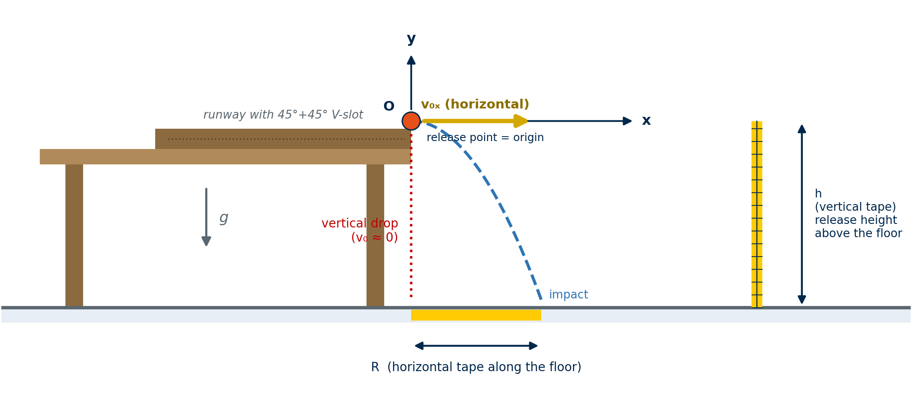
Figure B1 — launch geometry: origin at the release point (table edge), x along the flight, y up; h from the vertical tape, R along the floor tape.
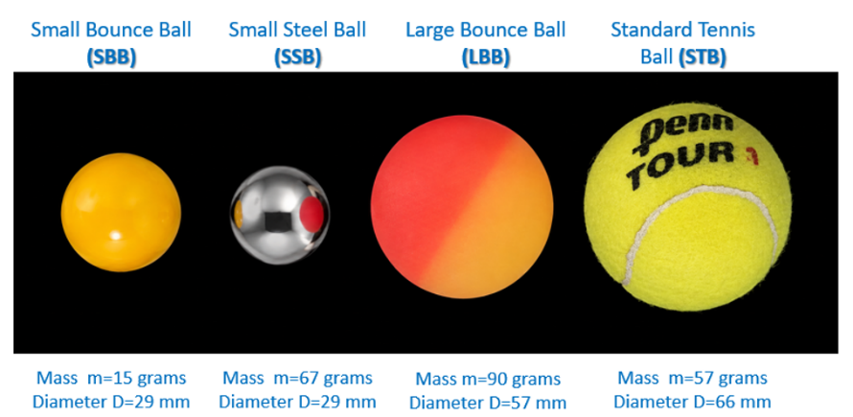
Figure B2 — the four Chapter 1 balls. Only the LBB (Large Bounce Ball, 90 g, 57 mm) is analyzed in this homework.
B1 — Commit to a Prediction. Answer BEFORE opening either ball video in Tracker.
1. Both releases start at the same height at the same instant. Which ball reaches the floor first — the dropped one, the launched one, or both together? Give a one-line physical reason.
2. Write the ideal projectile model for a horizontal launch from height h with origin at the release point and y up: a_x = ?, a_y = ?, x(t) = ?, y(t) = ?, v_y(t) = ?. Circle (or state) whether the launch speed v_0x appears anywhere in the y equations.
3. Compute the ideal fall time t_f = √(2h / g) with the stated h and g = 9.81 m/s². Show the substitution.
Ideal fall time: t_f = ____________ s
ANSWER B1:
B2 — Tracker: Vertical Drop of the LBB (Video 3). Place the origin at the release point with y up (so y becomes negative during the fall — state your convention). Calibrate with the vertical tape. Track the ball from the release frame to the impact frame. Then:
1. Record the release frame, the impact frame, the frame rate, and the measured fall time Δt_drop = (impact frame − release frame) / frame rate.
2. Plot y(t) and fit a parabola (Tracker Data Tool: y = A·t² + B·t + C). Record A, B, C with units. Since y = y₀ + v_y0·t − ½·g·t², the fit gives g_eff = −2A (y up). Report g_eff.
3. Plot v_y(t). Is it approximately a straight line? What is its slope, and what should it be?
Required evidence (ONE or TWO screenshots): the tracked path with axes and calibration, and the y(t) plot with the parabola fit and its coefficients visible. (The v_y(t) plot may be included in the same capture.)
PASTE TRACKER EVIDENCE FOR THE LBB VERTICAL DROP (VIDEO 3) HERE
(tracked path + axes + calibration + y(t) with parabola-fit coefficients — click here and paste — Ctrl+V / Cmd+V)

B3 — Tracker: Horizontal Launch of the SAME LBB (Video 4). Same origin convention (release point at the table edge), x along the flight, y up; calibrate with the same tape. Track from release to impact. Then:
1. Record the release frame, the impact frame, and the measured flight time Δt_launch.
2. Fit x(t) with a straight line (x = A·t + B): the slope A is the horizontal velocity v_0x. Is there any visible curvature in x(t)? What would curvature mean physically?
3. Fit y(t) with a parabola exactly as in B2: record A, B, C and g_eff = −2A. From the fit (or the v_y column at the release frame) report v_y at release — is it ≈ 0, as a horizontal launch requires?
Required evidence (TWO screenshots): (i) the tracked path with axes and calibration together with the y(t) parabola fit; (ii) the x(t) linear fit with its coefficients. These same fits are re-used in Part C — no additional screenshots are needed there.
PASTE TRACKER EVIDENCE FOR THE LBB HORIZONTAL LAUNCH (VIDEO 4) HERE
(tracked path + y(t) parabola fit AND x(t) linear fit with coefficients — click here and paste — Ctrl+V / Cmd+V)

B4 — Compare the Vertical Motions. Fill the table from B2 and B3, then answer.
Quantity | Ideal model | Vertical drop (Video 3) | Horizontal launch (Video 4)
Fall / flight time (s) | t_f = √(2h/g) =
Vertical acceleration g_eff = −2A (m/s²) | 9.81
v_y at release (m/s) | 0
Shape of y(t) | parabola
Horizontal velocity v_0x (m/s) | 0 (drop) / constant (launch) | 0

1. Frame-time resolution: at your frame rate one frame is Δt_fr = 1 / (frame rate) = ______ s, so each measured time carries roughly ± 1–2 frames of uncertainty. Is the difference between the two measured fall times larger than that, or inside it?
2. Did giving the ball a horizontal velocity change its vertical motion — y(t), v_y(t), g_eff, or the time to reach the floor? Answer with your numbers, judged against the frame resolution.
3. Explain the result physically, not by quoting fit coefficients: what is the only force on the ball after release, which direction is it in, why do the x and y equations separate (Part 2), and why therefore can the y motion not “know” about v_0x?
4. Was your B1 prediction right? If not, what did you believe that the data refuted?
ANSWER B4:
THE VERTICAL MOTION DOES NOT KNOW ABOUT THE HORIZONTAL MOTION — in the ideal model. a_x = 0 and a_y = −g are two scalar equations for ONE motion. The launch speed sets how FAR the ball goes, never how LONG it is in the air. Whether the real ball agrees, at the resolution of your video, is what you just tested.

PART C · Model → Predict → Validate (2 points · ≈ 15 min)
Now treat the horizontally launched LBB (Video 4) as an engineering prediction problem. Use only two experimental inputs — the release height h and the Tracker-measured launch speed v_0x from B3 — build the ideal model, predict, and then let the floor weigh in.
C1 — Set Up the Model. State, in your own words, the model you are about to use: the particle, the origin and axes, the knowns (h, v_0x, g), the unknowns, and the three assumptions you consider most likely to be violated by a real bouncy ball rolling off a table (rank them before you see the comparison).
ANSWER C1:
C2 — Predict. With h and the Tracker v_0x, compute the ideal-model predictions. Show each substitution.
1. Time of flight: t_f = √(2h / g) = ____________ s
2. Horizontal range: R = v_0x · t_f = ____________ m
3. Vertical velocity at impact: v_y = −g · t_f = ____________ m/s
4. Impact speed |v| = √(v_0x² + v_y²) = ____________ m/s and angle below horizontal θ = tan⁻¹(|v_y| / v_0x) = ________ °
5. Trajectory: eliminate t to write y as a function of x for this launch, y(x) = ____________ (with your numbers). What curve is it, and what happens to its steepness if v_0x is smaller?
ANSWER C2 (item 5):
C3 — Measure and Compare. From Video 4 (no new Tracker work — read your B3 data): the measured flight time Δt_launch from the frame count, and the measured range R_exp = x at the impact frame (Tracker table; cross-check against the floor tape if it is readable). Complete the table with % difference = |experiment − model| / model × 100 %.
Quantity | Model prediction | Experiment (Video 4) | % difference
Time of flight t_f (s)
Horizontal range R (m)
Vertical acceleration (m/s²) | 9.81 | g_eff =
Launch speed v_0x (m/s) — two routes | Tracker x(t) slope: | R_exp / Δt_launch =

Frame-time budget: one frame at your frame rate = ______ s; a ± 1-frame error at EACH end of the flight is ± ______ s, which is ± ______ % of your measured t_f.
C4 — Interpret (this is the part that counts). Answer each in one to three sentences, using the numbers above.
1. How closely did the ideal model match the experiment? Is the % difference in t_f inside or outside the frame-time budget you just computed? What about R?
2. Which of your C1 assumptions does the data actually challenge, and which does it leave untested? (A single flight cannot test everything.)
3. Sort the discrepancies using their fingerprints from Part 3: a g_eff that is off by a constant factor for the whole flight points to ______ (scale / parallax — measurement); a curved x(t) or a range that falls SHORT of the prediction points to ______ (air drag — physics omitted from the model); v_y ≠ 0 at release points to ______ (non-horizontal exit — setup). Which fingerprint, if any, do YOUR data show?
4. Engineering verdict: is the disagreement large enough to question the ideal projectile model for THIS ball over THIS height, or is the model adequate at the resolution of this experiment? Either verdict can earn full credit if your evidence supports it.
ANSWER C4:
A PREDICTION IS A HYPOTHESIS UNTIL THE FLOOR WEIGHS IN. The engineering question is never “was there error?” — there always is. It is: which errors are large enough to change the conclusion, and which measurement would settle it.

PART D · Transfer — Same Ball, Lower Launch Speed (1 point · ≈ 5 min)
The instructor also recorded the SAME LBB launched horizontally from the SAME height, but at a lower (medium) launch speed. Do NOT analyze that video. Using only the ideal projectile model and your Part C results, predict what changes and what does not. Give a one-line physical justification for each.
If v_0x is LOWER (same h, same ball) … | larger / smaller / unchanged | Why (one line, from the model)
Time of flight t_f
Horizontal range R
Vertical motion y(t), v_y(t), a_y
Vertical velocity at impact v_y
Impact speed |v| and impact angle
Shape of the trajectory y(x)

1. If the lower launch speed were exactly half of your Part C v_0x, what would the range be, numerically? What quantity would you read from that video with a single frame count to confirm your prediction?
ANSWER D1:

PART E · Engineer Decides — AI Engineering Companion (1 point · ≈ 5 min)
E1 — AI as Modeling Partner. Give a capable AI assistant a question such as:
“My Tracker-measured flight time for a ball launched horizontally from a table differs from the ideal projectile prediction by ___ %, and the measured range differs by ___ %. Give me possible causes, but do not decide which is correct. For each cause, tell me what fingerprint it would leave in x(t), y(t), or g_eff, and what additional measurement would distinguish it.”

Do NOT paste the AI transcript. Instead, report the following:
1. ONE physically plausible cause the AI proposed, and the fingerprint it claims that cause would leave in the data. (1–2 sentences)
2. Does YOUR Part B/C evidence show that fingerprint? Quote the number or plot feature that supports your answer. (1 sentence)
3. At the frame-time resolution of your video, is the effect large enough to matter for the engineering verdict you gave in C4? (1 sentence)
4. Did the AI say anything you had to correct or verify against Chapter 2? (1 sentence — “no” is acceptable if you checked.)
ANSWER E1:
PHYSICALLY POSSIBLE ≠ SUPPORTED BY EVIDENCE ≠ LARGE ENOUGH TO MATTER. AI generates possibilities. Engineers use evidence to decide which possibilities are credible. The final decision belongs to the student engineer.

SUBMIT · Evidence Checklist & Human Review (≈ 2 min)
Submit ONE completed Word document — this file — containing all of the following:
- Prediction before measurement for the steady wheel (A1) and for the two ball releases (B1)
- Tracker evidence for the steady-speed wheel — Part A2 (one screenshot) and completed A2 results tables
- Tracker evidence for the slowing wheel — Part A3 (one screenshot) and T_early / T_late table
- Position / velocity / speed / acceleration sort-out table (A4) and refutation of the claim (A5)
- Tracker evidence for the LBB vertical drop — Part B2 (path + y(t) fit with coefficients)
- Tracker evidence for the LBB horizontal launch — Part B3 (path + y(t) fit, and x(t) fit)
- Completed vertical-motion comparison table and physical explanation — Part B4
- Model set-up, predictions with substitutions, model-vs-experiment table with % differences, and interpretation — Parts C1–C4
- Transfer predictions for the lower-speed launch — Part D
- AI Engineering Companion response evaluation — Part E1
- Human review statement signed and dated (below)

SUBMIT ONE COMPLETED HOMEWORK DOCUMENT
Keep all required answers and Tracker evidence in this document rather than as separate Tracker, video, or image files. If this homework is being used as part of a course, follow your instructor's submission and file-naming requirements.

HUMAN REVIEW: (Parts A–E: 9 points · Human Review / Completeness: 1 point · Total: 10 points)
“I reviewed the Tracker measurements, calculations, model predictions, comparisons, AI-assisted analysis, and engineering conclusions in this submission and confirm that they represent the work I performed and reviewed.”
Human reviewed and approved: __________________________
Student name: __________________________ Date: ____________
AI assists. Humans observe. Humans verify. Humans decide. Humans approve.

Suggested Assessment Rubric — 10 points
Used by the instructor and, where applicable, by an AI grading agent. All required evidence must appear inside this document — the grader will not open separate Tracker, video, or image files.
Criterion | What full credit looks like | Pts
Bicycle wheel: prediction, Tracker measurement, and the speed-vs-velocity distinction (A1–A5) | Genuine Tracker evidence for BOTH wheel videos with stated origin/calibration; T read from successive peaks; amplitudes ≈ r; ω, v = ωr, a = ω²r computed correctly with units; one-row check x·v_x + y·v_y ≈ 0 interpreted as v ⟂ r (tangent); slowing wheel shows longer period with unchanged amplitude and v_late < v_early; A4 table consistent; A5 refutes “constant speed ⇒ a = 0” using ω²r and the Δv construction. | 2.5
Drop vs. launch: prediction, Tracker fits, and the physical explanation (B1–B4) | Prediction committed before data; ideal t_f computed from √(2h/g); Tracker evidence for BOTH ball videos with parabola-fit coefficients visible; g_eff = −2A extracted with correct sign; v_0x from the x(t) slope; comparison table complete; the two fall times compared against the frame-time resolution before any conclusion; physical explanation cites the single vertical force and the separation of the x and y equations, not merely the fit numbers. | 2.5
Model → predict → validate (C1–C4) | Assumptions stated and ranked; t_f, R, impact v_y, impact speed and angle, and y(x) computed with substitutions; measured t_f and R with % differences; v_0x obtained by two routes and compared; frame-time budget computed; discrepancies sorted by fingerprint (scale/parallax vs. drag vs. non-horizontal exit); a defensible verdict on model adequacy at the experiment's resolution. | 2
Transfer — lower launch speed (D) | t_f, y(t), v_y(t), a_y, and impact v_y unchanged; R and impact speed smaller (angle steeper); trajectory a narrower parabola; half v_0x ⇒ half R with the numerical value; identifies the range (one frame/tape reading) as the confirming measurement; reasons from the model, not from intuition. | 1
AI Engineering Companion — critical evaluation (E1) | AI hypothesis evaluated against the student's OWN fingerprints and frame-time resolution — physically possible ≠ supported by evidence ≠ large enough to matter; no transcript pasted. | 1
Human review / completeness | All checklist items present; screenshots legible with axes/calibration visible; answers concise; human-review statement signed and dated. | 1
 | TOTAL | 10

