ME 345 ENGINEERING DYNAMICS  CHAPTER 2 — CURVILINEAR PARTICLE KINEMATICS  Self-Assessment  Can I See It, Model It, Solve It in Any Language, and Validate It?  Ungraded · for your own learning · work at your own pace |   Figure: AI First Engineering (AIFE) course logo
Taner Onsay, Ph.D. © 2026 AI First Engineering
AI TUTOR MODE — read this first
You do not need to complete every question in one sitting. Start with each group. If you can confidently solve the first questions independently, sample the remaining questions. Spend more time in groups where you need AI or human help. Try each question yourself first. If you become stuck, AI may be used as a tutor — not as an answer machine. Instead of asking for the answer, try:
“Do not solve this for me. Ask me one question or give me one small hint at a time.”
The purpose of this self-assessment is to determine what YOU understand — not what your AI can answer. This is the course workflow in action: Observe › Idealize › Model › Solve / Analyze › Validate › Report.

After each group, rate yourself with the four checkboxes. Your pattern of ratings — not a score — is the output: it tells you exactly what to review, practice, or bring to office hours before Chapter 3. Chapter 2 has seven lecture parts; this one document covers all of them — and it now includes short challenges on all five Virtual Engineering Laboratory modules — so sample freely inside groups you already own and slow down where a rating surprises you.

VIRTUAL ENGINEERING LABORATORY (VEL) CHALLENGES — read before the first VEL item
Questions tagged VEL use the AIFE Virtual Engineering Laboratory (lab.aifirstengineering.org), which now has five Particle Motion Animator modules: Rectilinear Motion · Projectile Motion — Basketball · Normal–Tangential Motion · Polar r–θ Motion · Stopping Distance. Every VEL item follows the same rhythm: SEE → PREDICT → MODEL → RUN → CALCULATE INDEPENDENTLY → VALIDATE → EXPLAIN. Commit your prediction on paper before you press PLAY (PREDICTION MODE hides the graphs for exactly this reason). Then compute at least one number yourself and compare it with the readout. The VEL is never the answer key: if your number and the machine’s disagree, one of you is wrong — and finding out which is the exercise. These are short diagnostic challenges, not a second Homework 3; where Homework 3 varied one thing, these vary another.

GROUP 1 · Explain It — From Straight Paths to Curved Paths
Reason with sketches, arrows, and words. The VEL item that closes the group is the Chapter 1 bridge: a turning point is not a pause. (Part 1, with a look ahead to Part 2.)
1. Position, Displacement, or Distance — On a Curve
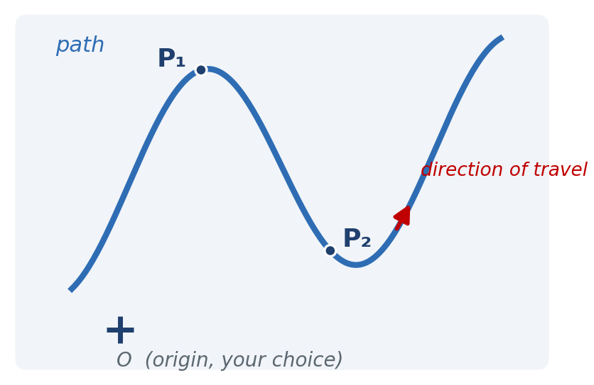
A ground robot follows the curved path shown. It passes $P_{1}$ at $t_{1}$ and $P_{2}$ at $t_{2}$. The origin O was chosen by you.
A. On the figure, draw the position vectors ${\vec{r}}_{1}$ and ${\vec{r}}_{2}$, and the displacement $Δ\vec{r} = {\vec{r}}_{2} - {\vec{r}}_{1}$.
B. Is the distance traveled along the path from $P_{1}$ to $P_{2}$ equal to $\left|Δ\vec{r}\right|$? Larger? Smaller? Explain in one sentence.
C. Draw the velocity vector $\vec{v}$ at $P_{1}$ and at $P_{2}$. What single rule fixes its direction, whatever origin you chose?
D. A teammate moves the origin O to a different spot. Which of the following change: ${\vec{r}}_{1}, Δ\vec{r}$, the path distance, $\vec{v}$ at $P_{1}$? Which are physically real and which depend on the chosen origin?
Then complete: “Velocity points from the origin to the particle” is __________ (true / false), because __________.

2. Constant Speed — Is the Bead Accelerating?
The front bicycle wheel of the Chapter 2 apparatus spins at approximately constant angular speed. The silver bead near the rim therefore moves at approximately constant speed on a circle of radius $r$.
A. Commit first: Is the bead accelerating? yes / no / only if the wheel speeds up. Write one sentence saying what “acceleration” means before you answer.
B. Sketch the bead at two nearby instants, $t_{1}$ and $t_{2}$, and draw ${\vec{v}}_{1}$ and ${\vec{v}}_{2}$ (same length, different directions). Slide both to a common tail and draw $Δ\vec{v} = {\vec{v}}_{2} - {\vec{v}}_{1}$. Which way does $Δ\vec{v}$ point?
C. In the limit $Δt → 0$, which way does $\vec{a}$ point? Is $\vec{a}$ tangent to the path?
D. Now a rubber friction element is pressed against the hub and the wheel slows gradually. List the two contributions to $\vec{a}$ that now exist at the same time, and sketch the resulting $\vec{a}$ (direction only) at one bead position.

3. Three Reasons for Acceleration — Classify Before You Compute
For each situation, decide whether the particle’s acceleration comes from a change in speed, a change in direction, both, or neither, and sketch the direction of $\vec{a}$ relative to the path (along, across, tilted, or zero). No numbers.
– a car braking hard on a straight test road;
– the bead on the steadily spinning bicycle wheel;
– the same bead while the wheel is being braked;
– a car accelerating out of a bend (speeding up while still turning);
– an elevator rising at constant speed;
– a package on a conveyor rounding a gentle curve at constant belt speed.
Then answer in one sentence: for which of the six is $\vec{a}$ tangent to the path? For which is it perpendicular?

4. Where Is $\left|\vec{a}\right|$ Largest on the Figure-8?
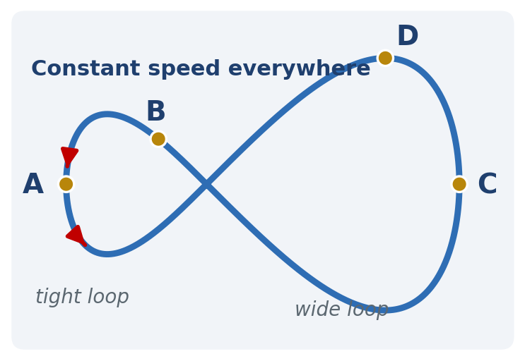
A test vehicle drives the figure-8 track at constant speed. Points A and B are on the tight loop, C and D on the wide loop.
A. Rank $\left|\vec{a}\right|$ at A, B, C, D from largest to smallest. Is $\left|\vec{a}\right|$ zero anywhere on this track? Explain using curvature only.
B. Draw $\vec{v}$ and $\vec{a}$ at A and at C (directions only; relative lengths should reflect your ranking).
C. The driver brakes at B. Which way does $\vec{a}$ tilt now? Draw it.
D. The driver now drives the same track with the same $\left|\vec{a}\right|$ everywhere. What must the driver do to the speed between the wide loop and the tight loop? Explain why.

5. VEL · Rectilinear Motion The Turning Point — Pause or Not?
Open the Rectilinear Motion module (Describe it). Build a two-segment motion for a delivery robot on a straight aisle, with $s = 0$ at the start and right positive:
– Segment 1 — RIGHT, SLOW DOWN from cruise speed $v_{0}$ to rest, lasting $t_{1} = v_{0}/a_{1}$ (choose $v_{0}$ and $a_{1}$; for example $v_{0} = 2.0$ m/s and $a_{1} = 0.50$ m/s²);
– Segment 2 — LEFT, SPEED UP from rest with $a_{2} = 2a_{1}$, for the same duration $t_{1}$.
A. Predict before GENERATE (on paper): (i) the sign of $a$ in each segment and at the turning point; (ii) does the robot re-cross its starting position before Segment 2 ends? If so, is it moving faster or slower than $v_{0}$ when it does? (iii) sketch $s(t), v(t), a(t)$ for the whole motion.
B. Model, then compute — in symbols first, then numbers: the farthest position $s_{max}$, the instant $t_{×}$ at which the robot re-crosses $s = 0$, and its velocity there. (Hint: $s_{max} = v_{0}^{2}/(2a_{1})$; the return trip from rest with $a_{2}$ covers $s_{max}$ in a time you can solve for.)
C. Run. Step to the turning point ($t = t_{1}$) and record $s$, $v$ and $a$ just before and just after it. Does the animation show the robot “pausing”? Describe what $v = 0$ with $a ≠ 0$ looks like on the v–t graph and on the s–t graph.
D. Validate: compare $t_{×}$ and $v(t_{×})$ with the VEL readouts. Then check the limiting case $a_{2} = a_{1}$ (the symmetric reversal): where should the re-crossing move to, and at what speed? Confirm with one more run.
E. Explain in two sentences why “$v = 0$ means $a = 0$” is wrong here, and how the s–t curve shows it (what is happening to its slope while the slope is zero?).

RATE YOURSELF on this group before moving on:
- I can do this independently.
- I can do this with a small AI hint.
- I need substantial AI help.
- I still need human/instructor help.

GROUP 2 · Describe It in x–y — Cartesian Kinematics
Fixed axes, fixed basis vectors: differentiate the components, then reassemble one vector and check it on the sketch. (Part 2.)
6. What Tracker Actually Delivers
Tracker analysis of the steadily spinning bicycle wheel hands you a table with three columns: $t, x, y$ (every 1/120 s), with the origin at the spindle center.
A. Before looking at any plot, sketch what $x(t)$ and $y(t)$ should look like for a bead going around at steady speed. What is the physical meaning of the amplitude of each curve?
B. Nothing in the table says “circle”. What would you plot to see the circle? What would you compute to check that the tracked point is really 0.305 m from the spindle?
C. How does Tracker obtain $v_{x}$ and $v_{y}$ from the table? Is the result an instantaneous velocity or an estimate? (Connect to Chapter 1.)
D. The $x$- and $y$-columns can be differentiated separately. A classmate concludes: “So the bead is really two independent motions.” Explain precisely what “the equations separate” does and does not mean. What single equation ties $x$ and $y$ together for this wheel?

7. A Warehouse Rover — From $x(t), y(t)$ to One Vector
A rover’s tracking system reports, with fixed axes on the warehouse floor,
$x(t) = 3 - 2t$ , $y(t) = 0.5t^{2}$ , ($x, y$ in meters, $t$ in seconds).
A. Before differentiating, predict: at $t = 2$ s, in which quadrant is the rover, and roughly which way is it moving? Sketch the path for $0 ≤ t ≤ 3$ s.
B. Determine $\vec{v}(t)$ and $\vec{a}(t)$ as vectors.
C. At $t = 2$ s find the speed and the direction of $\vec{v}$ measured from the $+x$ axis. A calculator’s $\tan^{-1}(v_{y}/v_{x})$ gives $-45°$. Is that the rover’s heading? Check against your sketch and fix it if necessary.
D. Is $\vec{a}$ tangent to the path at $t = 2$ s? Is the rover speeding up or slowing down at that instant? Support your answer with the sign of $\vec{v} · \vec{a}$, then with words.
E. Why is the differentiation done component by component? Name the property of $\hat{i}$ and $\hat{j}$ that makes this legitimate.

8. A Cam Follower on a Known Rail — $y = f(x)$
A follower rides on a rail shaped $y = 0.25x^{2}$ ($x, y$ in meters). Its drive controls only the $x$-motion: at the instant when $x = 2$ m, $\dot{x} = 1.5$ m/s and $\ddot{x} = 0$.
A. Predict: a classmate writes “$\dot{y} = dy/dx = 0.5x = 1$ m/s”. Before computing, say what is wrong with that statement (units are a good place to start).
B. Compute $\dot{y}$ using the chain rule. Write $\vec{v}$ as a vector, find its magnitude and direction, and check that the direction matches the slope of the rail at $x = 2$ m.
C. Compute $\ddot{y}$. Even though $\ddot{x} = 0$, is the follower’s acceleration zero? Which term of $\ddot{y} = f″(x){\dot{x}}^{2} + f'(x)\ddot{x}$ survives, and what does it represent physically?
D. Draw $\vec{a}$ on the rail at $x = 2$ m. Does it point toward the concave side of the rail? Is the follower speeding up, slowing down, or moving at constant speed at this instant?
Keep your numbers — Question 36 revisits this rail in n–t language.

9. One Motion, Two Shadows — Prove the Part 1 Claim
The steady bead is modeled by $x = R cos ωt, y = R sin ωt$ with $R$ and $ω$ constant.
A. Differentiate to obtain $\vec{v}$ and $\vec{a}$ in $\hat{i}, \hat{j}$ components.
B. Show that the speed is constant and equal to $Rω$, yet $\vec{a} ≠ 0$. Show that $\vec{a} = -ω^{2}\vec{r}$. Which way does $\vec{a}$ point, and how large is it?
C. Show that $\vec{v} · \vec{r} = 0$ at every instant. What does this say geometrically about $\vec{v}$ and the circle?
D. The Cartesian components are complete but they “hide” something that Part 1 made visible. What is hidden, and which later description (Part 4 or Part 5) exposes it directly?

RATE YOURSELF on this group before moving on:
- I can do this independently.
- I can do this with a small AI hint.
- I need substantial AI help.
- I still need human/instructor help.

GROUP 3 · Model It, Measure It — Projectile Motion
The projectile model is Cartesian kinematics with $a_{x} = 0$ and $a_{y} = -g$. Say its assumptions out loud before every equation. (Part 3, built on Part 2.)
10. Three Balls Leave the Table — Predict, Then Model
Three identical balls leave the same table-edge height at the same instant: one is released from rest (drop), one rolls off slowly, one rolls off fast.
A. Commit before reading on: which reaches the floor first? dropped / slow / fast / all together. One-line reason.
B. Write down the projectile model as a list: particle, coordinates and origin, $a_{x}$ = ?, $a_{y}$ = ?, and every assumption you are making about gravity, air, spin and the release.
C. Using the model, explain why the launch speed changes how FAR the ball goes but not how LONG it is in the air. Which equation contains $v_{0x}$, and which does not?
D. Now the three balls are a steel ball, a tennis ball, and a ping-pong ball. Rank the assumptions in B by which you would doubt first for the ping-pong ball. What would you see in the 120 fps video if that assumption failed?

11. The V-Slot Launch — Calculate It
A tennis ball rolls off the V-slot at the table edge, $h = 0.90$ m above the floor, and lands $R = 1.10$ m from the point directly below the edge. Use the ideal model, $g = 9.81$ m/s².
A. Predict: if the ball had left twice as fast, would the flight time double, halve, or stay the same? Would $R$ double?
B. Compute the flight time $t_{f}$.
C. Infer the release speed $v_{0x}$ from $R$ and $t_{f}$.
D. Compute the velocity vector just before impact: components, magnitude, and angle below horizontal. Sketch it at the landing point.
E. The flight time is measured by counting frames. Estimate the relative uncertainty in $t_{f}$ for $±2$ frames at 30 fps and at 120 fps. Which quantity in C inherits this uncertainty, and how?

12. Tracker Data from a Launch — Interpret It
A Tracker export for a horizontally launched ball (origin on the floor below the release point, $y$ up, every 12th frame of a 120 fps clip shown, plus the last frame before impact):
$t$ (s) | $x$ (m) | $y$ (m)
0.0 | 0.0 | 0.75
0.1 | 0.15 | 0.7
0.2 | 0.31 | 0.55
0.3 | 0.45 | 0.31
0.375 | 0.56 | 0.06

A. Before computing: which column should be linear in $t$ and which quadratic? State the model reason for each.
B. Estimate $v_{0x}$ from the $x$-column. Is $v_{x}$ approximately constant?
C. Estimate $v_{y}$ at $t = 0.20$ s using the neighboring rows (central difference). Compare with the model’s $v_{y} = -gt$. Is your estimate an instantaneous value?
D. Estimate an effective $g$ from the $y$-data (for example from the $t = 0.30$ s row). How close is it to 9.81 m/s²?
E. The points do not fall exactly on the ideal parabola. Give three candidate causes and say what each would look like in the data. Does the disagreement mean the equations are wrong?

13. Toss to the Loading Dock — General Projectile
A worker tosses a package with speed 8.0 m/s at 35° above horizontal, releasing it 1.0 m above the ground. The edge of a loading dock is 5.0 m away horizontally and its top is 1.5 m above the ground. Ideal model; $g = 9.81$ m/s².
A. Predict: at the top of its arc, is the package’s velocity zero? Does the package clear the dock edge — commit to yes/no before computing.
B. Set up $x(t)$ and $y(t)$ with a stated origin and axes. Find the time at which the package reaches $x = 5.0$ m.
C. Find its height at that instant. Does it clear the 1.5 m edge, and by how much?
D. At the dock edge, is the package rising or falling? Give the velocity components and the speed there.
E. Find the apex height and the velocity at the apex.
F. Validate your speed in D by a second route that does not use time (hint: $v_{y}^{2} = v_{0y}^{2} - 2g(y - y_{0})$). Do the two routes agree?

14. VEL · Projectile Motion — Basketball Change One Thing
Open the Projectile Motion — Basketball module and load the preset shot: $v_{r} = 8.73$ m/s, $θ_{r} = 50.0°, h_{r} = 2.10$ m, $L = 6.75$ m, rim height 3.05 m. It is a make. Now change exactly one parameter: raise the release height to $h_{r} = 2.40$ m (a taller shooter), keeping $v_{r}$ and $θ_{r}$.
A. Predict before PLAY: short / make / long? Does the time to reach the rim plane ($x = L$) change? Does the $x$-equation contain $h_{r}$ at all?
B. Model: write $x(t)$ and $y(t)$ with the common time $t$ and a stated origin. Compute the time at which $x = L$ and the height $y$ there, for $h_{r} = 2.10$ m and for 2.40 m. How far above or below the rim is the ball at the rim plane in each case?
C. Run in PREDICTION MODE, then REVEAL. Where ($x$) does the ball cross rim height on the way down? Read it from the VEL (step frames and interpolate if the pane does not report it directly). Compute that crossing point independently by solving $y = 3.05$ m for the descending root, and compare.
D. Validate: (i) units; (ii) limiting reasoning — raising the release by $Δh$ shifts the height at the rim plane by exactly $Δh$: explain why using the two equations; (iii) is the VEL’s agreement within its 0.05 s time step?
E. Predict only, then check: back to $h_{r} = 2.10$ m, lower the angle to $θ_{r} = 45.0°$ at the same speed. Short or long? Explain in one sentence with $t = L/(v_{r} cos θ_{r})$ and the $y$-equation: the rise term ($v_{r} sin θ_{r}$)$t$ and the drop term $½gt^{2}$ both shrink — which shrinks more, and why does that decide it?

RATE YOURSELF on this group before moving on:
- I can do this independently.
- I can do this with a small AI hint.
- I need substantial AI help.
- I still need human/instructor help.

GROUP 4 · Speed vs. Direction — Normal–Tangential Kinematics
When the path is known, ride with the particle: ${\hat{u}}_{t}$ along the path, ${\hat{u}}_{n}$ toward the center of curvature. $a_{t} = dv_{sp}/dt$ changes speed; $a_{n} = v_{sp}^{2}/ρ$ changes direction. (Part 4.)
15. Draw $\vec{a}$ on the Bent Wire — No Numbers
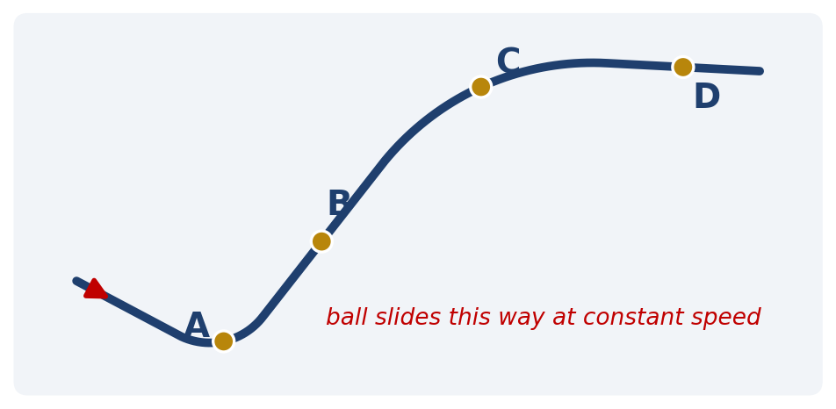
A golf ball slides along the bent wire at constant speed, passing A, B, C, D in that order.
A. At each of A, B, C, D draw ${\hat{u}}_{t}$ and ${\hat{u}}_{n}$. Where is ${\hat{u}}_{n}$ hardest to place, and why?
B. Draw $\vec{a}$ at each point with lengths that reflect your ranking of $\left|\vec{a}\right|$. Where is $\left|\vec{a}\right|$ largest? Where is it (nearly) zero? What is $ρ$ doing there?
C. Now the ball speeds up steadily from A to D. Redraw $\vec{a}$ at A and at C. Which component changed and which did not?
D. Complete: “A unit vector cannot change its length, so its derivative must be __________ to it, with magnitude equal to its __________.”

16. Two Highway Curves — Predict, Then Calculate
Curve 1 is posted at 40 km/h with radius 50 m. Curve 2 is posted at 80 km/h with radius 150 m.
A. Commit first: which curve produces the larger sideways (normal) acceleration at the posted speed, and roughly by what factor?
B. Compute $a_{n}$ for each curve in m/s² and as a fraction of $g$. Were you right?
C. What radius would Curve 2 need for the same $a_{n}$ as Curve 1? State the general rule: doubling the speed requires __________ the radius.
D. A car takes Curve 1 at the posted speed but is braking at 2.0 m/s². Find $\left|\vec{a}\right|$ and its direction relative to the tangent. Is $\left|\vec{a}\right|$ simply $a_{t} + a_{n}$? Why not?

17. The Tightening Off-Ramp — Multi-Step Model
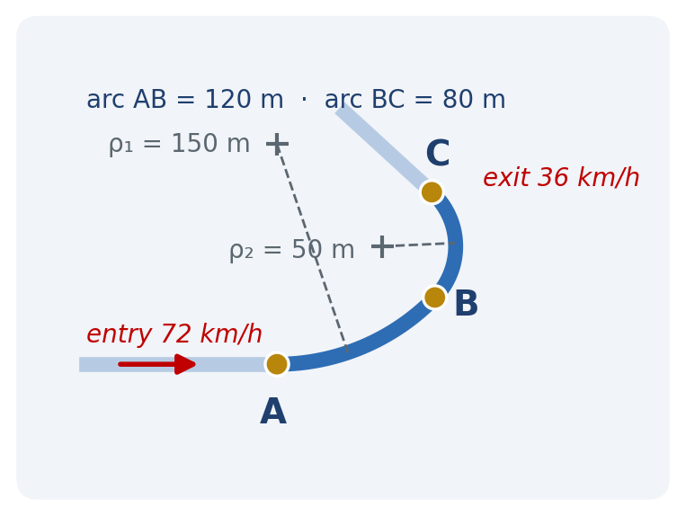
An autonomous vehicle enters the off-ramp at A at 72 km/h and must exit at C at 36 km/h. The controller plans a constant tangential deceleration over the whole ramp. Arc AB: $ρ_{1} = 150$ m, length 120 m. Arc BC: $ρ_{2} = 50$ m, length 80 m. Comfort limit: $\left|\vec{a}\right| ≤ 0.3g ≈ 2.94$ m/s².
A. Predict before computing: at which of A, B⁻, B⁺, C is $\left|\vec{a}\right|$ largest? Why did you pick that point?
B. Compute the constant $a_{t}$ (Chapter 1 kinematics along the path, with $s$ as the coordinate).
C. Compute the speed at B.
D. Compute $a_{n}$ at A, B⁻, B⁺ and C. Why do B⁻ and B⁺ differ although the speed is the same?
E. Compute $\left|\vec{a}\right|$ at the worst point. Is the plan within the comfort limit? If not, what maximum speed at B would keep arc BC within the limit (ignore $a_{t}$ for this estimate)?
F. In one sentence: what should the controller do differently, and why is “constant braking” the wrong plan here?

18. The Bicycle-Wheel Bead by the Numbers — Measure, Then Brake
The bead is $r = 0.30$ m from the spindle. From the 120 fps video you count $N = 12$ revolutions in $Δt = 10.0$ s at steady speed.
A. Predict: if the wheel were spun at twice the rate, by what factor would $v_{sp}$ change? And $a_{n}$?
B. Compute $f, ω$ (rad/s), the bead speed $v_{sp}$, and $a_{n}$. Express $a_{n}$ in g’s. Is $a_{t}$ zero here?
C. Plausibility: is “about 1.7 $g$ on a bicycle bead” believable? What would happen to a bead that was not glued on, and which chapter answers why?
D. The brake is applied and $ω$ falls from its steady value to half of it in 5.0 s, roughly linearly. Estimate $α, a_{t}$, and $a_{n}$ at the end of the 5 s. Which component dominates $\left|\vec{a}\right|$ throughout the braking?
E. $a_{t}$ is tiny compared with $a_{n}$. Does that mean the brake is doing almost nothing? Explain what each component is “about”.

19. The Accelerometer Knows $\left|\vec{a}\right|$ — You Must Find $ρ$
A data logger on a test car on a curved track reports, at one instant: speed 18 m/s and total acceleration $\left|\vec{a}\right| = 4.0$ m/s² directed 25° from the inward normal, tilted toward the rear of the car.
A. Predict: is the car speeding up or slowing down? Is the local radius of curvature larger or smaller than $v_{sp}^{2}/\left|\vec{a}\right|$? Sketch ${\hat{u}}_{t}, {\hat{u}}_{n}$ and $\vec{a}$.
B. Resolve $\vec{a}$ into $a_{n}$ and $a_{t}$. Give the signs.
C. Find $ρ$. Is this the radius of the track at that instant, or something else?
D. The same $\left|\vec{a}\right|$ is reported 25° ahead of the normal. What changes and what does not?
E. Validate: units; the limits 0° (pure turning) and 90° (straight road) — do $a_{n}, a_{t}$ and $ρ$ behave sensibly?

20. VEL · Normal–Tangential Motion Crest, Trough, Crest — Where Is $a_{n}$ Largest?
Open the Normal–Tangential Motion module. DEFINE THE PATH: Sine curve, $A = 1.0$ m, $λ = 4.0$ m (the path runs $0 ≤ x ≤ 2λ$: crest, trough, crest). SPEED ALONG THE PATH: SLOWING DOWN, $v_{0} = 3.0$ m/s, $\left|a_{t}\right| = 0.40$ m/s², $T = 10$ s. Turn on ${\hat{u}}_{t}/{\hat{u}}_{n}, a_{t}, a_{n}$, and the centre of curvature / osculating circle.
A. Predict before GENERATE: (i) where is $ρ$ smallest, and at how many places? (ii) where is $a_{n}$ largest — the same place(s)? (iii) at the inflection points ($x = 0, 2, 4, 6$ m) is the total acceleration zero? (iv) which way does ${\hat{u}}_{n}$ point at the trough — up or down? (v) does the particle reach the end of the path (its arc length, shown by the VEL, is about 11.7 m)?
B. Model before PLAY: compute $ρ$ at a crest of $y = A sin(2πx/λ)$ from $ρ = {\left[1 + (y')^{2}\right]}^{3/2}/\left|y″\right|$ ($y' = 0$ there). Is $ρ$ the same at both crests and at the trough?
C. Run. Pause at crest 1, the trough, and crest 2; record $s, v_{sp}, a_{n}$, $ρ$. Then compute $a_{n} = v_{sp}^{2}/ρ$ independently at each, using $v_{sp}^{2} = v_{0}^{2} - 2\left|a_{t}\right|s$ with the VEL’s $s$. Compare.
D. Explain: same $ρ$, three different $a_{n}$ — why? Where along the path is $\left|\vec{a}\right|$ exactly $\left|a_{t}\right|$? Where does the motion end, and why does it end before the end of the path?
E. Validate by a second run: switch to CONSTANT speed 3.0 m/s. Predict first: are the three $a_{n}$ now equal? What is their value?

RATE YOURSELF on this group before moving on:
- I can do this independently.
- I can do this with a small AI hint.
- I need substantial AI help.
- I still need human/instructor help.

GROUP 5 · Range and Bearing — Polar Kinematics
Fixed origin, rotating basis vectors: ${\hat{u}}_{r}$ points from O to the particle, ${\hat{u}}_{θ}$ is 90° ahead in the direction of increasing $θ$. Radians throughout. (Part 5.)
21. The Turntable — Answer in Polar Words
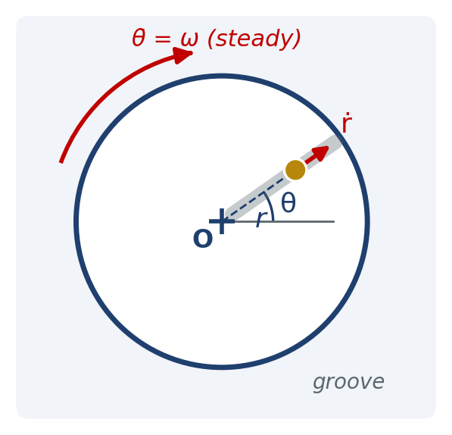
A turntable spins at a steady rate $\dot{θ} = ω$. A ball sits in a straight radial groove.
A. The ball is held still in the groove at fixed $r$. Is it accelerating? Which polar term is responsible, and which way does that term point? (You answered this in Part 1 and Part 4 words — use polar words now.)
B. Now the ball slides outward along the groove at a steady rate $\dot{r}$, while $\dot{θ}$ stays constant. Commit: is there any acceleration in the ${\hat{u}}_{θ}$ direction? no — $\dot{θ}$ is constant / yes, forward / yes, backward.
C. Explain the $2\dot{r}\dot{θ}$ term in two different ways using the turntable (hint: one picture is about the transverse speed $r\dot{θ}$ growing; the other is about the radial velocity vector $\dot{r}{\hat{u}}_{r}$ rotating).
D. The ball now slides inward. Which way does the transverse acceleration point? What if the table were stopped ($\dot{θ} = 0$)?
E. Write $\vec{v}$ and $\vec{a}$ for case B in terms of $r, \dot{r}, \dot{θ}$ and the unit vectors. Which terms are zero and why?

22. Telescoping Aerial-Lift Boom — Calculate It
A boom pivots about O in a horizontal plane. At one instant the platform at its tip is $r = 10$ m from O, the boom is extending at $\dot{r} = 0.40$ m/s (constant) and slewing at $\dot{θ} = 0.20$ rad/s (constant).
A. Predict: $\ddot{r} = 0$ and $\ddot{θ} = 0$. Is the platform’s acceleration zero? Commit before computing.
B. Fill in the six-number table at this instant: $r, \dot{r}, \ddot{r}, θ, \dot{θ}, \ddot{θ}$. (Which of the six is irrelevant to the magnitudes here?)
$r$ (m) | $\dot{r}$ (m/s) | $\ddot{r}$ (m/s²) | $θ$ (rad) | $\dot{θ}$ (rad/s) | $\ddot{θ}$ (rad/s²)

C. Assemble $\vec{v}$: components, speed. Which term is the “line of sight sweeping around”?
D. Assemble $\vec{a}$: $a_{r}, a_{θ}, \left|\vec{a}\right|$. Interpret the sign of $a_{r}$ and the physical origin of $a_{θ}$ — what does the worker on the platform feel, and why, if the slew rate is perfectly steady?
E. The operator now also increases the slew rate at $\ddot{θ} = 0.030$ rad/s². Recompute $a_{θ}$. Compare the size of the $r\ddot{θ}$ term with the $2\dot{r}\dot{θ}$ term.

23. A Radar Station Tracks a Straight-Flying Drone — Validate It
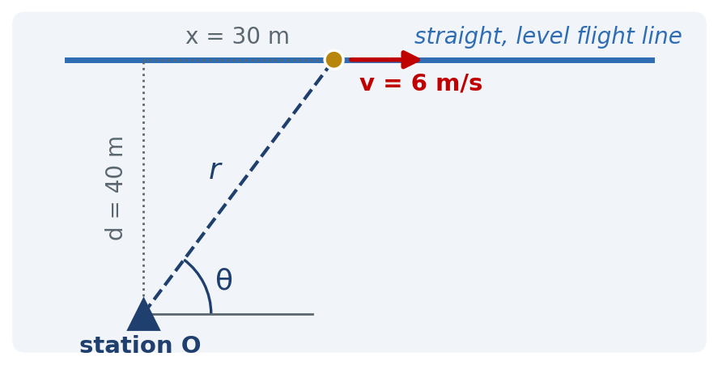
A drone flies a straight, level line at constant speed $v_{sp} = 6.0$ m/s. The line passes at perpendicular distance $d = 40$ m from a tracking station O, which measures range $r$ and bearing $θ$. Consider the instant when the drone is $x = 30$ m past the closest-approach point (so $r = 50$ m, $θ = 53.1°$).
A. Predict: is the range rate $\dot{r}$ equal to 6.0 m/s? Larger? Smaller? Why?
B. From $r^{2} = d^{2} + x^{2}$ ($d$ constant, $\dot{x} = v_{sp}$), differentiate to find $\dot{r}$. From $tan θ = d/x$, or from geometry, find $\dot{θ}$ (sign!).
C. Write $v_{r}$ and $v_{θ}$. Verify that $\sqrt{v_{r}^{2} + v_{θ}^{2}} = 6.0$ m/s.
D. Differentiate once more to find $\ddot{r}$. Take $\ddot{θ} = +0.0138$ rad/s² as given (its derivation is in the Part 5 appendix). Compute $a_{r} = \ddot{r} - r{\dot{θ}}^{2}$ and $a_{θ} = r\ddot{θ} + 2\dot{r}\dot{θ}$.
E. What must $a_{r}$ and $a_{θ}$ add up to for this flight, and why? Did your numbers pass? If $a_{r}$ had come out equal to $\ddot{r}$, what would you conclude?
F. Which description did you compute in, and which did you validate in? Why is that the natural order here?

24. A Pin in a Rotating Slotted Arm — $r$ as a Function of $θ$
A pin slides in a slotted arm that rotates about O at constant $\dot{θ} = 3.0$ rad/s. A cam forces the pin’s radius to follow $r = 0.20 + 0.10θ$ ($r$ in meters, $θ$ in radians). Consider the instant $θ = π/2$.
A. A classmate substitutes $θ = 90$ and gets $r = 9.2$ m. What went wrong, and what is the correct $r$ at this instant?
B. Find $\dot{r}$ and $\ddot{r}$ using the chain rule ($\dot{r} = (dr/dθ) \dot{θ}$).
C. Assemble $\vec{v}$ and $\vec{a}$: components, magnitudes. Which acceleration term exists only because $r$ is changing while $θ$ changes?
D. Sketch the arm at $θ = π/2$ with ${\hat{u}}_{r}, {\hat{u}}_{θ}, \vec{v}$ and $\vec{a}$ drawn to a rough scale. Is $\vec{v}$ along the slot? Is $\vec{a}$?
E. Limiting case: if the cam held the pin at fixed $r = 0.357$ m, which terms drop out, and what familiar result remains?

25. VEL · Polar r–θ Motion The Spiral Painter — Four Terms: Which Survive?
Open the Polar r–θ Motion module. PATH / PATTERN: an Archimedean spiral $r = r_{0} + kθ$ (choose $r_{0} ≈ 0.5$ m and $k ≈ 0.2$ m/rad, or the closest pattern the module offers — write down its equation). MOTOR / ANGULAR LAW: constant rate, $θ = ωt$ with $ω ≈ 1.0$ rad/s. Turn on the radial and transverse velocity components and the display of the four acceleration contributions shown separately.
A. Predict before PLAY — commit on paper: (i) the signs of $v_{r}$ and $v_{θ}$ throughout the motion; (ii) is $\vec{v}$ along ${\hat{u}}_{θ}$, along ${\hat{u}}_{r}$, or in between — and does its angle from ${\hat{u}}_{θ}$ grow or shrink as the spiral opens? (iii) which of the four acceleration terms $\ddot{r}, -r{\dot{θ}}^{2}, r\ddot{θ}, 2\dot{r}\dot{θ}$ are nonzero for this motion; (iv) is there any transverse acceleration although $\dot{θ}$ is constant? (v) does $\vec{a}$ point toward O?
B. Run. Pause at $θ = π$ rad (or the nearest step). Record $r, \dot{r}, \dot{θ}, v_{r}, v_{θ}, a_{r}, a_{θ}$ and each of the four contributions as the VEL displays them.
C. Calculate independently: build the six-number table (chain rule: $\dot{r} = (dr/dθ)\dot{θ} = kω, \ddot{r} = k\ddot{θ} = 0$), then $v_{r}, v_{θ}, a_{r}, a_{θ}, \left|\vec{v}\right|, \left|\vec{a}\right|$. Compare with the VEL to the displayed precision. If they disagree, who is wrong — and how would you find out?
D. Explain $2\dot{r}\dot{θ}$ from what you SAW: which arrow is growing and which arrow is turning? Write the two contributions of $\dot{r}\dot{θ}$ each in one sentence.
E. Limiting cases — predict, then run each: (i) $k = 0$ (a circle): which terms vanish, what remains, and why is $a_{r}$ negative; (ii) motor stopped ($ω = 0$): what happens to $\dot{r}$ even though $r$ “depends on $θ$” — why? (iii) reverse the spiral ($k < 0$, sliding inward): the sign of $a_{θ}$? (iv) if the module allows an accelerating motor ($\ddot{θ} ≠ 0$): which term appears, and could it cancel $2\dot{r}\dot{θ}$?
F. The trap: a classmate whose arithmetic is flawless insists “$a_{r} = \ddot{r} = 0$, because the spiral opens at a steady rate.” What did they miss, and what does the VEL’s radial acceleration arrow show?

RATE YOURSELF on this group before moving on:
- I can do this independently.
- I can do this with a small AI hint.
- I need substantial AI help.
- I still need human/instructor help.

GROUP 6 · Connected and Relative — Cables, Pulleys, Moving Observers
Two more descriptions: what one body must do because a cable ties it to another, and what a translating observer actually sees. (Part 7.)
26. Which Segments Change Length? — Fixed-Geometry Hoist
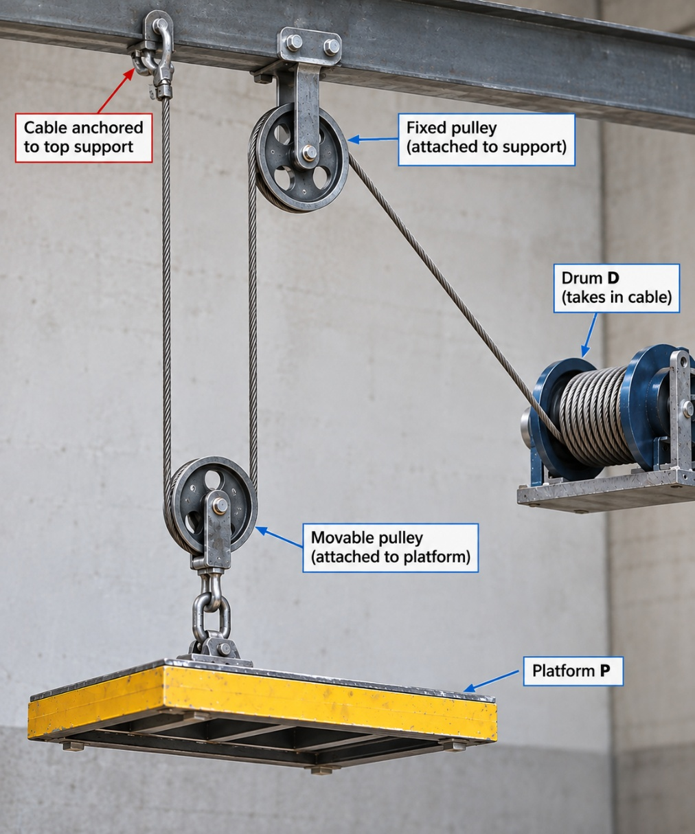
$$s (+ Down)$$
A construction hoist uses one fixed sheave and one movable sheave attached to the platform. The drum takes in cable at $v_{D} = 0.80$ m/s and is speeding up at $a_{D} = 0.20$ m/s².
A. Commit before any equation: the platform rises at 0.80 / 0.40 / 1.60 m/s. Say in words which pieces of cable get shorter when the platform rises, and how many.
B. Choose the datum shown and $s$ positive downward. Write the cable-length relation $L$ = … keeping only the segments that can change length. Why do the arcs around the sheaves drop out?
C. Differentiate once for velocities and once for accelerations. With $v_{D} = +0.80$ m/s (cable point moving down toward the drum), find $v_{P}$ and $a_{P}$. Interpret the signs.
D. A teammate measures the platform upward from the floor instead. Show that the relation changes form but the physical answer does not.
E. The hoist must lift the platform 12 m in 30 s at steady speed. What cable speed must the drum maintain?

27. The Towed Sensor Cart — Variable Geometry
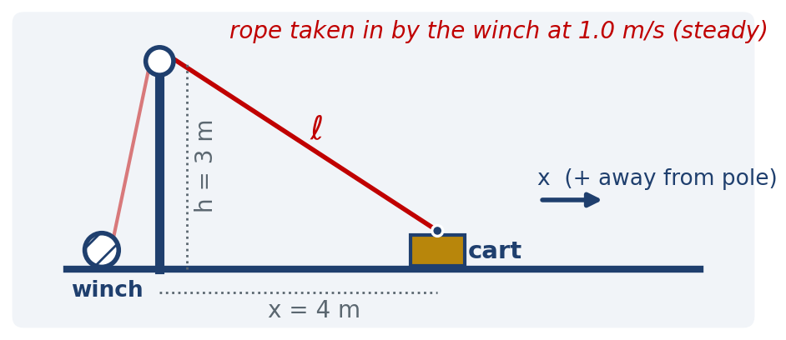
A cart on a straight level track is towed by a rope that runs over a small pulley at the top of a pole of height $h = 3$ m down to a winch at the base. The winch takes in rope at a steady 1.0 m/s. At the instant shown the cart is $x = 4$ m from the pole base.
A. Commit first: does the cart move at exactly 1.0 m/s? faster / slower / exactly / it depends on $x$. Second vote: with the rope taken in at constant speed, is the cart accelerating?
B. Write the position relation between the rope length $l$ (pulley to cart) and $x$. What is $\dot{l}$, with sign, at this instant?
C. Differentiate once. Find $\dot{x}$ at $x = 4$ m. Interpret the sign.
D. Differentiate again ($\ddot{l} = 0$). Find $\ddot{x}$. Is the cart speeding up or slowing down? Where does this acceleration “come from” when the winch never changes rate?
E. Validate with limits: what do $\dot{x}$ and $\ddot{x}$ approach when $x ≫ h$? What happens to the model as $x → 0$, and what would physically happen to the cart?

28. Two Cars, One Radar — What “Relative To” Means
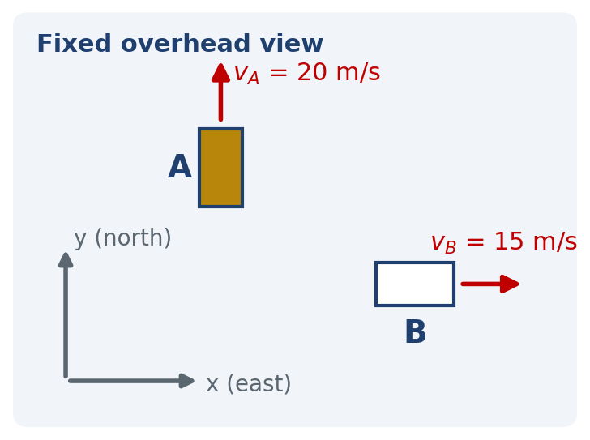
Car A travels north at 20 m/s; car B travels east at 15 m/s. Both are on straight lanes at this instant. Use $x$ east, $y$ north, and translating (non-rotating) observer axes.
A. Find ${\vec{v}}_{B/A}$ — the velocity of B as measured by a radar on A: components, magnitude, and direction. Draw the vector triangle.
B. Find ${\vec{v}}_{A/B}$. How is it related to ${\vec{v}}_{B/A}$? Which subscript names the observer?
C. Conceptual trap: later, both cars are in the same lane and A’s radar reports “closing at 5 m/s”. Is the car ahead braking? Is A accelerating? Can you tell from the radar alone? What additional sensor settles it?
D. Still later, B rounds a curve of radius 100 m at a constant 15 m/s, heading east at the instant of interest and turning toward the north; A continues north at a constant 20 m/s. What acceleration ${\vec{a}}_{B/A}$ does A’s radar report? (Careful: constant speed is not zero acceleration.)
E. A’s radar reports ${\vec{a}}_{B/A} = 0$ for a while. Does that mean neither car is accelerating? Explain.
F. State the caveat under which ${\vec{v}}_{B} = {\vec{v}}_{A} + {\vec{v}}_{B/A}$ and ${\vec{a}}_{B} = {\vec{a}}_{A} + {\vec{a}}_{B/A}$ are valid. Give one everyday observer for which they are not valid.

RATE YOURSELF on this group before moving on:
- I can do this independently.
- I can do this with a small AI hint.
- I need substantial AI help.
- I still need human/instructor help.

GROUP 7 · Verify Before You Trust — Judge the Machine
Each item is an AI-generated statement or solution. For each: (1) what is wrong, (2) why it is wrong physically or mathematically, (3) how you would verify the correction — by hand, by a sketch, or by a VEL run you have checked independently. The purpose is not to trick you — it is to make “verify, then trust” a habit.
29. AI Says: “Constant Speed, So $\vec{a} = 0$”
You ask an AI about a car holding a steady 15 m/s through a 60 m-radius bend. It replies: “Since the speed is constant, the acceleration is zero. There is nothing to compute.”
Classify the claim: Correct / Sometimes Correct / Incorrect. Diagnose the confusion in one sentence, compute the acceleration the AI missed, and describe the fastest experiment or sketch that would have exposed the error.

30. AI Says: “The Faster Ball Stays Up Longer”
An AI explains the table-edge launch experiment: “The ball launched at 3.0 m/s has more velocity than the one launched at 1.5 m/s, so it stays in the air longer and therefore lands farther away.”
The conclusion “lands farther away” is right. Is the reasoning right? Identify exactly which equation the AI has mixed a horizontal quantity into. Then state what does determine the flight time, and describe the frame-count measurement that would settle the disagreement in one afternoon.

31. AI Gives a Beautiful Polar Result — in Degrees
For a boom with $r = 2.0$ m, $\dot{r} = 0.50$ m/s (constant), $\dot{θ} = 30°$/s (constant), an AI reports:
$a_{r} = \ddot{r} - r{\dot{θ}}^{2} = 0 - (2.0)(30)^{2} = -1800$ m/s² ; $a_{θ} = r\ddot{θ} = 0$ .
There are two independent errors. Find both, explain why each is wrong (units are your friend), give the corrected $a_{r}$ and $a_{θ}$, and state a limiting-case check you would apply to the corrected result.

32. Two AI Claims About Direction
A. Normal direction. An AI solving the off-ramp writes: “${\hat{u}}_{n}$ points outward, away from the center of the curve, because the car is pushed outward in a turn.” Is the normal component of $\vec{a}$ ever outward for a particle following a curved path? Explain the confusion (what is “pushed outward” describing?) and state the rule that fixes ${\hat{u}}_{n}$.
B. Relative velocity. For car A at 20 m/s north and car B at 15 m/s east, an AI writes ${\vec{v}}_{B/A} = {\vec{v}}_{A} - {\vec{v}}_{B} = (-15, 20)$ m/s and concludes “B is approaching A from the west.” Identify the error, give the correct ${\vec{v}}_{B/A}$, and explain how the observer is encoded in the subscript.
For each, name the one-line sketch check you would perform before trusting any relative-motion or n–t result an AI hands you.

33. AI Says: “The Data Disagree, So the Model Is Wrong”
From a 30 fps video, a student measures a flight time of 0.45 s for a ball launched from $h = 0.90$ m. The ideal model predicts 0.43 s. An AI concludes: “The measured time is 5 % longer, so the projectile equations do not apply to this ball.”
A. Estimate the timing uncertainty of a $±2$-frame count at 30 fps. Is a 0.02 s disagreement resolvable with this camera?
B. List three things that must be separated before anyone blames the model: the model’s assumptions, the measurement’s resolution, and __________. Which one explains what was seen here?
C. Propose the single additional measurement that would distinguish “drag matters” from “frame-count resolution”. What would each look like in the data?

34. VEL · Stopping Distance AI Says: “Double the Speed, Double the Stopping Distance”
An AI-written driving-safety summary states: “Stopping distance is proportional to speed — at twice the speed you need twice the distance.” Test it with the Stopping Distance module: reaction time $t_{r} = 1.0$ s, DRY road ($a = 7.0$ m/s²), first at 40 km/h and then at 80 km/h.
A. Predict before running: the ratio of the two total stopping distances — 2? less than 2? more than 2? Which part of the stopping distance scales with $v_{sp}$ and which with $v_{sp}^{2}$? Sketch $v_{sp}(t)$ for both cases on the same axes.
B. Run both. Record the reaction distance $d_{r}$, braking distance $d_{b}$, total $d_{stop}$, and braking time $t_{b}$.
C. Calculate independently: $d_{r} = v_{sp} t_{r}, d_{b} = v_{sp}^{2}/(2a), t_{b} = v_{sp}/a$ for both speeds. Compare with the readouts; compute the ratio of totals.
D. Judge the claim: Correct / Sometimes Correct / Incorrect. At what speed (for these settings) are $d_{r}$ and $d_{b}$ equal, and on which side of that speed is the AI’s claim least wrong?
E. Validate: show that the area under your sketched $v_{sp}(t)$ (rectangle plus triangle) equals $d_{stop}$ for one case; check dimensions of $v_{sp}^{2}/(2a)$.

RATE YOURSELF on this group before moving on:
- I can do this independently.
- I can do this with a small AI hint.
- I need substantial AI help.
- I still need human/instructor help.

GROUP 8 · Choose the Description — One Motion, Three Languages
Same physical motion, different mathematical descriptions. The instrument often makes the first choice; the choice of where to answer and validate is yours. (Part 6, synthesizing Parts 2–5 and 7.)
35. Which Language Would You Start In — and Why?
For each situation, choose the description you would begin with — Cartesian x–y, normal–tangential n–t, or polar r–θ — and give a one-sentence justification built on the three questions: What do I know? What am I asked? What did the instrument measure? Then name one piece of information that would flip your choice.
– a roller-coaster car on a known track, with a rider-comfort limit stated as an acceleration;
– a ship tracked by harbor radar (range and bearing every second), asked for its acceleration;
– a Tracker video of a bouncing ball, asked for the velocity between bounces;
– a bead sliding outward along a spoke of the spinning bicycle wheel;
– a car on a cloverleaf ramp with a GPS logger delivering $x(t), y(t)$, asked whether the ride exceeded 0.3 $g$ sideways;
– a pendulum bob on a fixed cord — and then the same bob while the cord is being reeled in.
Is any one description universally “better”? Answer in one sentence.

36. Same Rail, Second Language — Validate Question 8
Return to the cam follower on $y = 0.25x^{2}$ at $x = 2$ m with $\dot{x} = 1.5$ m/s, $\ddot{x} = 0$. In Question 8 you found $\vec{v} = (1.5, 1.5)$ m/s and $\vec{a} = (0, 1.125)$ m/s².
A. Compute the radius of curvature of the rail at $x = 2$ m from $ρ = {\left[1 + (y')^{2}\right]}^{3/2}/\left|y″\right|$. Check it against a straight line ($y″ = 0$) before you trust the formula.
B. Compute $a_{n} = v_{sp}^{2}/ρ$.
C. Write ${\hat{u}}_{t}$ and ${\hat{u}}_{n}$ at this point as x–y unit vectors (sketch first — which side is concave?). Project the Cartesian $\vec{a}$ onto ${\hat{u}}_{n}$ and onto ${\hat{u}}_{t}$.
D. Do the two routes to $a_{n}$ agree? What does the sign of $a_{t}$ tell you that the pair ($\ddot{x}, \ddot{y}$) = (0, 1.125) did not say out loud?
E. In one sentence: what did the n–t description reveal that Cartesian hid, and what did Cartesian give you that n–t needed as input?

37. The Steady Bead in Three Languages
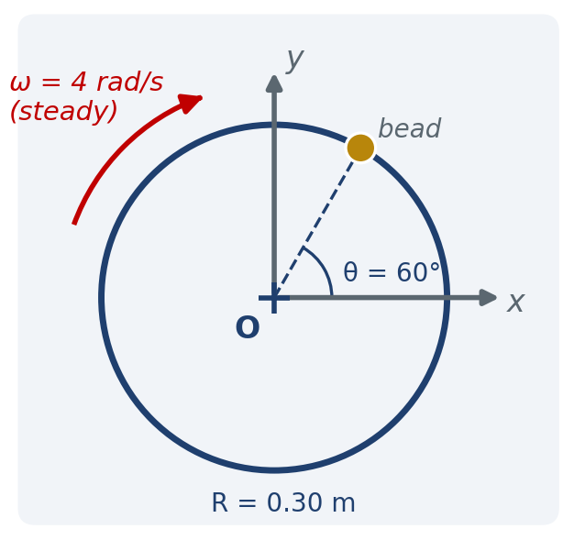
The bead is at $R = 0.30$ m, $θ = 60°$, on a wheel turning counterclockwise at a steady $ω = 4.0$ rad/s.
A. Cartesian: write $\vec{v}$ and $\vec{a}$ in $\hat{i}, \hat{j}$ components at this instant (use $x = R cos θ, y = R sin θ$). Give $\left|\vec{v}\right|$ and $\left|\vec{a}\right|$.
B. n–t: write $\vec{v}$ and $\vec{a}$. How many numbers did you need?
C. Polar: write $\vec{v}$ and $\vec{a}$. Why is $a_{r}$ negative while $a_{n}$ in part B is positive, for the same vector?
D. Rotate the Cartesian components into the tangent direction with $φ = 150°$ (the angle of ${\hat{u}}_{t}$ from the $x$-axis): $a_{t} = a_{x} cos φ + a_{y} sin φ, a_{n} = -a_{x} sin φ + a_{y} cos φ$. Do you recover B?
E. Which description tells you where $\vec{a}$ points, and which tells you why? Which would you compute in if the data were a Tracker table?

38. A Projectile Seen Through n–t
Use the package toss of Question 13 ($v_{0} = 8.0$ m/s at 35°, no drag). The only acceleration is $\vec{g}$ downward — a Cartesian statement. Describe the same acceleration in n–t.
A. Predict: at the apex, is $a_{t}$ zero, and what is $a_{n}$? At the instant of release, are both nonzero?
B. At the apex: write $a_{t}, a_{n}$, and compute the radius of curvature of the flight path there.
C. At release: resolve $\vec{g}$ along ${\hat{u}}_{t}$ and ${\hat{u}}_{n}$ (sketch the two unit vectors on the launch direction first). Compute $a_{t}, a_{n}$, and $ρ$ at release.
D. Where along the arc is $\left|a_{t}\right|$ largest, and where is $ρ$ smallest? Explain with the sketch, not with algebra.
E. Reflect: both descriptions give the same $\vec{a} = \vec{g}$. What question about the flight would make n–t the useful language?

39. From a Tracker Export to $a_{t}$ and $a_{n}$ — You Are the Engineer
You receive a Tracker export ($t, x, y$) at 120 fps for the bead on the braking bicycle wheel. Your task is to report the tangential and normal accelerations as functions of time, and to check them against the rotation-count method of Question 18.
A. Write the pipeline as a short numbered list: what you compute from the table, in which description, and what you convert to at the end. Where in the pipeline does the measurement resolution enter?
B. At one instant the pipeline yields $\vec{v} = (-0.72, 0.96)$ m/s and $\vec{a} = (-3.70, -3.07)$ m/s². Find the angle $φ$ of ${\hat{u}}_{t}$ from the $x$-axis, then rotate to obtain $a_{t}$ and $a_{n}$. Which side did you put ${\hat{u}}_{n}$ on, and how did you decide?
C. From your $a_{t}$ and $a_{n}$: is the bead speeding up, slowing down, or at constant speed at this instant? What is the local radius of curvature? Is that consistent with the bead of Question 18?
D. Give two independent validations for the whole pipeline (limiting case, alternate description, or a known invariant).

40. Design the Ramp — Synthesis Challenge
You are asked to size a circular exit ramp. Vehicles enter at 25 m/s and must leave at 12 m/s after 200 m of arc, with a constant $a_{t}$. The comfort limit is $\left|\vec{a}\right| ≤ 0.3g ≈ 2.94$ m/s² everywhere on the ramp.
A. Predict: will the binding constraint be at the entry or the exit? Why?
B. If the ramp were driven at a constant 25 m/s, what minimum radius would the comfort limit require?
C. Now include the braking: compute $a_{t}$, then the minimum radius such that $\left|\vec{a}\right|$ at the entry stays within the limit. How much larger is it than your answer to B, and why?
D. Validate: check units, check the limit $a_{t} → 0$ against B, and describe the alternate-description check (x–y at the entry point) that would confirm $\left|\vec{a}\right|$.
Challenge: A colleague suggests a tightening spiral instead of a circle, so that $ρ$ decreases as the vehicle slows. Using $a_{n} = v_{sp}^{2}/ρ$, explain in words how $ρ(s)$ could be shaped so that $\left|\vec{a}\right|$ stays constant along the whole ramp — and which chapter-2 description would make that design calculation easiest.

RATE YOURSELF on this group before moving on:
- I can do this independently.
- I can do this with a small AI hint.
- I need substantial AI help.
- I still need human/instructor help.

Reading your ratings. Mostly “independently” → you own the Chapter 2 foundations; move forward to Chapter 3, where forces supply the $a_{n}$ every curve demands. “Small AI hint” clustered in one group → that is your review target; retry those questions later without AI. “Substantial AI help” → return to the corresponding lecture part (Group 1 → Part 1 and the Chapter 1 rectilinear model; Group 2 → Part 2; Group 3 → Part 3; Group 4 → Part 4; Group 5 → Part 5; Group 6 → Part 7; Groups 7–8 → Part 6 and the whole chapter) and retry. Any “human/instructor help” → bring those exact questions to class, office hours, or your instructor — that is what they are for.
THE GOAL IS NOT 40 CORRECT ANSWERS.
The goal is to know: “What can I explain, sketch, calculate, and validate — in any coordinate language — without outsourcing my thinking?”
AI assists. The engineer observes, models, validates, decides, and approves.

