ME345 ENGINEERING DYNAMICS · CHAPTER 3 · PARTS 1–7  Engineering Homework 5  Forces and Particle Motion — Boundaries, Causes, Curves, Machines, Judgement  Choose the system › build the diagram › solve it › decide whether to believe it  Suggested assessment · 100 points · target effort ≈ 3 hours (3.5 hours maximum) · type your answers directly into this document | 
Taner Onsay, Ph.D. · © 2026 AI First Engineering
AI IS ALLOWED AND ENCOURAGED — AS AN ASSISTANT
AI may help you check an equation, rearrange algebra, write a plotting script, or argue with your reasoning. The system boundaries you choose, the free-body diagrams you draw, the assumptions you state, the numbers you substitute, the validation you perform and the engineering verdict you sign are YOUR OWN work. Assessment rewards evidence, reasoning and validation — not polished prose, and not length.
Where a question asks you to PREDICT, commit to your prediction before you calculate. A prediction that merely restates a result you have already computed earns nothing; a wrong prediction that you then confront honestly earns full credit.

NOTATION — THE COURSE STANDARD, USED THROUGHOUT
Scalars are italic; vectors carry an arrow; unit vectors carry a hat. Speed is written v_{sp} and never as a bare v. Overdots are time derivatives. Keep every angle in radians inside a derivative.
Velocity and acceleration in the three descriptions you now own:

v⃗ = v_{sp} û_{t} a⃗ = a_{t} û_{t} + a_{n} û_{n} a_{t} = v̇_{sp} , a_{n} = v_{sp}² / ρ
v⃗ = ṙ û_{r} + r θ̇ û_{θ} a⃗ = (r̈ − r θ̇²) û_{r} + (r θ̈ + 2 ṙ θ̇) û_{θ}
∑ F⃗ = m a⃗
∑ F_{x} = m a_{x} , ∑ F_{y} = m a_{y} ∑ F_{t} = m a_{t} , ∑ F_{n} = m a_{n} ∑ F_{r} = m a_{r} , ∑ F_{θ} = m a_{θ}
PERSONALISED PARAMETERS — READ THIS BEFORE YOU START
Wherever a parameter is given as a range, you select your own value inside that range and record it in the table below before you begin. Use Engineering Utilities → Random Number Generator on the course webpage (ME345-Random-Number-Generator.xlsx): enter the lower and upper limits and record what it returns, rounded to the stated precision.
Every student therefore analyses a slightly different machine. You are graded on your method, on the internal consistency of your own numbers, and on your validation — not on agreement with one universal answer. Do not change a recorded value later unless a question explicitly asks for a parameter study.
Use g = 9.81 m/s² throughout. Report three significant figures unless a question says otherwise.

P0 Record your parameters. (3 points)
Generate the eleven personalised values and record them here. Everything not listed in this table is the same for every student.
Where | Parameter | Allowed range | Precision | MY VALUE
Problem 1 | drive force at the tyres F_{d} | 2.6 to 3.4 kN | 0.1 kN
Problem 1 | rear trailer mass m_{C} | 600 to 750 kg | 10 kg
Problem 2 | unladen van mass m₁ | 2400 to 3000 kg | 50 kg
Problem 2 | peak tractive force F_{max} | 4.6 to 5.8 kN | 0.1 kN
Problem 2 | measured stopping distance s_{b} | 32.0 to 38.0 m | 0.5 m
Problem 3 | counterweight mass m_{A} | 180 to 240 kg | 10 kg
Problem 4 | ramp entry speed v₁ | 21.0 to 23.0 m/s | 0.5 m/s
Problem 4 | ramp radius ρ | 90 to 115 m | 5 m
Problem 5 | carriage mass m | 6.0 to 9.0 kg | 0.5 kg
Problem 5 | table rate θ̇ | 7.0 to 11.0 rad/s | 0.5 rad/s
Problem 5 | radius at the instant r | 0.40 to 0.70 m | 0.05 m

Time guide. Problem 1 ≈ 25 min · Problem 2 ≈ 30 min · Problem 3 ≈ 28 min · Problem 4 ≈ 32 min · Problem 5 ≈ 22 min · Problem 6 ≈ 35 min. The optional Problem 7 adds about 30 minutes and is not required.

PROBLEM 1 · Where You Draw the Line (15 points · ≈ 25 min)
One machine, more than one system. Changing the boundary changes the diagram — and changes nothing about the motion.
A battery-electric yard tractor of the type used inside distribution centres tows two loaded roll-cage trailers up the access ramp of a distribution centre. The ramp rises at a constant grade of 3.0 % (a rise of 3.0 m in 100 m along the ground). The tractor has mass m_{T} = 1400 kg, the front trailer m_{B} = 900 kg, and the rear trailer has your own mass m_{C}. Rolling resistance on every unit is modelled as 1.5 % of that unit's normal force. The tractor's tyres deliver your own drive force F_{d} along the ramp surface. At the instant considered the train is speeding up.
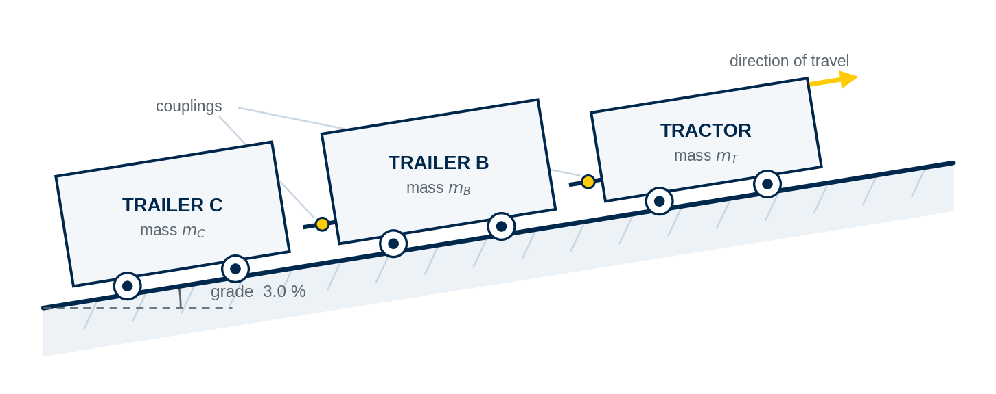
Figure 1 · Yard tractor and two trailers on the 3.0 % access ramp. Geometry and given data only — no forces are drawn for you.
MODEL ASSUMPTIONS — STATED, AND MEANT
Each unit is treated as a particle. The couplings are rigid two-force members aligned with the ramp. The wheels roll freely. Aerodynamic drag is neglected at these speeds. The grade is constant over the length of the train.

1.1 PREDICT — before any equation. (2 points)
1. You enclose the whole train in one boundary. Is the coupling force between the front and rear trailers visible on that diagram? One sentence saying why.
2. Is the acceleration of the rear trailer the same as the acceleration of the tractor? Commit to YES or NO and say what physically guarantees your answer.
3. You now enclose the rear trailer alone. Name every force that crosses that new boundary. No numbers.
ANSWER 1.1:

1.2 MODEL — choose your systems and draw them. (4 points)
1. Choose and state TWO different system boundaries: one that lets you find the acceleration of the train in a single equation, and one that exposes the force in the rear coupling. Say in one line why each boundary suits its question.
2. For each of your two systems, draw the free-body diagram and, beside it, a SEPARATE ma-diagram. Label every force with a source you can name.
3. State your coordinate choice and your positive direction, and say why you chose them rather than horizontal and vertical axes.
SKETCH YOUR TWO SYSTEMS HERE (1.2): two free-body diagrams, two ma-diagrams, axes and positive direction clearly marked — a photograph of a clear hand sketch is fine

1.3 SOLVE — with your own parameters. (5 points)
Show every equation with your numbers substituted, and carry units.
1. the acceleration of the train, a = ____________ m/s²;
2. the force in the REAR coupling (between the two trailers), ____________ N;
3. the force in the FRONT coupling (between the tractor and the front trailer), ____________ N. Obtain this from a boundary of your own choosing, then check it against a different boundary and report both numbers.
ANSWER 1.3 (equations, substitutions, results):

1.4 INTERPRET — what changed and what did not. (2 points)
1. List the quantities that changed when you moved the boundary, and the quantities that did not. Be specific about the coupling force.
2. A colleague says: “the coupling force appeared because you cut there.” Correct the statement in one sentence.
3. Which of your three numbers would you hand to the engineer sizing the rear drawbar, and why not one of the others?
ANSWER 1.4:

1.5 VALIDATE — two limiting cases. (2 points)
1. Set the grade to zero, leave everything else alone, and recompute the acceleration. State by how much it rises and say whether that is the direction you expected.
2. Find the drive force that would hold the train at a STEADY SPEED on the ramp, with the wheels still rolling. What does your equation give for the rear coupling force at that condition, and is that physically sensible?
ANSWER 1.5:

PROBLEM 2 · Both Directions of the Same Machine (17 points · ≈ 30 min)
Forces → acceleration → motion, and then motion → acceleration → the force that was required. One diagram, read twice.
A battery-electric parcel van is tested on a level track. Unladen it has your own mass m₁. Once the van is moving, rolling and driveline resistance together are modelled as a constant force equal to 1.0% of the van's weight, opposing the motion. For the launch analysis in Parts 2.2 and 2.3, neglect rolling and driveline resistance. For the launch calculation, take t=0 as the instant the van begins to move. Aerodynamic drag is neglected throughout this problem, including the braking test.
Launch test. From rest, the motor controller ramps the tractive force linearly from zero to your own F_{max} over t_{r} = 2.5 s, and then holds it constant.
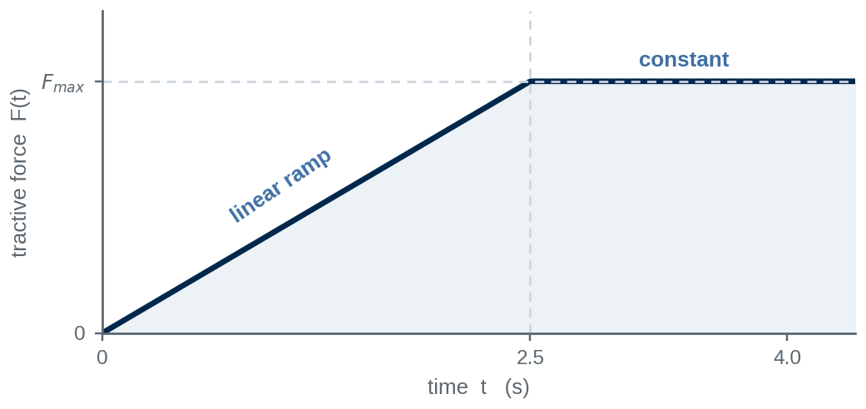
Figure 2 · Commanded tractive force history for the launch test. F_{max} is your own value.
2.1 PREDICT — before any equation. (2 points)
1. Sketch, by hand and without calculating, the shape of the speed-time curve over the first 4 seconds. Mark the instant where its curvature changes and say what happens there.
2. A classmate proposes to get the speed at 4.0 s from v_{sp} = v_{sp,0} + a t using the acceleration at 4.0 s. Commit now: will that overestimate, underestimate, or get it right? One sentence of reasoning.
ANSWER 2.1:

2.2 MODEL — the diagram and the assumptions. (3 points)
1. Draw the free-body diagram of the van and a separate ma-diagram. State your axes.
2. Write the equation of motion in the direction of travel, with the tractive force left as the function F(t).
3. At t=0, determine the van's acceleration. Then determine its acceleration at $t=t_{r}$. Explain physically why the acceleration is not constant during the launch..
ANSWER 2.2:

2.3 SOLVE — the launch, done legally. (5 points)
1. State in one sentence why the constant-acceleration formulas of Chapter 1 are not available for 0 ≤ t ≤ t_{r}. Name the condition they require.
2. Integrate the equation of motion over the ramp and obtain the speed at t = t_{r} = 2.5 s. Show the integral and its limits.
3. For t > t_{r} the tractive force is constant. Obtain the acceleration there and the speed at t = 4.0 s. Say explicitly which formula you are now allowed to use, and why you are allowed to use it here but not before.
ANSWER 2.3 (equations, integration, substitutions):

2.4 COMPARE — how wrong is the illegal route? (2 points)
Compute the speed at 4.0 s the way your classmate proposed in 2.1, express the error as a percentage of your correct answer, and explain in one or two sentences where the missing speed went. Was your 2.1 prediction right?
ANSWER 2.4:

2.5 INVERSE — the motion is measured; the force is the question. (4 points)
The same van, now carrying an 800 kg payload, is braked from 60.0 km/h to rest on a wet section of the same track. The braking distance is measured as your own s_{b}. Take the deceleration as constant and the van as a particle with all four wheels braked. In the braking test the tractive force is zero and the rolling resistance is negligible against the braking effort, so treat the ENTIRE net decelerating force as tyre friction.
1. the deceleration, ____________ m/s², and the net braking force, ____________ N;
2. the coefficient of friction the road had to supply, ____________ ;
3. the wet surface was measured at μ_{s} = 0.45. State your verdict: was the stop within what the road could deliver, and with how much reserve? Give the reserve as a percentage.
4. Does your required coefficient depend on the payload? Show it from the equations in one line, and say what that means for a fleet operator.
ANSWER 2.5:

2.6 VALIDATE. (1 point)
Carry out two checks and name the move you are using each time: a units check on your integration in 2.3, and a limiting case in which the ramp time t_{r} goes to zero. State what the second check proves.
ANSWER 2.6:

PROBLEM 3 · What the Rope Will Not Let Them Do (15 points · ≈ 28 min)
Two bodies, two diagrams, and one piece of information the force equations do not contain.
A rooftop service hoist is being used on a building retrofit. A chiller module B of mass m_{B} = 540 kg hangs from a movable sheave. The rope runs from a fixed anchor on the roof beam, down around the movable sheave, back up over a fixed sheave on the beam, and down to a counterweight A of your own mass m_{A}, which runs in vertical guide rails. The system is released from rest.
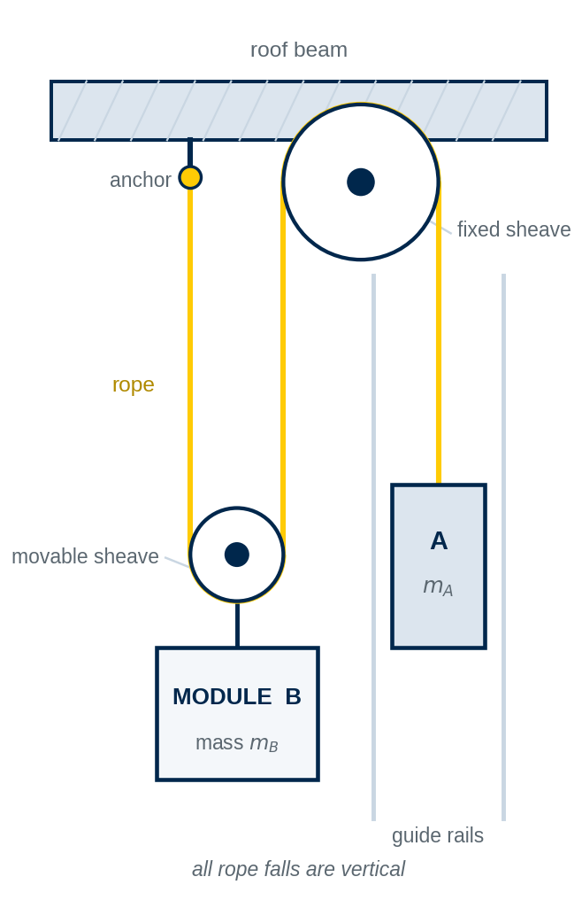
Figure 3 · The two-to-one reeved service hoist. Rope path and geometry only — no datum, no coordinates and no forces are supplied.
MODEL ASSUMPTIONS
The rope is inextensible and massless. Both sheaves are ideal: frictionless, with negligible radius and negligible mass. All rope falls are vertical. Guide-rail friction is neglected. A and B are treated as particles.

3.1 PREDICT — before any equation. (2 points)
1. Which moves faster once the system is released, A or B? By what factor? Commit, and give one sentence of physical reasoning from the rope, not from a formula.
2. Is the rope tension equal to half the module's weight? Answer YES or NO with one sentence.
3. Which way does the module move for your own counterweight? Commit before you calculate.
ANSWER 3.1:

3.2 MODEL — build the constraint from the rope, not from memory. (4 points)
1. Choose a datum and a positive direction and state them. Define one position coordinate for A and one for B, both measured from that single datum, and name them.
2. List every rope segment in Figure 3. Mark which segments change length as the module rises and which do not, and state how many change.
3. Write the constant-length relation for the rope, including the constants you are dropping and why they drop.
4. Differentiate it once for the velocity relation and again for the acceleration relation. Show both lines.
SKETCH YOUR DATUM AND WRITE YOUR CONSTRAINT HERE (3.2): the datum, the positive direction, the two named coordinates, the length relation and both derivatives must all be visible

3.3 MODEL — two free-body diagrams. (3 points)
1. Draw a separate free-body diagram and a separate ma-diagram for A and for B.
2. One rope carries one tension T. Explain, from your diagrams, why the force pulling up on the module is 2T while the force pulling up on the counterweight is T. This is the physical content of the reeving — say it in words.
3. Count your unknowns and your equations, and state whether the model is closed. Name the equation that closes it.
SKETCH YOUR TWO FREE-BODY DIAGRAMS HERE (3.3):

3.4 SOLVE — with your own counterweight. (4 points)
1. the acceleration of the module B, ____________ m/s², stating its direction;
2. the acceleration of the counterweight A, ____________ m/s², stating its direction;
3. the rope tension, ____________ N;
4. compare the tension with m_{A} g and with m_{B} g / 2. Explain in one sentence why it equals neither.
ANSWER 3.4 (equations and substitutions):

3.5 DESIGN AND SIGN. (1 point)
1. What counterweight mass would hold the module in equilibrium? Derive it, do not guess it.
2. A technician proposes m_{A} = 320 kg “so it lifts by itself”. Recompute the acceleration of the module with that counterweight and state what the sign of your answer means physically. Do not restart the problem.
ANSWER 3.5:

3.6 VALIDATE. (1 point)
Take the counterweight mass to zero in your symbolic result. What should the module's acceleration become, and what should the tension become? Does your expression deliver both? Name the validation move you just used.
ANSWER 3.6:

PROBLEM 4 · Braking Through the Bend (17 points · ≈ 32 min)
The tangential component changes the speed. The normal component changes the direction. The road has to supply both at once.
A car of mass 1650 kg leaves a freeway at your own entry speed v₁ and enters an unbanked off-ramp of constant radius ρ — your own value. The driver brakes steadily along the ramp so that the speed falls to v₂ = 13.0 m/s after 120 m of arc. Treat the deceleration along the path as constant and the car as a particle.
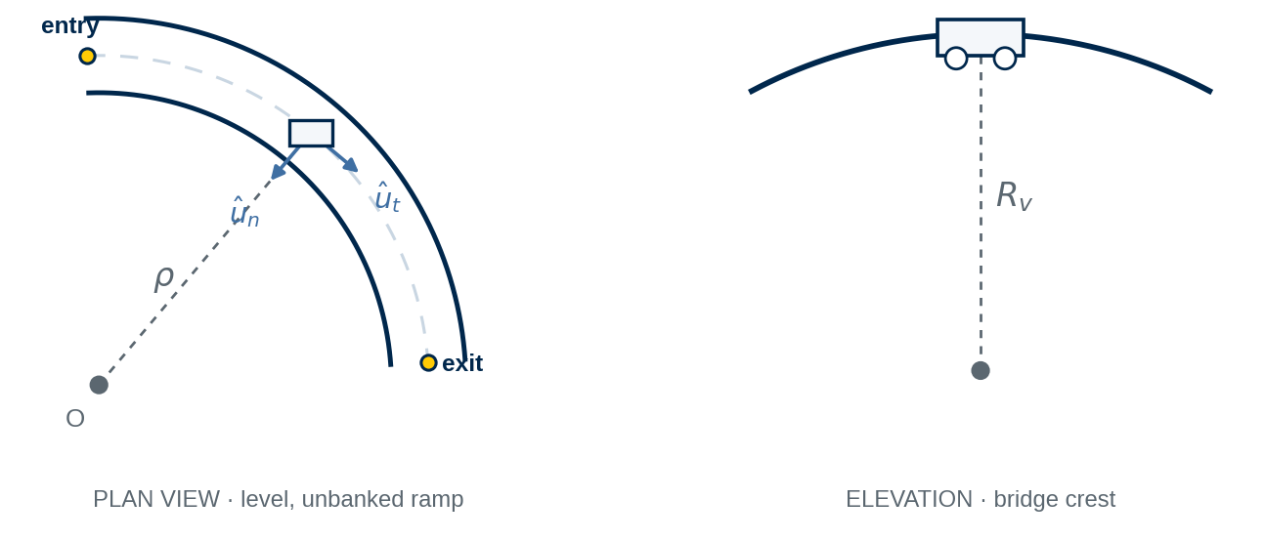
Figure 4 · Left: the off-ramp in plan, with the n–t directions marked at one instant. Right: the bridge crest of part 4.5, in elevation.
4.1 PREDICT — before any equation. (2 points)
1. At the instant the car ENTERS the ramp, sketch the direction of the acceleration vector relative to the path. Is it tangent to the path, perpendicular to it, or neither?
2. Which of the two acceleration components is larger at entry — commit, and give one sentence of reasoning before you compute either one.
3. If the driver had entered at the same speed and NOT braked, would the demand on the tyres be larger, smaller or unchanged? One sentence.
ANSWER 4.1:

4.2 MODEL. (3 points)
1. State why n–t is the natural description here and what would make you choose r–θ instead.
2. Draw the free-body diagram of the car seen from behind, and a plan view showing the horizontal contact force and the n–t directions. Draw the ma-diagram separately.
3. Write the three component equations of motion and state your assumptions about the road surface, the load transfer and the tyres.
SKETCH YOUR DIAGRAMS AND EQUATIONS HERE (4.2):

4.3 SOLVE — at the instant of entry. (5 points)
1. the tangential acceleration along the ramp, ____________ m/s², with its sign explained;
2. the normal acceleration at entry, ____________ m/s², and its direction;
3. the magnitude of the total acceleration, ____________ m/s²;
4. the total horizontal contact force the road must supply at entry, ____________ N, and the angle it makes with the direction of travel;
5. the coefficient of friction required, ____________ .
ANSWER 4.3 (equations and substitutions):

4.4 VERDICT. (3 points)
1. Dry asphalt on this ramp is measured at μ_{s} = 0.80; a worn wet surface is measured at μ_{s} = 0.35. Give a verdict for each, with the reserve or the shortfall as a percentage.
2. Show from your equations that the verdict does not depend on the mass of the car. State what that means for how a ramp is signed.
3. The posted advisory speed for the ramp is 50 km/h. Compare it with your entry speed and comment on what the driver actually did, in one or two sentences of engineering language.
ANSWER 4.4:

4.5 THE CREST — where the normal force is not the weight. (3 points)
Beyond the curve the ramp crosses a bridge crest whose profile has a vertical radius of curvature R_{v} = 140 m. The car passes over it at v₂ = 13.0 m/s, travelling straight.
1. the normal force at the crest, ____________ N, and the ratio N / W;
2. the speed at which contact with the road would be lost, ____________ m/s, also in km/h. Is that speed reachable on this ramp?
3. the friction the road can supply is proportional to N. By what percentage is the available grip reduced at the crest compared with level road, and why does that matter to someone designing the ramp geometry?
ANSWER 4.5:

4.6 VALIDATE. (1 point)
Set the braking to zero in your own working and show that the required coefficient reduces to the constant-speed friction-limited-turn result. Name the validation move and state what it proves about your 4.3 algebra.
ANSWER 4.6:

PROBLEM 5 · Sizing a Rotating Machine (13 points · ≈ 22 min)
The machine supplies the coordinates. Every acceleration term is somebody's design load.
A rotating weld-inspection fixture carries a horizontal arm that turns about a vertical axis through O. A carriage of your own mass m rides in a smooth radial slot in the arm and is driven along it by a lead screw. At the instant considered the arm is at your own radius r, the table is turning at your own rate θ̇ and is speeding up at θ̈ = 3.00 rad/s², and the lead screw is driving the carriage outward at a constant ṙ = 0.300 m/s.
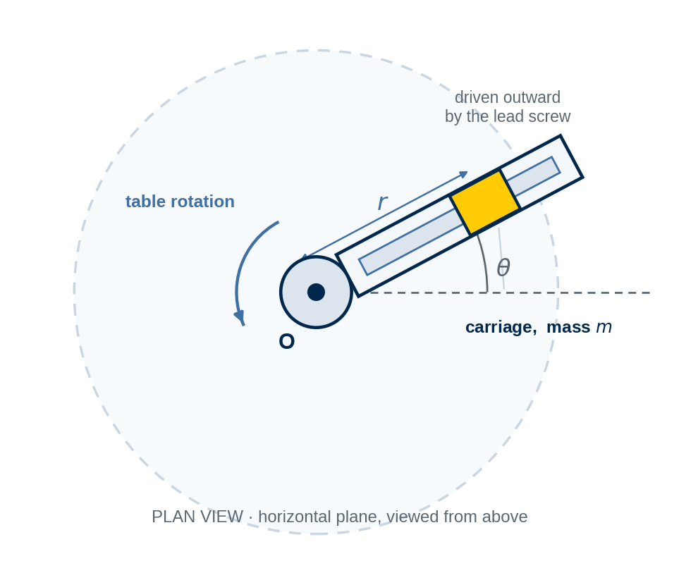
Figure 5 · The fixture in plan. The motion is in a horizontal plane, so the weight is carried vertically by the slot and does not enter the planar equations.
5.1 PREDICT — before any equation. (2 points)
1. The lead screw holds the radial rate exactly constant, so r̈ = 0. Does that make the radial acceleration zero? Commit YES or NO with one sentence.
2. Suppose the table instead turned at a perfectly constant rate, so θ̈ = 0, with the carriage still driven outward. Would there be any transverse force on the carriage? Commit before you calculate.
ANSWER 5.1:

5.2 MODEL. (3 points)
1. State why r–θ is the natural description for this machine and what would make you choose n–t instead. Name the origin you are using and say why it is physically meaningful.
2. Draw the free-body diagram of the carriage in the horizontal plane and a separate ma-diagram. Name what supplies each force.
3. Write the two planar equations of motion and list your assumptions.
SKETCH YOUR DIAGRAM AND EQUATIONS HERE (5.2):

5.3 SOLVE — with your own parameters. (4 points)
1. the radial acceleration a_{r}, ____________ m/s²;
2. the transverse acceleration a_{θ}, ____________ m/s²;
3. the radial force on the carriage F_{r}, ____________ N, with its direction stated in words;
4. the transverse force on the carriage F_{θ}, ____________ N, and which physical part of the machine supplies it.
ANSWER 5.3 (equations and substitutions):

5.4 INTERPRET — the number that surprises people. (3 points)
1. Split your transverse acceleration into its two contributions and report each as a force in newtons. Which is larger for your parameters, and by what factor?
2. Explain, in words and without writing the formula, why a transverse force is required even when the table turns at a perfectly constant rate. Use the picture of the carriage moving outward while the transverse direction itself rotates.
3. The lead screw is stopped, so the carriage is clamped at the same radius while everything else continues. State what happens to each of your four numbers, and say which design load disappears.
ANSWER 5.4:

5.5 DESIGN AND VALIDATE. (1 point)
1. The lead screw and its thrust bearing are rated for 1000 N of load along the arm. With the carriage parked at the arm's outer working radius of 0.800 m and the lead screw stopped, what is the highest table rate the rating allows? Report it in rad/s and in rev/min.
2. Carry out a unit check on the term r θ̇² and state the consequence for how angular rates must be entered.
ANSWER 5.5:

PROBLEM 6 · The Model Meets the Measurement (20 points · ≈ 35 min)
A model is not good or bad. It is adequate or inadequate for a stated purpose — and finding out which is the engineering.
THIS PROBLEM USES THE TEST-REPORT PARAMETERS, NOT YOUR PROBLEM 1 VALUES
The same yard tractor train of Problem 1 has been instrumented and run as a straight-line acceleration trial along the level test lane of the yard. Use the numbers in this problem exactly as given; everyone diagnoses the same data set.

The prediction. Total train mass 2950 kg. An in-line load cell reads a steady drive force of 3000 N at the tyres. Rolling resistance is taken as 1.5 % of the total normal force, from the trailer manufacturer's data sheet. The surface is level; the train starts from rest. Aerodynamic drag was not included.
The measurement. Speed was logged at 1 Hz from the wheel-speed sensors over one 12-second run. The run was repeated five times and the table below is representative of all five — the pattern was the same every time.
time t (s) | 0 | 2 | 4 | 6 | 8 | 10 | 12
measured speed (m/s) | 0.00 | 1.75 | 3.44 | 5.14 | 6.73 | 8.30 | 9.75

Quantity | Value and stated uncertainty
total mass, weighbridge | 2950 ± 20 kg
drive force, load cell | 3000 N, calibrated to ± 1.5 %
speed, wheel-speed sensor | resolution ± 0.05 m/s
timing, data logger | 100 Hz, drift below 0.01 %
independent drag estimate | frontal area 5.6 m², drag coefficient 1.25 from a comparable vehicle, air density 1.20 kg/m³

6.1 COMPARE — quantify the gap before you name a cause. (3 points)
1. Compute the predicted acceleration and write the predicted speed at each logged instant.
2. Tabulate the residual (measured minus predicted) in m/s and as a percentage at each instant.
3. Plot measurement and prediction on one speed-time axis with a residual strip beneath, and describe the pattern in one sentence. Is the disagreement scattered about the prediction, or systematic?
ANSWER 6.1 — paste your table and your plot here:

6.2 DIAGNOSE — four places a disagreement can come from. (6 points)
For EACH of the four categories below, write what the data would have to look like if that category were the cause, then rule it in or out using a NUMBER from the supplied uncertainties. A category you cannot support with evidence is a guess wearing a label.
Category | What it would look like here | Ruled in or out, and the number that decides it
MODEL
PARAMETERS
MEASUREMENT
IMPLEMENTATION

Then answer: the signature of a growing, same-sign shortfall points at one category. Explain in one sentence why that signature is a diagnostic clue and not a law, and name one piece of evidence that would settle the question rather than merely suggest an answer.
ANSWER 6.2:

6.3 IMPROVE — one change, justified, with an independent coefficient. (5 points)
1. State the ONE improvement you are making to the model and write the new equation of motion.
2. Estimate the coefficient from the supplied geometry, NOT by fitting it to this data set. State the value and its units, and say in one sentence why the source of the coefficient matters.
3. Solve the improved equation of motion and tabulate the new predicted speeds at the logged instants. A numerical integration is expected; if you use the closed-form result quoted in the Part 3 optional appendix, state the assumption that makes it applicable here.
4. Report the new residuals and compare the largest one with the load-cell calibration uncertainty. How much of the systematic trend is left, and is what remains larger or smaller than the measurement uncertainty?
ANSWER 6.3 — equation, coefficient, table and new residual plot:

6.4 ADEQUACY — the same model, two verdicts. (4 points)
Two different engineering decisions are to be made from this model.
Decision | The question being answered
A | Can this tractor start a fully loaded three-unit train and move it across the yard at all?
B | The train must start from rest at the dock and completely clear a service road crossing 60.0 m away within 12.0 s. Will it clear?

1. For Decision B, compute the distance travelled in 12.0 s from the original model, from your improved model, and from the measurement itself. Integrate the measured speeds with Simpson’s rule so that everyone uses the same quadrature. State the margin in each case.
2. Give a verdict for Decision A and a verdict for Decision B: for each, is the ORIGINAL model adequate? Justify each verdict with a number, not an adjective.
3. Explain in two sentences how the same model and the same disagreement can be adequate for one decision and inadequate for the other.
4. For Decision B, state what you would do next before anyone relied on your improved model.
ANSWER 6.4:

6.5 REPORT, AND AI AS CRITIC — strictly after you. (2 points)
Write the six-heading report, one page maximum: the model and its assumptions · the measurement and its uncertainty · the comparison · the diagnosis with its evidence · the one improvement and its effect · the verdict against a stated purpose.
Then, and only then, give an AI your own diagnosis and ask it to attack your assumptions and propose alternative explanations you did not consider. Record its strongest objection, say whether it is physically defensible, and answer it. You sign the final judgement.
ANSWER 6.5 — the report, then the AI challenge and your response:

OPTIONAL PROBLEM 7 · The Speed at Which the Model Runs Out (8 bonus points · ≈ 30 min)
Not required. Attempt it if you want the deeper version of Part 6 — a spring, a rotating arm, and a configuration the equations refuse to deliver.
A test rig carries a horizontal arm that rotates about a vertical axis through O at a constant rate θ̇. A block of mass m = 1.20 kg slides in a smooth radial slot in the arm and is connected to the hub by a spring of stiffness k = 900 N/m and unstretched length L₀ = 0.180 m. An outer stop limits the block to r ≤ 0.450 m. The values in this problem are the same for everyone.
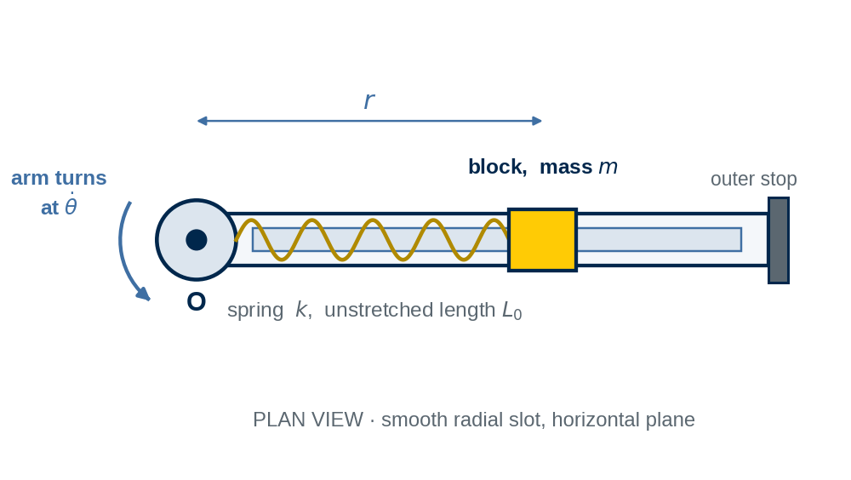
Figure 6 · The spring-restrained block on the rotating arm, in plan. Horizontal plane; the slot is smooth.
7.1 MODEL AND DERIVE. (3 points)
1. Draw the free-body diagram of the block and a separate ma-diagram. Write the spring force with the correct deformation — not the length.
2. The block sits at a steady radius, so ṙ = 0 and r̈ = 0. Write the radial equation of motion for that condition and solve it for the equilibrium radius as a function of θ̇.
3. Write the transverse equation for the same condition and state what it tells you about the load on the slot.
ANSWER 7.1:

7.2 EVALUATE. (2 points)
At θ̇ = 15.0 rad/s, compute the equilibrium radius, the spring deformation, the spring force, and the transverse force on the slot. Check your spring force against the inward force the motion requires, and say what that check proves.
ANSWER 7.2:

7.3 THE LIMIT. (2 points)
1. Find the table rate at which the block reaches the outer stop at r = 0.450 m. Report it in rad/s and rev/min.
2. Your expression for the equilibrium radius has a rate at which it stops returning a finite answer. Find that rate and explain, physically and without algebra, what the machine actually does as it is approached. Which of the two rates is reached first, and what does the other one then mean?
ANSWER 7.3:

7.4 VALIDATE AND JUDGE. (1 point)
Take the table rate to zero in your expression and say what the radius should become and whether it does. Then name the ONE modelling assumption whose failure would most change your answer near the outer stop, and say what measurement would test it.
ANSWER 7.4:

SUBMIT · Evidence Checklist and Human Review
Submit ONE completed Word document — this file — containing:
– the completed P0 parameter table, every value inside its range and at the stated precision;
– predictions committed before the corresponding calculation — 1.1, 2.1, 3.1, 4.1, 5.1;
– free-body diagrams and SEPARATE ma-diagrams — 1.2, 2.2, 3.3, 4.2, 5.2 (and 7.1 if attempted);
– hand calculations with equations, substitutions, units and signs — 1.3, 1.5, 2.3, 2.4, 2.5, 3.2, 3.4, 3.5, 4.3, 4.5, 5.3, 5.5, 6.1, 6.3, 6.4;
– the Problem 6 plots — the speed-time comparison with residuals, before and after the improvement;
– validation statements naming the move used — 1.5, 2.6, 3.6, 4.6, 5.5, 6.4;
– interpretations and verdicts — 1.4, 2.5, 3.5, 4.4, 5.4, 6.2, 6.4, 6.5;
– the one-page Problem 6 report and your response to the AI challenge;
– the human review statement below, signed and dated.
Keep every required answer inside this document rather than as separate image or screenshot files. Follow your instructor's submission and file-naming requirements.

HUMAN REVIEW (Problems 1–6: 100 points · optional Problem 7: 8 bonus points)
“I reviewed the modelling decisions, free-body diagrams, calculations, validation checks and engineering conclusions in this submission and confirm that they represent the work I performed and reviewed.”
Human reviewed and approved: __________________________________
Student name: ________________________________ Date: ______________
AI assists. Humans observe. Humans verify. Humans decide. Humans approve.

Suggested Assessment Rubric — 100 points
Used by the instructor and, where applicable, by an AI grading agent. Student parameters differ; the grader checks the method, the internal consistency of each student's own numbers, and the validation reasoning — not agreement with one universal answer.
Criterion | What full credit looks like | Pts
P0 · Parameters | Eleven personalised values recorded, each inside its range and at the stated precision. | 3
P1 · System boundary and Cartesian kinetics | Prediction committed before any equation, including the compatibility answer (1.1: 2). Two boundaries chosen and justified, complete FBDs with separate ma-diagrams, slope-aligned axes with a stated positive direction (1.2: 4). Acceleration, rear coupling and front coupling computed with substitutions, and the front coupling cross-checked from a second boundary (1.3: 5). Boundary dependence correctly interpreted and the design number identified (1.4: 2). Zero-grade case and hold force computed and read correctly (1.5: 2). | 15
P2 · Cause, effect and inference | Shape of the speed curve predicted and the constant-acceleration claim committed to (2.1: 2). FBD, ma-diagram and the equation of motion in F(t) form, with the passive-resistance argument and t₀ (2.2: 3). Illegality of the constant-acceleration formula stated, the ramp integrated with limits, speeds at 2.5 s and 4.0 s (2.3: 5). Illegal answer computed and the error explained (2.4: 2). Deceleration, braking force, required coefficient, verdict with reserve, and the mass-independence shown from the equations (2.5: 4). Units check and the t_{r} → 0 limiting case, both named (2.6: 1). | 17
P3 · Connected and constrained system | Two-to-one prediction and the tension question committed (3.1: 2). Datum, positive direction, two named coordinates, segments counted, constant-length relation derived from the drawing and differentiated twice (3.2: 4). Separate FBDs and ma-diagrams, the 2T versus T explained physically, unknowns counted against equations (3.3: 3). Both accelerations with directions, the tension, and the comparison with m_{A} g and m_{B} g / 2 (3.4: 4). Equilibrium counterweight derived and the 320 kg sign read as a direction (3.5: 1). m_{A} → 0 limiting case (3.6: 1). | 15
P4 · n–t kinetics and a contact condition | Direction of the acceleration sketched and the larger component committed (4.1: 2). Description justified, rear-view and plan diagrams, separate ma-diagram, component equations and assumptions (4.2: 3). a_{t}, a_{n}, |a|, the contact force with its angle, and the required coefficient (4.3: 5). Dry and wet verdicts with percentages, mass-independence shown, advisory speed discussed (4.4: 3). Crest normal force, N / W, contact-loss speed and the grip reduction (4.5: 3). Zero-braking limiting case named (4.6: 1). | 17
P5 · Rotating machine geometry | Both predictions committed before calculating (5.1: 2). Choice of r–θ justified with a named origin, FBD and separate ma-diagram, two equations and assumptions (5.2: 3). a_{r}, a_{θ}, F_{r} and F_{θ} with directions and sources (5.3: 4). Transverse contributions separated and compared, the radial-motion term explained in words, and the clamped case worked through (5.4: 3). Rated-load table rate and the radian unit check (5.5: 1). | 13
P6 · Model adequacy and judgement | Residual table and a plot with a residual strip, pattern described (6.1: 3). All four categories addressed, each ruled in or out against a supplied number, and the clue-not-a-law point made with a settling piece of evidence named (6.2: 6). One improvement, an independently sourced coefficient with units, the improved solution tabulated, and the new residual compared with the calibration uncertainty (6.3: 5). Distances and margins for three cases, two verdicts justified numerically, the adequacy-for-a-purpose argument, and the next step named (6.4: 4). Six-heading report within one page, AI challenge recorded after the student's own diagnosis and answered (6.5: 2). | 20
 | TOTAL | 100
Optional P7 · Integrated challenge | Spring deformation written correctly and the equilibrium radius derived (7.1: 3). Radius, deformation, spring force and the independent check at 15.0 rad/s (7.2: 2). Outer-stop rate and the rate at which no equilibrium exists, with the physical explanation and the ordering of the two (7.3: 2). Zero-rate limit and one named assumption with a test for it (7.4: 1). | +8

