ME345 ENGINEERING DYNAMICS · CHAPTER 3 · PARTS 1–7  Chapter 3 Self-Assessment  Forces and Particle Motion — Do I Understand This Well Enough to Move On?  Diagnostic · ungraded · organised by lecture Part so you know exactly what to review  24 items · ≈ 60 minutes · work at your own pace · no grade is recorded | 
Taner Onsay, Ph.D. · © 2026 AI First Engineering
AI TUTOR MODE — READ THIS FIRST
This is not a second homework assignment. It is shorter, faster and deliberately diagnostic: its output is not a score but a pattern — the Parts you own and the Parts you need to go back to.
Try each item yourself first. If you get stuck, AI may be used as a tutor, not as an answer machine. Instead of asking for the answer, try: “Do not solve this for me. Ask me one question, or give me one small hint at a time.”
The point is to find out what YOU understand, not what your AI can answer. Several items are written so that the plausible answer is the wrong one; getting one of those wrong is more useful than getting it right.

HOW TO USE IT
Work through a Part, then tick one of the four boxes at the end of it. Sample freely inside a Part you already own; slow down where a rating surprises you.
Items are marked by type: multiple choice · predict first · short explanation · identify the error · choose the diagram · small calculation · equation selection · model selection · limiting case · model validity.
Exams contain no conceptual surprises relative to this document. Use g = 9.81 m/s².

PART 1 · Why Does Motion Change?
Acceleration is the evidence of a net force. What a scale reads, what mass is, and what a net force actually causes.
1. What does the scale read? · multiple choice
A passenger stands on a bathroom scale inside a lift. The scale reading is a measure of:
□ A. the gravitational force acting on the passenger;
□ B. the mass of the passenger;
□ C. the support force the scale surface exerts on the passenger;
□ D. the net force acting on the passenger.
Then, in one sentence: name a situation in which your answer and option A happen to be numerically equal, and say what makes them equal there.
ANSWER 1:

2. Two lift questions in a row. · multiple choice
(i) The lift now rises at a constant 3.0 m/s. Compared with the reading when the lift was parked, the scale now reads:
□ A. more, because the lift is moving upward;
□ B. less, because the passenger is being carried;
□ C. the same;
□ D. it cannot be determined without the mass of the lift.
(ii) The cable is cut and the lift falls freely. A heavy passenger and a light passenger release identical pens at the same instant. Which pen reaches the lift floor first?
□ A. the heavy passenger's, because it weighs more;
□ B. the light passenger's, because it has less inertia;
□ C. neither — both pens stay where they were released, relative to the cabin;
□ D. both, together, after a short fall.
ANSWER 2:

3. Two sentences that sound right. · short explanation
Take each claim in turn. Refute or repair it in no more than two sentences, naming the law or the result you are using.
A. “A force is needed to keep something moving.” Give one counterexample from Chapter 3 and state what a net force actually causes.
B. “If the net force on a body is zero, the body is at rest.” True or false? If false, give the correct statement.
ANSWER 3:

4. The lift, with numbers. · small calculation
A 68.0 kg passenger stands on a scale in a lift.
A. The lift accelerates upward at 1.60 m/s². What does the scale read in newtons, and as a multiple of the passenger's weight?
B. What acceleration would make the scale read exactly half the passenger's weight? State its direction.
C. A second passenger of twice the mass rides the same lift on the same trip. Does the RATIO of scale reading to weight change? Show why in one line.
ANSWER 4:

RATE YOURSELF on Part 1 before moving on. □ I can do this independently. □ I can do this with a small AI hint. □ I need substantial AI help. □ I still need human or instructor help.

PART 2 · What Forces Act on the Selected System?
The free-body diagram is a model, not a drawing procedure. Boundary first, forces second, and never m a among them.
5. Choose the correct free-body diagram. · choose the diagram
A crate sits on the bed of a flatbed truck. The truck is speeding up to the right and the crate does not slide on the bed. Each diagram below isolates the crate alone.
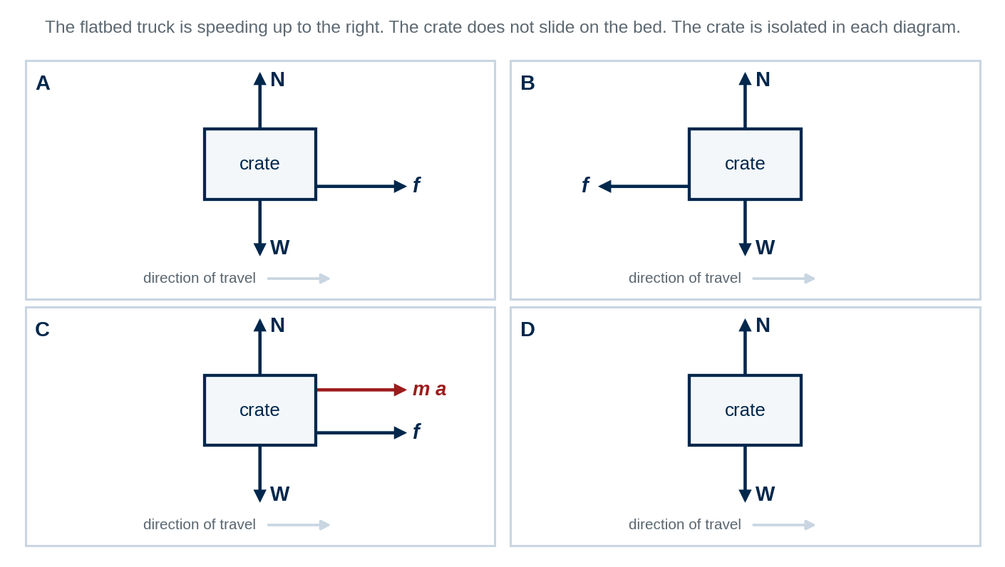
Four candidate free-body diagrams for the crate. The crate is isolated in each.
Which diagram is correct? Then name the single defect in each of the other three, in a few words each — and for the one that shows m a among the forces, name the diagram it belongs on instead — the free-body diagram or the ma-diagram?
ANSWER 5:

6. Find every defect in a supplied solution sketch. · identify the error
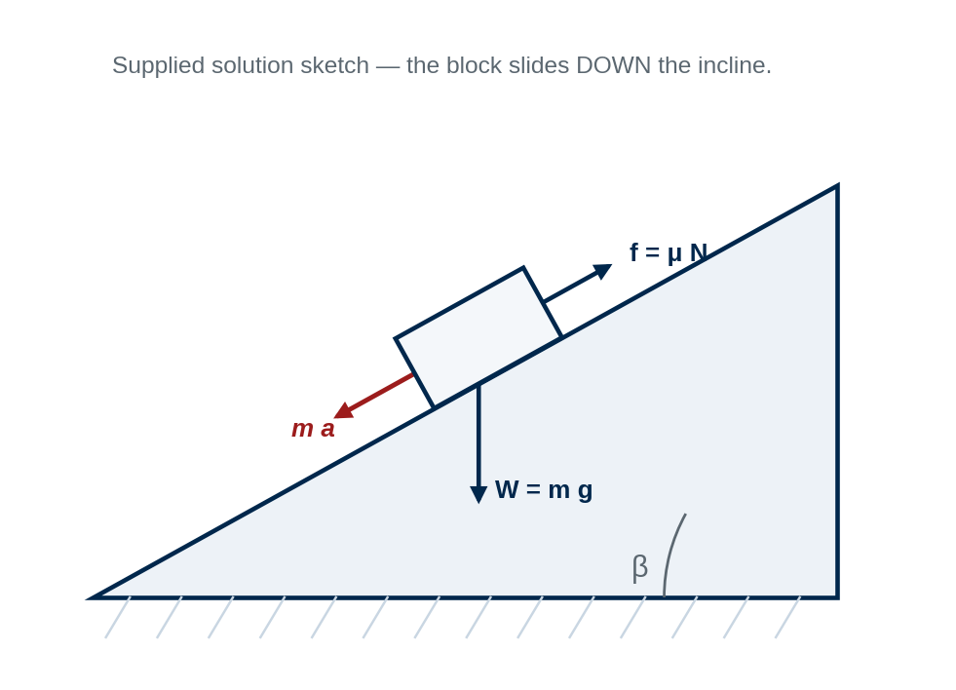
A student's sketch for a block sliding DOWN a rough incline.
List every defect you can find in this sketch. For each one, say in a few words what it would do to the answer. Be careful: not everything that looks surprising is wrong — if you decide something is correct, say so and say why.
ANSWER 6:

7. One scene, three boundaries. · system-boundary reasoning
A tractor tows a front trailer and a rear trailer, all accelerating together. Consider three choices of system boundary: (i) the whole train; (ii) the tractor plus the front trailer; (iii) the rear trailer alone.
A. For each boundary, state whether the force in the REAR coupling is internal or external, and whether it appears on that free-body diagram.
B. Does changing the boundary change the acceleration of the rear trailer? One sentence, with the reason.
C. “Internal forces should also be shown on the whole-system diagram, so that the diagram is complete.” True or false, and why?
ANSWER 7:

8. Two force models, and the conditions attached to them. · multiple choice
(i) The statement N = m g for a body resting on a surface is true:
□ A. always, whenever a body is in contact with a surface;
□ B. only on a level surface, with no vertical acceleration and no other vertical force acting;
□ C. only when the body is at rest;
□ D. whenever the friction at the contact is static.
(ii) The friction force acting on a body in contact with a surface is:
□ A. always equal to μ_{s} N;
□ B. always equal to μ_{k} N;
□ C. whatever the equations of motion require, up to a limit of μ_{s} N, and equal to μ_{k} N once sliding has begun;
□ D. always opposite to the velocity of the body.
ANSWER 8:

RATE YOURSELF on Part 2 before moving on. □ I can do this independently. □ I can do this with a small AI hint. □ I need substantial AI help. □ I still need human or instructor help.

PART 3 · Cartesian Kinetics — Cause and Effect
Net force causes a change in velocity, not velocity. And the same diagram runs backwards.
9. Steady across the apron. · multiple choice
A yard train crosses level ground at a steady 4.0 m/s. The net force on it is:
□ A. 4.0 N, forward;
□ B. zero;
□ C. forward, and equal in magnitude to the drive force at the tyres;
□ D. indeterminable without the mass of the train.
Then, in one sentence: reconcile your answer with the fact that the drive force at the tyres is clearly not zero.
ANSWER 9:

10. Which relation are you allowed to use? · equation selection
A vehicle of mass m starts from rest. The tractive force rises with time as F(t) = b t with b constant, and the resistances are negligible. You are asked for the speed at t = 3.0 s.
□ A. v_{sp} = v_{sp,0} + a t, with a evaluated at t = 3.0 s;
□ B. v_{sp}² = v_{sp,0}² + 2 a s;
□ C. m dv_{sp} / dt = F(t), separated and integrated;
□ D. F = m a applied at t = 3.0 s, then the result multiplied by 3.0 s.
Then: state the single condition that options A and B require, and name one later stage of the SAME launch at which option A would become legal.
ANSWER 10:

11. Read the force from the motion. · predict first, then calculate
A van brakes steadily from 90.0 km/h and stops in 55.0 m on level road.
A. Predict before calculating. Is the coefficient of friction the road had to supply closest to 0.3, 0.6 or 0.9? Commit, with one line of reasoning.
B. Compute the deceleration and the required coefficient.
C. The same van, now carrying a payload that doubles its mass, repeats the same stop in the same distance. Does the required COEFFICIENT change? Does the required braking FORCE change? Show both from the equations.
ANSWER 11:

RATE YOURSELF on Part 3 before moving on. □ I can do this independently. □ I can do this with a small AI hint. □ I need substantial AI help. □ I still need human or instructor help.

PART 4 · Connected and Constrained Particle Systems
A connection restricts the motion the bodies are allowed to have. It is a physical restriction, not an extra line of algebra.
12. “Connected means the same acceleration.” · short explanation
State when that sentence is true and when it is false. Give one example of each from Chapter 3, say precisely what a connection actually constrains, and write the compatibility condition that expresses it.
ANSWER 12:

13. A two-to-one rig. · small calculation
A rope runs from a fixed anchor on an overhead beam, down around a movable pulley that carries a load, and back up over a fixed sheave to a hauler. Both position coordinates are measured DOWNWARD from one datum on the beam: s_{L} to the load and s_{H} to the hauler's end of the rope. All falls are vertical; the rope is inextensible and the pulleys are ideal.
A. Write the constant-length relation and differentiate it once.
B. At the instant considered the hauler is drawing the rope end downward at 0.900 m/s. How fast is the load moving, and in which direction?
C. At that same instant the rope tension is 400 N. What upward force acts on the load?
D. The load weighs 700 N. Is it accelerating? In which direction, and at what rate?
ANSWER 13:

14. One line of a solution, and what is wrong with it. · identify the error
A 40.0 kg crate hangs from a single vertical cable and is being hauled upward at increasing speed. A student writes: “the cable tension is T = m g = 392 N.”
A. Identify the error and state the correct relation.
B. Compute the tension if the crate accelerates upward at 1.20 m/s².
C. In one sentence, name the earlier Chapter 3 result that already contradicted the student's claim.
ANSWER 14:

RATE YOURSELF on Part 4 before moving on. □ I can do this independently. □ I can do this with a small AI hint. □ I need substantial AI help. □ I still need human or instructor help.

PART 5 · Forces Cause Curved-Path Motion — n–t
The tangential net force changes speed. The normal net force changes direction. There is no outward force.
15. Constant speed round a bend. · multiple choice
A car rounds a bend at a constant 20 m/s. Its acceleration is:
□ A. zero, because the speed is not changing;
□ B. tangent to the path, in the direction of travel;
□ C. directed toward the centre of curvature;
□ D. directed away from the centre of curvature.
ANSWER 15:

16. Which horizontal forces are on the car? · choose the diagram
A car rounds a level, unbanked bend at constant speed, seen from above. The centre of the curve is marked in each frame. Only horizontal forces are drawn.
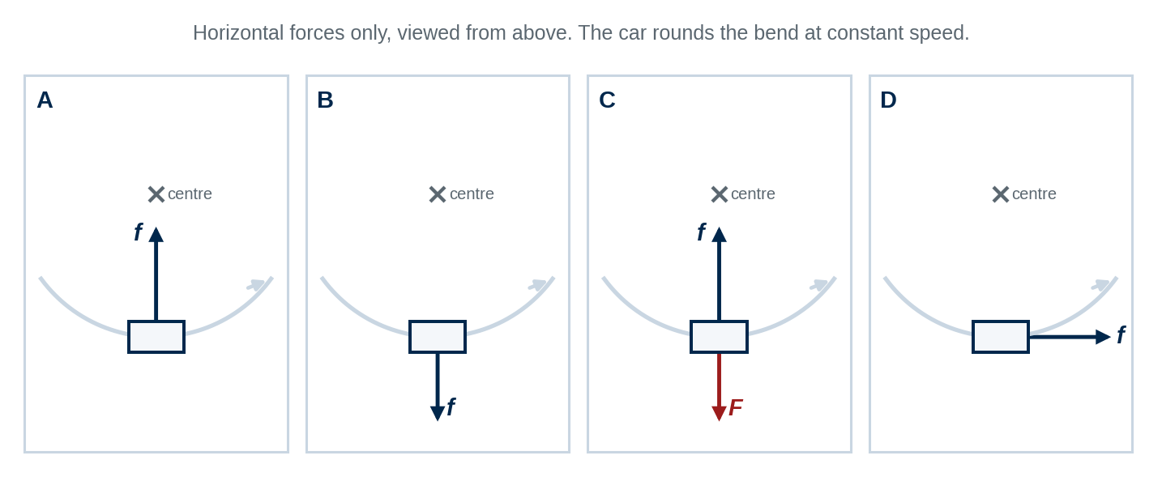
Four candidate horizontal-force sets for a car at constant speed on a level, unbanked curve.
Which set is correct? Then, in one or two sentences, say what is wrong with set C in particular — and what the passenger who insists on it is actually feeling.
ANSWER 16:

17. Over the crest. · small calculation and limiting case
A car of mass 1400 kg crosses a bridge crest whose profile has a radius of curvature of 60.0 m, travelling at 18.0 m/s.
A. Compute the normal force and the ratio N / W.
B. At what speed would N reach zero? Say in one sentence what physically happens at and above that speed.
C. A classmate computes N at 30.0 m/s, gets a negative number, and concludes they made a sign error. Respond in one sentence.
ANSWER 17:

18. Speeding up through the bend. · direction of acceleration
A vehicle travels left to right along the bend shown and is SPEEDING UP as it goes. The centre of the curve is marked in each frame.
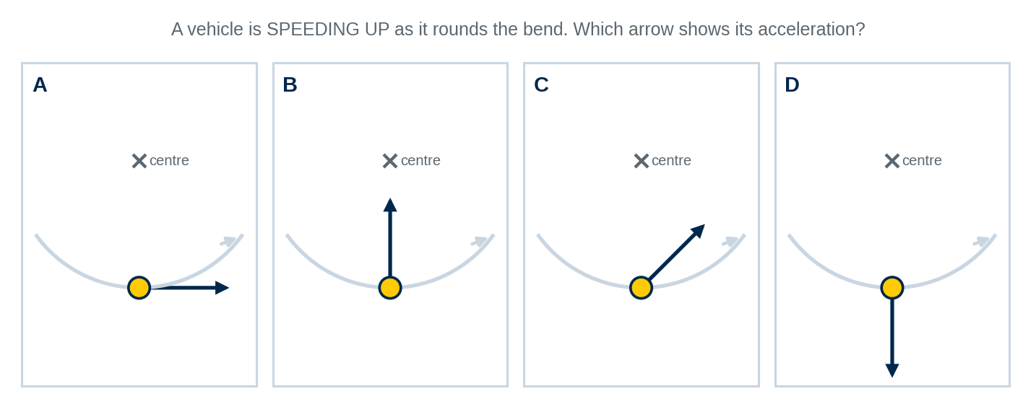
One bend, four candidate acceleration arrows.
Which arrow is right? Then: which component changes the speed and which changes the direction, and what would the arrow look like instead if the driver were braking through the same bend?
ANSWER 18:

RATE YOURSELF on Part 5 before moving on. □ I can do this independently. □ I can do this with a small AI hint. □ I need substantial AI help. □ I still need human or instructor help.

PART 6 · Forces in Rotating Machine Geometry — r–θ
n–t follows the path. r–θ follows the machine. And the radial acceleration is not the second derivative of r.
19. A part sliding freely in a smooth rotating tube. · multiple choice
A small part slides freely inside a smooth straight radial tube fixed to a horizontal turntable rotating at the constant rate $\dot{θ}=6 rad/s.$. At the instant considered the part is at r = 0.300 m. Neglect friction. Because the tube is smooth and radial, it exerts no force on the part in the radial direction. The radial acceleration $α_{r}$is therefore::
□ A. zero;
□ B. $+10.8 m/s^{2}$; outward
□ C. $-10.8 m/s^{2}$; inward
□ D. cannot be determined without $\dot{r}$.
Then: use $α_{r}=\ddot{r}-r{\dot{θ}}^{2}$ to determine $\ddot{r}.$ Explain in one sentence why $\ddot{r}$ is not the radial component of acceleration $α_{r}.$
ANSWER 19:

20. Steady rotation, moving part. · small calculation
A 3.00 kg carriage rides in a radial slot on an arm that turns at a CONSTANT 5.00 rad/s, so θ̈ = 0. A drive pushes the carriage outward at a constant 0.400 m/s. At the instant considered r = 0.500 m. The plane is horizontal.
A. Is there a transverse force on the carriage? Compute a_{θ} and F_{θ}.
B. Compute a_{r} and F_{r}, and state the direction of F_{r} in words.
C. In one sentence, and without writing the formula, say why a transverse force exists even though nothing is speeding up.
ANSWER 20:

21. Which description, and why? · model selection
For each situation choose n–t or r–θ and justify it in one line.
– a car on a highway curve of known radius, asked for the friction required;
– a robot end-effector on a rotating arm with a radial slide, asked for the load on the slide;
– a bead on a wire whose shape is given as y = f(x), asked for the normal force from the wire;
– a package on a conveyor whose path curves with a radius that changes steadily along the belt;
– a block sliding in a slot cut in a rotating crank plate, asked for the actuator force.
Then, in one sentence: is either description ever more CORRECT than the other, or only more convenient? Say what actually decides the choice.
ANSWER 21:

RATE YOURSELF on Part 6 before moving on. □ I can do this independently. □ I can do this with a small AI hint. □ I need substantial AI help. □ I still need human or instructor help.

PART 7 · Can We Trust the Model?
A model is adequate or inadequate for a purpose. Diagnose on evidence, change one thing, and say what the residual means.
22. The same 5 %, two decisions. · model validity
A hoist's predicted lift time is known to be within 5 % of the true time, though the direction of the error is not known. Two decisions are to be made from the model.
Decision | The question being answered
A | Is the motor large enough to lift this load at all?
B | Will the lift finish inside a 30.0 s crane-slot window, when the model predicts 29.0 s?

Give a verdict for each and justify each with a NUMBER, not an adjective. Then complete the sentence: “A model is not simply good or bad. A model is adequate or inadequate ____________.”
ANSWER 22:

23. Four patterns, four places to look. · match the signature
Assign each pattern below to MODEL, PARAMETERS, MEASUREMENT or IMPLEMENTATION.
– the predicted and measured curves have the same shape, but the measurement sits 8 % low at every speed including the lowest;
– the measured points scatter about the prediction by about the size of the sensor resolution, with no trend;
– the prediction is forty times the measurement and points the wrong way;
– agreement is good at low speed and the gap grows steadily as the speed rises.
Then answer both of these in one sentence each: why is a signature like these a diagnostic clue rather than a law? And: a classmate concludes from the fourth pattern that ∑ F⃗ = m a⃗ must be wrong — what do you say?
ANSWER 23:

24. Two claims about improving a model. · short explanation
Critique each in no more than two sentences.
A. “I adjusted the drag coefficient until the predicted and measured curves matched, so the model is now validated.” Also state what WOULD count as validation here.
B. “The more physics you put into a model, the better the model.” State the stopping rule the chapter gives for when to stop improving a model.
ANSWER 24:

RATE YOURSELF on Part 7 before moving on. □ I can do this independently. □ I can do this with a small AI hint. □ I need substantial AI help. □ I still need human or instructor help.

READING YOUR RESULTS
The output of this document is a pattern, not a score.
If your ratings look like this | Then do this
mostly “independently” across all seven Parts | You own Chapter 3. Move forward — Chapter 4 asks whether you needed the acceleration at every point in the first place.
“small AI hint” clustered in one Part | That Part is your review target. Retry those items later without AI before you decide you have fixed it.
“substantial AI help” in a Part | Return to that lecture Part and rework its worked example before retrying: Part 1 → items 1–4 · Part 2 → 5–8 · Part 3 → 9–11 · Part 4 → 12–14 · Part 5 → 15–18 · Part 6 → 19–21 · Part 7 → 22–24.
any “human or instructor help” | Bring those exact item numbers to class or office hours. That is what they are for.

THE GOAL IS NOT 24 CORRECT ANSWERS. The goal is to be able to say: “given a machine, I can choose the system, draw the diagram, pick the description, solve it, and then say whether I believe the answer — without outsourcing the judgement.”
AI assists. The engineer observes, models, validates, decides, and approves.

