AI-AUGMENTED ENGINEERING DYNAMICS: A CONVERSATIONAL APPROACH  CHAPTERS 1–3 COMPREHENSIVE ASSESSMENT  Particle Kinematics and Kinetics | 
Taner Onsay, Ph.D. · © 2026 AI First Engineering LLC · 34 responses · 100 points · about 105 minutes
Purpose. This comprehensive assessment is a learning checkpoint. It lets you integrate and evaluate your understanding of the concepts, modelling approaches and problem-solving methods developed in Chapters 1–3: describing motion on straight and curved paths, choosing a coordinate description, and connecting forces to the motion they cause. The questions ask you to do what an engineer does — understand the situation, choose the model, compute, interpret, and decide whether the answer is believable.
How this checkpoint works
• Three parts: A · Concept and Model Checkpoints (10 responses, 20 points, ≈ 15 min) · B · Setup and Calculate (6 responses, 24 points, ≈ 25 min) · C · Linked Engineering Scenarios (18 responses, 56 points, ≈ 64 min).
• Type every answer in its labelled field. Where a field asks for Equation used, write the governing equation, with known values inserted if you like; it earns credit even if your arithmetic slips.
• In linked scenarios, a later answer is graded using your own earlier answer, so one early mistake is not penalised twice.
• Use g = 9.81 m/s² and report three significant figures with units. Each question states its origin, axes and positive directions; use them.
• For the most useful self-assessment, complete the checkpoint independently using only the provided formula sheet and a calculator. Afterward, use AI as a tutor to investigate missed questions and strengthen your understanding.
Typing equations: use the mathematical symbols and notation shown in the provided formula sheet. Use ordinary keyboard equivalents when needed; put units after numerical answers.

Part A — Concept and Model Checkpoints
10 responses · 20 points · ≈ 15 min
Select one answer for each question. Each is worth 2 points.
A01 · Momentarily at rest (2 pts)
A positioning stage moves along a straight rail. Its position is $s(t) = 2t³ - 9t² + 12t + 1$, with s in metres, t in seconds, and +s to the right. Which statement is correct?
A. It is momentarily at rest at t = 1 s and t = 2 s, and its acceleration is zero at both instants.
B. It is momentarily at rest at t = 1 s and t = 2 s, with a = −6 m/s² at t = 1 s and a = +6 m/s² at t = 2 s.
C. It is momentarily at rest only at t = 1.5 s, where a = 0.
D. It is momentarily at rest at t = 1 s and t = 2 s, with a = +6 m/s² at t = 1 s and a = −6 m/s² at t = 2 s.
E. It is never at rest, because s(t) is never zero.
A01
Your choice (A–E)

A02 · Reading a v–t graph (2 pts)
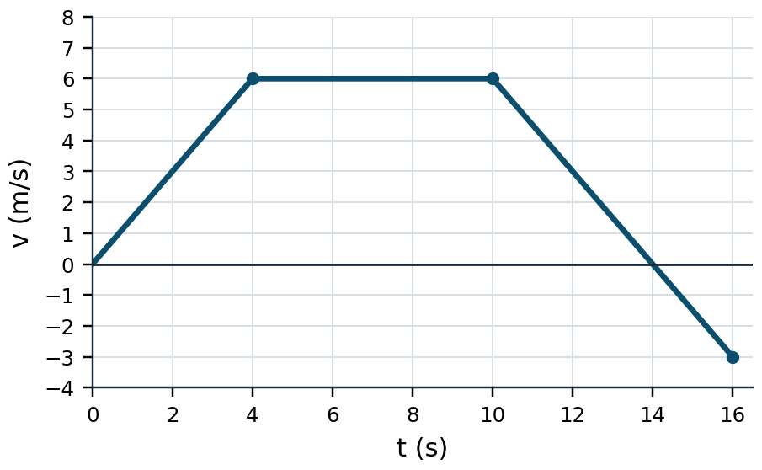
Figure A02 · Velocity of a cart on a straight track; +s to the right.
The graph shows the velocity of a cart on a straight track (+s to the right). Which statement is correct?
A. The cart reverses direction at t = 10 s, where its velocity starts to decrease.
B. The cart reverses direction at t = 14 s.
C. The acceleration is zero at the instant the velocity is zero.
D. Between t = 14 s and t = 16 s the cart is slowing down, because its acceleration is negative.
E. The cart is back at its starting position at t = 16 s.
A02
Your choice (A–E)

A03 · A reversal (2 pts)
A cart on a straight track is at s₀ = −2.0 m at t = 0 moving to the right at 6.0 m/s. Its acceleration is constant, 1.5 m/s² to the left. Take +s to the right. Which statement describes the motion for 0 ≤ t ≤ 6.0 s?
A. The cart moves to the right for the whole 6.0 s and is at s = 7.0 m at t = 6.0 s.
B. The cart stops at t = 4.0 s at s = 10 m, reverses, and at t = 6.0 s is at s = 7.0 m moving left at 3.0 m/s.
C. The cart stops at t = 4.0 s, reverses, and at t = 6.0 s is at s = 9.0 m moving left at 3.0 m/s.
D. The cart's displacement over the 6.0 s is negative because its acceleration is negative.
E. The cart stops at t = 4.0 s and remains at rest, because nothing pushes it back.
A03
Your choice (A–E)

A04 · Constant speed on a circle (2 pts)
A survey drone flies a horizontal circle of radius 40 m at a constant speed of 12 m/s. Its acceleration is:
A. zero, because its speed is constant.
B. 3.6 m/s², tangent to the path.
C. 3.6 m/s², directed toward the centre of the circle.
D. 3.6 m/s², directed away from the centre of the circle.
E. 0.30 m/s², directed toward the centre of the circle.
A04
Your choice (A–E)

A05 · Landing lower than launch (2 pts)
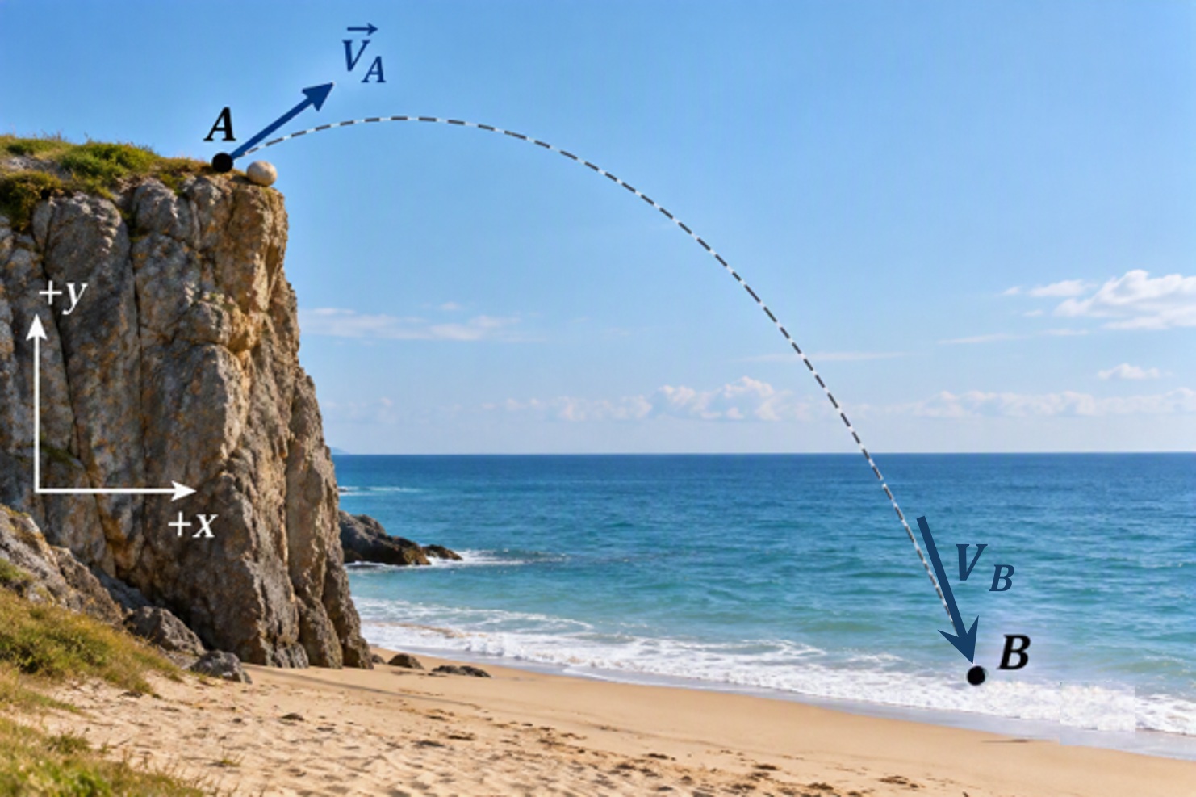
Figure A05 · A stone thrown from the cliff top at A lands on the beach at B; +x right, +y up.
Neglect air resistance. Which statement is correct?
A. $|\vec{v}B| > |\vec{v}A|$ and v_{Bx} = v_{Ax}
B. $|\vec{v}B| = |\vec{v}A|$ and v_{Bx} = v_{Ax}
C. $|\vec{v}B| < |\vec{v}A|$and v_{Bx} < v_{Ax}
D. $|\vec{v}B| > |\vec{v}A|$and v_{Bx} > v_{Ax}
E. $|\vec{v}B| = |\vec{v}A|$and v_{By} = −v_{Ay}
A05
Your choice (A–E)

A06 · Average speed on a two-loop track (2 pts)
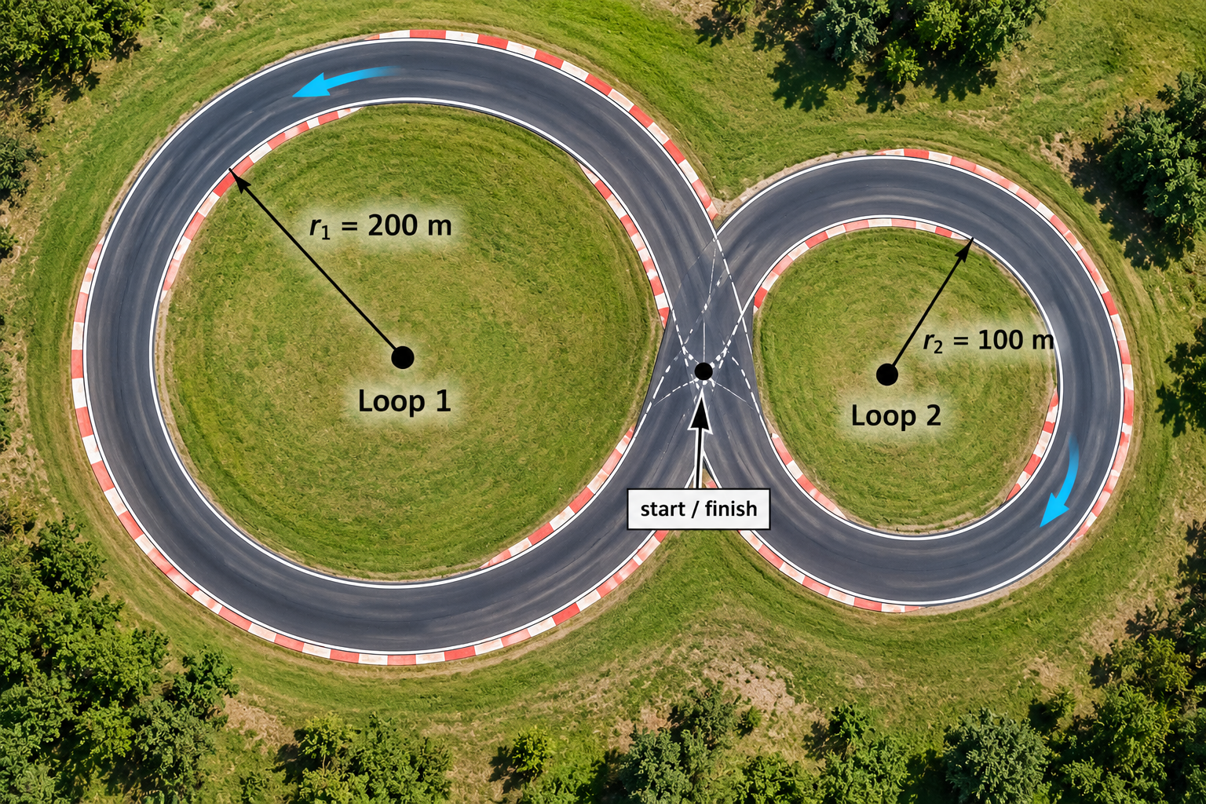
Figure A06 · Figure-8 test track of two tangent circular loops.
A test car drives Loop 1 once in 25 s, then Loop 2 once in 10 s. Let v_{sp1}, v_{sp2} and v_{sp,track} be its average speeds on Loop 1, on Loop 2, and over the whole track. Which is correct?
A. v_{sp1} = v_{sp2} = v_{sp,track}
B. v_{sp2} > v_{sp,track} > v_{sp1}
C. v_{sp,track} = (v_{sp1} + v_{sp2})/2
D. v_{sp1} > v_{sp2}, because Loop 1 is longer
E. All three average speeds are zero, because the car returns to its starting point.
A06
Your choice (A–E)

A07 · Choosing the description (2 pts)
A coastal radar station at O reports a ship's range r and bearing θ once per second. Engineers need the ship's acceleration. Which starting description is best justified?
A. Cartesian x–y, because Cartesian components always give the most accurate acceleration.
B. Normal–tangential, because every curved path must be analysed with û_{t} and û_{n}.
C. Polar r–θ with origin at O, because the instrument measures r and θ directly, so ṙ, r̈, θ̇, θ̈ follow from the data.
D. Normal–tangential, because the other descriptions give a different magnitude of acceleration.
E. Polar r–θ, because a_{r} = r̈ can then be read straight from the range data.
A07
Your choice (A–E)

A08 · The free-body diagram (2 pts)
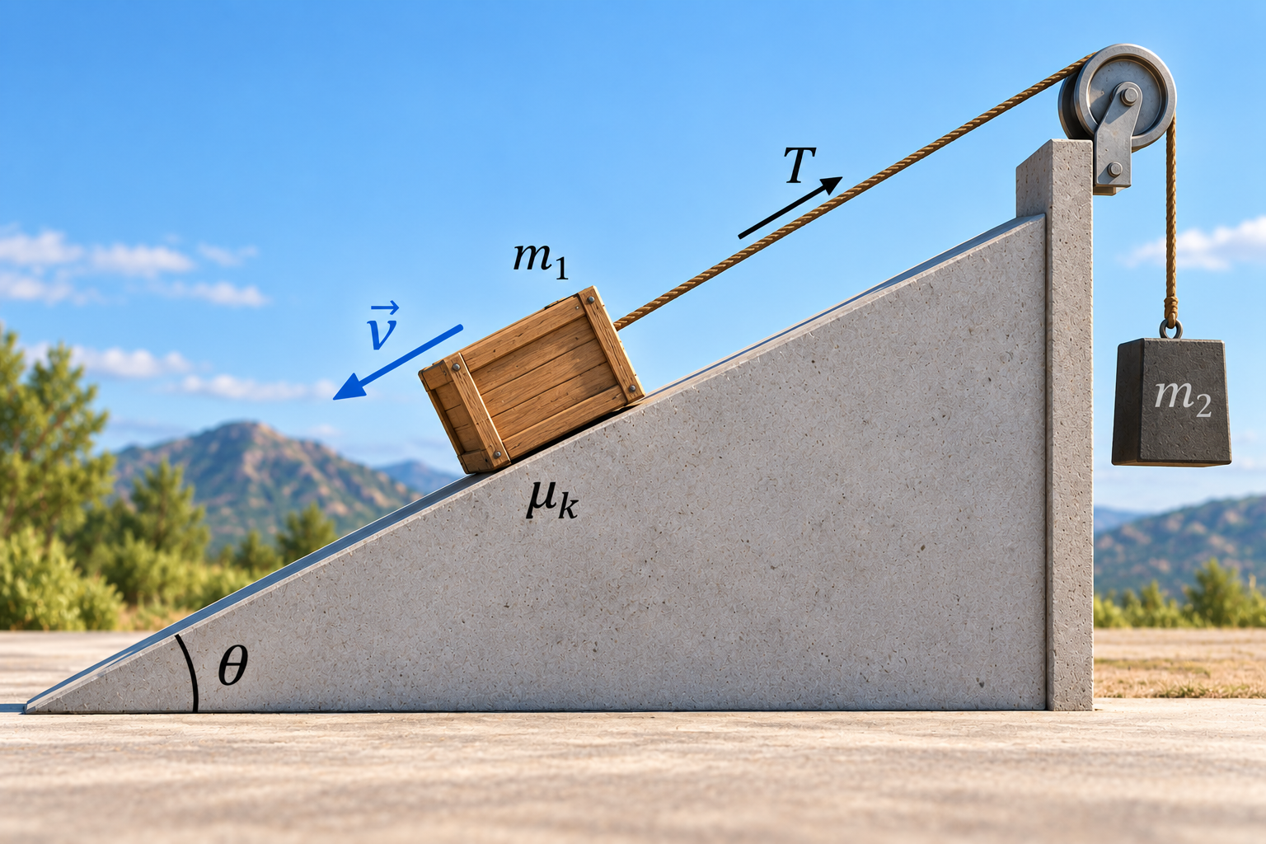
Figure A08 · A crate slides down a rough incline while a rope parallel to the slope pulls up-slope.
A crate slides down a rough incline while connected by a light inextensible cable over a frictionless pulley to a second mass. At the instant shown, the crate is moving down the incline with velocity $\vec{v}$. Which list gives the forces acting on the crate?
A. W vertically down; N perpendicular to the slope; T up the slope; friction μ_{k}N down the slope.
B. W vertically down; N perpendicular to the slope; T up the slope; friction μ_{k}N up the slope.
C. W vertically down; N perpendicular to the slope; T up the slope; friction μ_{k}W up the slope.
D. W vertically down; N perpendicular to the slope; T up the slope; friction μ_{k}N up the slope; and a force ma⃗ down the slope.
E. W vertically down; N vertically up; T up the slope; friction μ_{k}N up the slope.
A08
Your choice (A–E)

A09 · The crate on the truck bed (2 pts)
A 50 kg crate rides on the flat bed of a truck that speeds up at 2.0 m/s² on a level road. The crate does not slide. Between crate and bed, μ_{s} = 0.40 and μ_{k} = 0.30. The friction force on the crate is:
A. zero, because the crate and truck move together.
B. 196 N, opposite to the truck's motion.
C. 100 N, in the direction of the truck's acceleration.
D. 196 N, in the direction of the truck's acceleration.
E. 147 N, in the direction of the truck's acceleration.
A09
Your choice (A–E)

A10 · Where the disagreement comes from (2 pts)
An electric shuttle's speed was predicted with Σ F⃗ = ma⃗ using a constant drive force and constant rolling resistance. Measured speeds were compared with the prediction over a 12 s run, five times:
t (s) | 2 | 4 | 6 | 8 | 10 | 12
(measured − predicted)/predicted | −0.2 % | −0.8 % | −1.9 % | −3.2 % | −4.8 % | −6.6 %

The pattern is the same in all five runs. The speed sensor resolves ±0.05 m/s; mass and drive force are known to ±0.7 % and ±1.5 %. Which is the best-supported first diagnosis?
A. Measurement: sensor noise, because real data never match a model exactly.
B. Model: a resistance that grows with speed, such as aerodynamic drag, is missing.
C. Σ F⃗ = ma⃗ does not hold at the higher speeds.
D. Parameters: the mass is wrong.
E. Implementation: a units error in the calculation.
A10
Your choice (A–E)

Part B — Setup and Calculate
6 responses · 24 points · ≈ 25 min
Each response is worth 4 points. Write the governing equation you used, then the result with units. The equation earns credit on its own.
B01 · The shuttle leaves the stop line (4 pts)
An autonomous shuttle crosses a stop line at t = 0 and moves along a straight road. For 0 ≤ t ≤ 4.0 s its velocity is $v(t) = 0.6t² + 1.2t + 2.0$ (v in m/s, t in s, positive in the direction of travel). At t = 4.0 s the controller switches to holding the speed constant.
B01.eq
Equation used for the acceleration: a(t) =
B01.res.a_before
a just before t = 4.0 s (m/s²)
B01.res.a_after
a just after t = 4.0 s (m/s²)

B02 · Average velocity on an arc (4 pts)
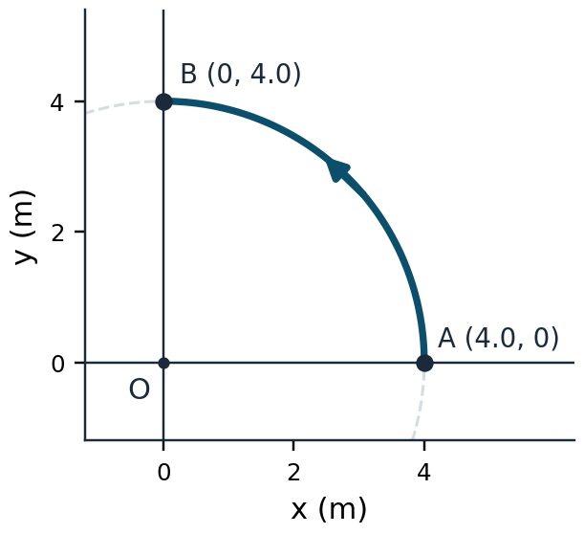
Figure B02 · Quarter-circle path of radius 4.0 m from A to B, counter-clockwise.
A robot moves along the quarter-circle from A to B in 2.0 s.
B02.eq
Equation used: ${\vec{v}}_{avg} =$
B02.res
Result: ${\vec{v}}_{avg} =$ ( ____ , ____ ) m/s

B03 · What the car's sensor reports (4 pts)
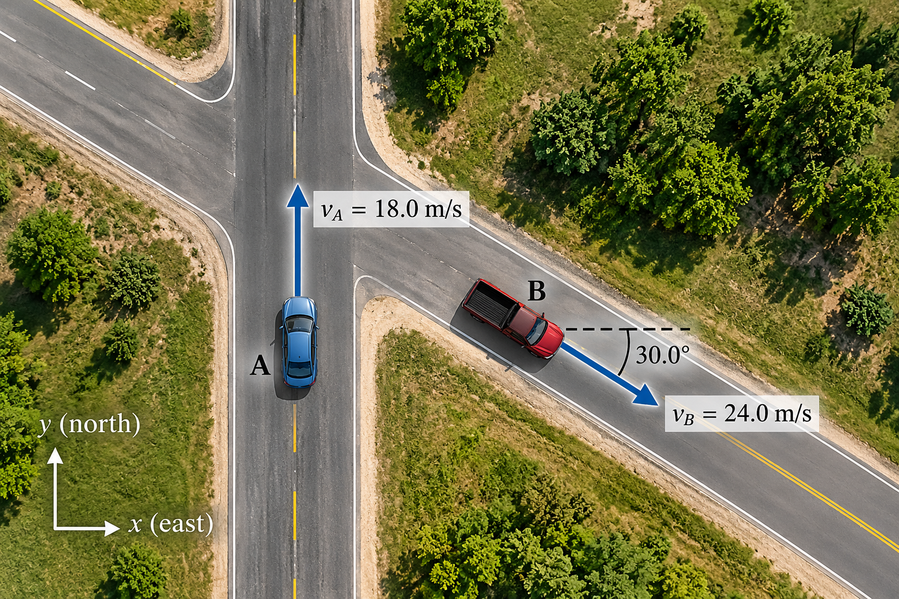
Figure B03 · Plan view: car A northbound, truck B heading 30.0° south of east; x east, y north.
Car A travels north at 18.0 m/s. Truck B travels at 24.0 m/s in the direction 30.0° south of east. Treat A as a translating (non-rotating) observer; use x east and y north.
B03.eq
Equation used: ${\vec{v}}_{B/A} =$
B03.res
Result: ${\vec{v}}_{B/A}$ = ( ____ , ____ ) m/s

B04 · Is the end-effector speeding up? (4 pts)
A robot end-effector moves in a plane with fixed x–y axes: x(t) = 0.5t³ − 3t and y(t) = 4 − t² (x, y in metres, t in seconds). Consider t = 2.0 s.
B04.eq
Equation used for the tangential acceleration: a_{t} =
B04.res.v_sp
v_{sp} at t = 2.0 s (m/s)
B04.res.a_t
a_{t} at t = 2.0 s (m/s²)

B05 · Package on a chute (4 pts)
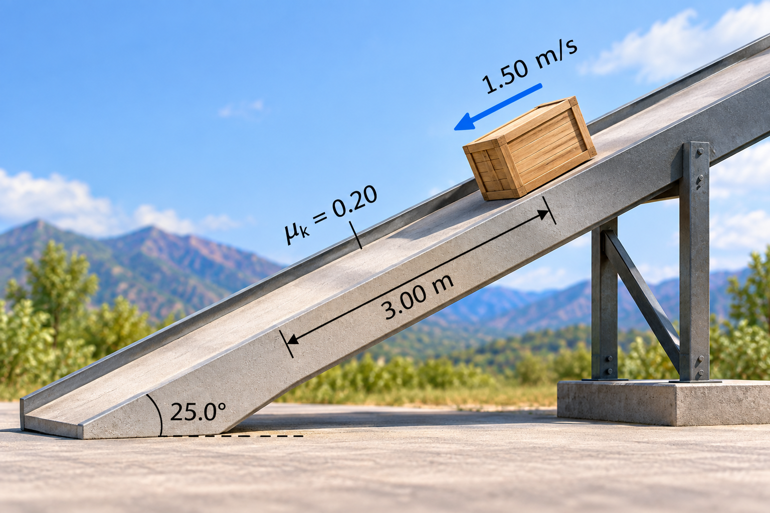
Figure B05 · Package on a straight chute inclined at 25.0°; μ_{k} = 0.20.
A package slides down the chute. It passes the top mark at 1.50 m/s. Find its speed 3.00 m further down the chute.
B05.eq
Equation used (along the chute):
B05.res
Result: v_{sp} (m/s)

B06 · Lifting a pallet (4 pts)
A 250 kg pallet hangs from a single vertical crane cable. At the instant considered the pallet accelerates upward at 1.20 m/s².
B06.eq
Equation used:
B06.res
Result: T (N)

Part C — Linked Engineering Scenarios
18 responses · 56 points · ≈ 64 min
Each scenario is a chain. Answer in order. Later answers are graded using your own earlier answers.
Scenario 1 — A test ball launched onto a raised platform
S1-1 to S1-5 · 14 points · ≈ 17 min
A pneumatic launcher on an outdoor test range fires a smooth, solid rubber test ball from point A with speed 55.0 m/s at 20.0° above the horizontal. In the ideal projectile model (a particle with no air resistance), the ball lands exactly on the front edge B of a raised target platform, 180 m from A measured horizontally. An engineer uses the model to find how high B is above A, then checks whether the model can be trusted.
Take the origin at A, +x horizontal toward the platform, +y vertically up. Ball data (used only in S1-5): smooth sphere, mass 72.0 g, diameter 50.0 mm, drag coefficient C_{D} = 0.47; air density 1.20 kg/m³.
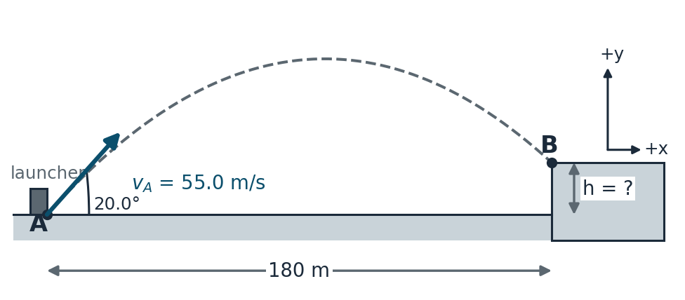
Figure S1 · Side elevation: launcher at A (origin), ideal trajectory to the front edge B of a raised platform; +x toward the platform, +y up.
S1-1 · Select the model (2 pts)
Which pair of equations describes the ideal flight in the stated axes?
A. $x = (55.0 cos 20.0°)t and y = (55.0 sin 20.0°)t - ½gt²$
B. $x = 55.0t and y = 55.0t - ½gt²$
C. $x = (55.0 cos 20.0°)t - ½gt² and y = (55.0 sin 20.0°)t - ½gt²$
D. $x = (55.0 cos 20.0°)t and y = (55.0 sin 20.0°)t + ½gt²$
E. $x = (55.0² sin 40.0°)/g and y = 0 at landing$
S1-1
Your choice (A–E)

S1-2 · Time to reach B (3 pts)
S1-2.eq
Equation used:
S1-2.res
Result: t (s)

S1-3 · Height of B above A (3 pts)
S1-3.eq
Equation used:
S1-3.res
Result: h (m)

S1-4 · Speed at B, checked by a second route (3 pts)
Find the speed at B without using the time, and state whether the ball is rising or descending there.
S1-4.eq
Equation used:
S1-4.res.v_sp
Result: v_{sp} at B (m/s)
S1-4.res.direction
Rising or descending at B?

S1-5 · Is neglecting drag reasonable? (3 pts)
Estimate the aerodynamic drag force on the ball just after launch using the Chapter 3 quadratic drag model, compare it with the ball's weight, and state in one sentence whether neglecting drag is reasonable for predicting h.
S1-5.F_D
F_{D} just after launch (N)
S1-5.ratio
F_{D} / W
S1-5.verdict
Verdict (one sentence)

Scenario 2 — Braking through an exit ramp, then a crest
S2-1 to S2-4 · 14 points · ≈ 15 min
A 1500 kg car leaves a highway onto a level, unbanked exit ramp that is a circular arc of radius ρ = 120 m. It enters the ramp at point A at 24.0 m/s and brakes so that its speed decreases at a constant rate, reaching 14.0 m/s at point C, 100 m of arc later. Treat the car as a particle; the road must supply the whole horizontal force through tyre friction.
Beyond C the road runs straight but passes over a crest D whose profile, in vertical section, is a circular arc of radius 40.0 m; the car crosses D at 14.0 m/s.
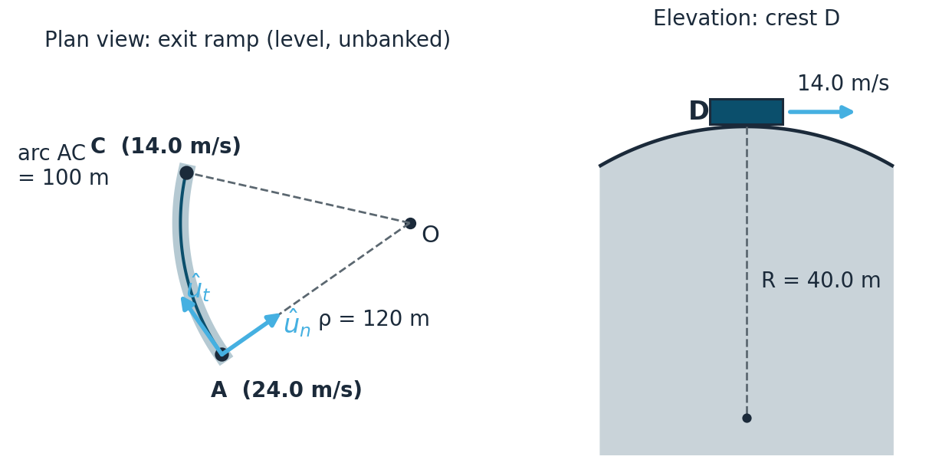
Figure S2 · Left: plan view of the circular exit ramp A→C. Right: elevation of the crest D.
S2-1 · Tangential acceleration (3 pts)
S2-1.eq
Equation used:
S2-1.res
Result: a_{t} (m/s²)

S2-2 · Total acceleration at entry (4 pts)
S2-2.eq
Equation used:
S2-2.res.a_n
a_{n} at A (m/s²)
S2-2.res.a_mag
$|\vec{a}|$at A (m/s²)

S2-3 · Can the road supply it? (4 pts)
The wet ramp surface has μ_{s} = 0.60 between tyres and road. Find the friction coefficient the manoeuvre requires at A, and give a verdict with the reserve, defined as (μ_{s} − μ_{required})/μ_{s} × 100 %.
S2-3.eq
Equation used:
S2-3.res.mu_req
μ required
S2-3.res.reserve
Reserve (%)
S2-3.verdict
Verdict: within capacity / exceeds capacity

S2-4 · Over the crest (3 pts)
At what speed would the normal force at the crest D become zero? Then, in one sentence, say what a calculation that returns a negative normal force at a higher speed means physically.
S2-4.eq
Equation used:
S2-4.res
v_{sp} at which N = 0 (m/s)
S2-4.meaning
Meaning of a negative N (one sentence)

Scenario 3 — A crate and a load on a movable pulley
S3-1 to S3-5 · 14 points · ≈ 17 min
On a level loading dock, crate A (m_{A} = 20.0 kg) rests on the floor; the kinetic friction coefficient between crate and floor is μ_{k} = 0.25. A cable is attached to A, runs horizontally to a small fixed pulley P at the dock edge, passes over P and runs vertically down to a movable pulley M, passes under M, and runs vertically up to a fixed anchor Q on the dock edge beside P. Load B hangs from M; the combined mass of B and M is m_{B} = 30.0 kg. The cable is inextensible and massless; the pulleys are small, massless and frictionless; both vertical falls stay vertical. The system is released from rest and moves with B descending.
Coordinates: the datum is the horizontal line through the axle of P (Q is on this line). s_{A} is the horizontal distance from P to A, positive away from P. s_{B} is the vertical distance from the datum down to the axle of M, positive downward.
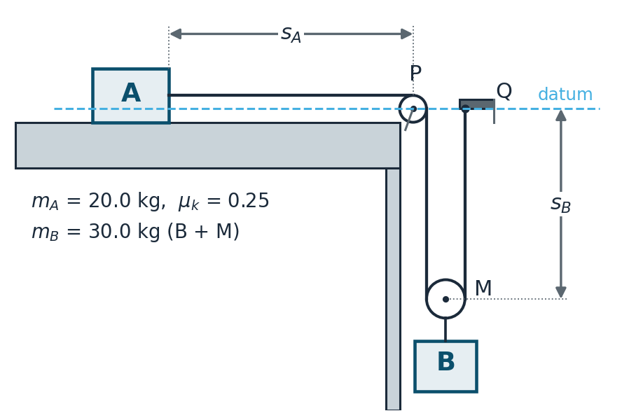
Figure S3 · Side view of the loading dock: crate A, fixed pulley P, movable pulley M carrying load B, fixed anchor Q; datum through P and Q.
S3-1 · The constraint (2 pts)
Write the constant-length relation for the cable in terms of s_{A} and s_{B}, and the acceleration relation it implies.
S3-1.length
Length relation: ________ = constant
S3-1.accel
Acceleration relation:

S3-2 · Equations of motion (3 pts)
From here on, let a_{A} be the crate's acceleration measured toward P and a_{B} the load's acceleration measured downward; T is the cable tension. Which pair of equations is correct?
A. Crate: T − μ_{k}m_{A}g = m_{A}a_{A} · Load: m_{B}g − 2T = m_{B}a_{B}
B. Crate: T − μ_{k}m_{A}g = m_{A}a_{A} · Load: m_{B}g − T = m_{B}a_{B}
C. Crate: T + μ_{k}m_{A}g = m_{A}a_{A} · Load: m_{B}g − 2T = m_{B}a_{B}
D. Crate: T − μ_{k}m_{A}g = m_{A}a_{A} · Load: 2T = m_{B}g
E. Crate: T − μ_{k}m_{B}g = m_{A}a_{A} · Load: m_{B}g − 2T = m_{B}a_{B}
S3-2
Your choice (A–E)

S3-3 · The accelerations (3 pts)
S3-3.eq
Equation used (after combining):
S3-3.res.a_B
a_{B} (m/s², downward)
S3-3.res.a_A
a_{A} (m/s², toward P)

S3-4 · The tension (3 pts)
S3-4.eq
Equation used:
S3-4.res
Result: T (N)

S3-5 · Faster than free fall? (3 pts)
A colleague claims that nothing in this system can ever accelerate faster than g. Replace the crate with a lighter one, m_{A} = 5.00 kg (everything else unchanged), compute a_{A}, and respond to the claim in one sentence.
S3-5.res
a_{A} with m_{A} = 5.00 kg (m/s²)
S3-5.sentence
Response to the claim (one sentence)

Scenario 4 — A slider on a rotating arm
S4-1 to S4-4 · 14 points · ≈ 15 min
A horizontal arm of an inspection fixture rotates about a fixed vertical axis through O. Its angle, measured counter-clockwise from a fixed reference line, is θ = 0.20t² (θ in radians, t in seconds). A 2.50 kg slider moves along a smooth radial slot in the arm, driven by an actuator along the slot so that r = 0.40 + 0.20t (r in metres from O). The motion is in a horizontal plane; weight and the vertical support force balance and do not enter the planar equations.
Consider the instant t = 2.00 s. Use polar coordinates with origin O: û_{r} from O toward the slider, û_{θ} perpendicular to it in the direction of increasing θ.
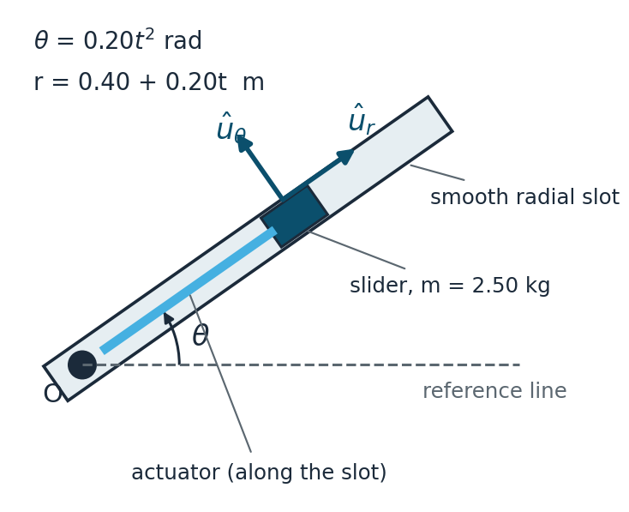
Figure S4 · Plan view of the rotating arm, radial slot and slider; θ measured counter-clockwise from the fixed reference line.
S4-1 · Which terms are present? (2 pts)
At t = 2.00 s, which of the four polar acceleration terms r̈, −rθ̇², rθ̈ and 2ṙθ̇ are non-zero?
A. $Only -r\dot{θ}²$
B. $-r\dot{θ}², r\ddot{θ} and 2\dot{r}\dot{θ}$
C. All four
D. Only $r\ddot{θ} and 2\dot{r}\dot{θ}$; the radial acceleration is zero because $r̈ = 0$
E. Only $-r\dot{θ}² and rθ̈$
S4-1
Your choice (A–E)

S4-2 · Acceleration components (4 pts)
S4-2.eq
Equations used: a_{r} = ________ , a_{θ} = __________
S4-2.res.a_r
a_{r} (m/s²)
S4-2.res.a_theta
a_{θ} (m/s²)

S4-3 · Forces on the slider (4 pts)
Find the radial and transverse components of the horizontal force on the slider, and name which part of the fixture supplies each.
S4-3.eq
Equations used:
S4-3.res.F_r
F_{r} (N)
S4-3.res.F_theta
F_{θ} (N)
S4-3.sources
Supplied by (F_{r} / F_{θ})

S4-4 · Clamping the slider (4 pts)
At t = 2.00 s the actuator stops and clamps the slider at r = 0.80 m, while the arm continues with the same θ̇ and θ̈ at that instant. Find the new transverse force on the slider and, in one sentence, explain which acceleration term's load has disappeared and why.
S4-4.res
F_{θ} with the slider clamped (N)
S4-4.sentence
Explanation (one sentence)

Reading your results
Mark each response you missed, then use the table to find the chapter Part to revisit. Rework missed items first without help; then use an AI tutor that gives hints rather than answers.
Response IDs | Revisit
A01–A03, B01 | Chapter 1 — rectilinear kinematics, graphs, constant acceleration
A06, B02 | Chapter 1–2 — displacement, distance, average velocity and speed
A04, S2-1, S2-2 | Chapter 2 Part 4 — normal–tangential kinematics
A05, S1-1 to S1-4 | Chapter 2 Part 3 — projectile motion
A07, B04 | Chapter 2 Parts 2 and 6 — Cartesian description and choosing a description
B03, S3-1 | Chapter 2 Part 7 — relative and constrained motion
S4-1, S4-2 | Chapter 2 Part 5 — polar kinematics
A08, A09, B05, B06 | Chapter 3 Parts 1–3 — free-body diagrams, friction, Cartesian kinetics
S3-2 to S3-5 | Chapter 3 Part 4 — connected particles
S2-3, S2-4 | Chapter 3 Part 5 — normal–tangential kinetics and contact
S4-3, S4-4 | Chapter 3 Part 6 — polar kinetics
A10, S1-5 | Chapter 3 Part 7 — model adequacy

The goal is not 100 points. The goal is to be able to say: “Given a moving machine, I can choose the description, draw the right diagram, compute what matters, and decide whether I believe the answer.”
AI assists. The engineer observes, models, validates, decides, and approves.

