AI AUGMENTED ENGINEERING DYNAMICS · CHAPTER 4 · PARTS 1–7  Engineering Homework 4  Work and Energy — Forces That Work, Rates of Work, Stored Energy, and Choosing a Method  Model it › calculate it › interpret it › validate it  Suggested assessment · 100 points · target effort ≈ 3.5 hours (4 hours maximum) · type your answers directly into this document | 
Taner Onsay, Ph.D. · © 2026 AI First Engineering
AI IS ALLOWED AND ENCOURAGED — AS AN ASSISTANT
AI may help you check an equation, rearrange algebra, or argue with your reasoning. The free-body diagrams you draw, the assumptions you state, the numbers you substitute, the validation you perform and the engineering conclusions you sign are YOUR OWN work. Assessment rewards evidence, reasoning and validation — not polished prose, and not length.
Every problem follows the same four steps: MODEL → CALCULATE → INTERPRET → VALIDATE. A validation that only repeats your first calculation earns nothing; an independent check that exposes your own error, honestly corrected, earns full credit.

NOTATION — THE COURSE STANDARD, USED THROUGHOUT
Scalars are italic; vectors carry an arrow; unit vectors carry a hat. Speed is written v_{sp} and never as a bare v. U is work, T kinetic energy, V potential energy (V_{g} gravitational, V_{spr} spring) and W is always weight, never work. N is a normal-reaction magnitude, F_{k} = μ_{k} N a kinetic-friction magnitude, F_{c} a cable-force magnitude, P a power and η an efficiency. ρ is the radius of curvature and û_{n} points toward the centre of curvature. For a spring, x is the signed deformation from the undeformed length and δ > 0 the compression magnitude, so x = −δ during compression.

$$T_{1} + U_{1→2}^{net}= T_{2}$$
$$T_{1} + V_{1} + U_{1→2}^{nc} = T_{2} + V_{2}$$
$$U_{1→2}^{}= \int{F_{t}}ds P = \vec{F}· \vec{v} η = P_{out}/P_in$$
$$Vg = m g y Vspr = ½ k x^{2} Σ \vec{F}=m \vec{a} a_{n} = v_{sp}^{2}/ρ$$
Use $g = 9.81 m/s²$ throughout. Report three significant figures unless a question says otherwise; carry more digits in intermediate steps.
PROBLEM A · Crate on a Rough Incline (25 points · ≈ 45 min)
Four forces act; four works add up to one change in speed. Then a second method checks the first.
A 25.0 kg crate is pulled uphill along a straight ramp inclined at 25° to the horizontal. A cable pulls on the crate with a constant force of 180 N, parallel to the ramp and directed uphill. The crate is already sliding uphill at 1.50 m/s when it passes position 1. Consider its motion over the next 3.00 m up the ramp, to position 2. The coefficient of kinetic friction between the crate and the ramp is μ_{k} = 0.20.
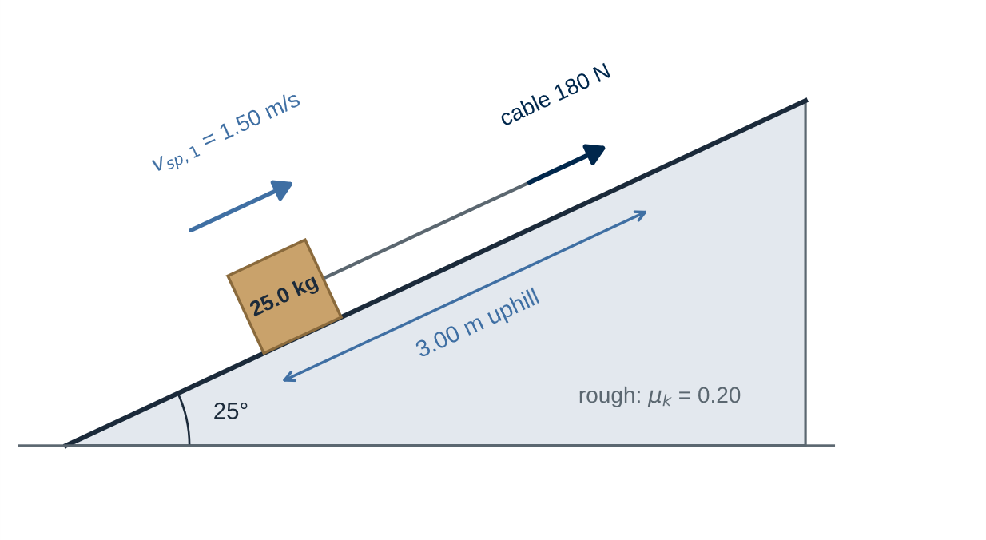
Figure A · Crate pulled up a rough 25° ramp. Geometry and given data only — no forces are drawn for you.
MODEL ASSUMPTIONS — STATED, AND MEANT
The crate is a particle. The ramp is straight and fixed. The cable force is constant in magnitude and stays parallel to the ramp. The crate is sliding uphill throughout the 3.00 m, so the friction is kinetic — this is a sliding problem, not an impending-motion problem. Air resistance is neglected.

A.1 MODEL — the system and its forces. (6 points)
1. Draw the free-body diagram of the crate while it slides uphill. Choose and show your coordinate axes. Label every force with a source you can name.
2. Determine the normal reaction N and the kinetic-friction force F_{k}. State the direction of the friction force and the reason for that direction.
SKETCH AND ANSWER A.1: free-body diagram with axes · a photograph of a clear hand sketch is fine

A.2 CALCULATE — work, then speed. (9 points)
1. Determine the work done on the crate between positions 1 and 2 by the cable, by gravity, by friction and by the normal reaction. Give each with its sign.
2. Determine the net-work and the crate's speed at position 2 (using the work–energy principle).
ANSWER A.2 (equations, substitutions, results):

A.3 INTERPRET — what each sign means. (4 points)
1. For each of the four forces, explain in one sentence what the sign of its work means physically.
2. The normal reaction acts on the crate throughout the 3.00 m. Explain why it does no work here.
ANSWER A.3:

A.4 VALIDATE — a second, independent method. (6 points)
1. Without using any work or energy, apply $Σ\vec{F}=m\vec{a}$along the ramp to find the acceleration, then use constant-acceleration kinematics to find the speed at position 2. Compare with A.2.
2. State the condition that makes constant-acceleration kinematics legitimate in this problem, and check that it holds.
ANSWER A.4:

PROBLEM B · Electric Hoist: Work, Power, and Efficiency (25 points · ≈ 45 min)
The same lift, described as work, as a rate of work, and as electrical energy bought.
An electric hoist lifts a 150 kg load vertically through 8.00 m. The load starts from rest and accelerates uniformly upward at 0.50 m/s² for 2.00 s. It then continues upward at the constant speed it has reached until the full 8.00 m has been covered. The overall efficiency of the hoist — mechanical energy delivered to the load by the cable, divided by electrical energy drawn — is 80 %.
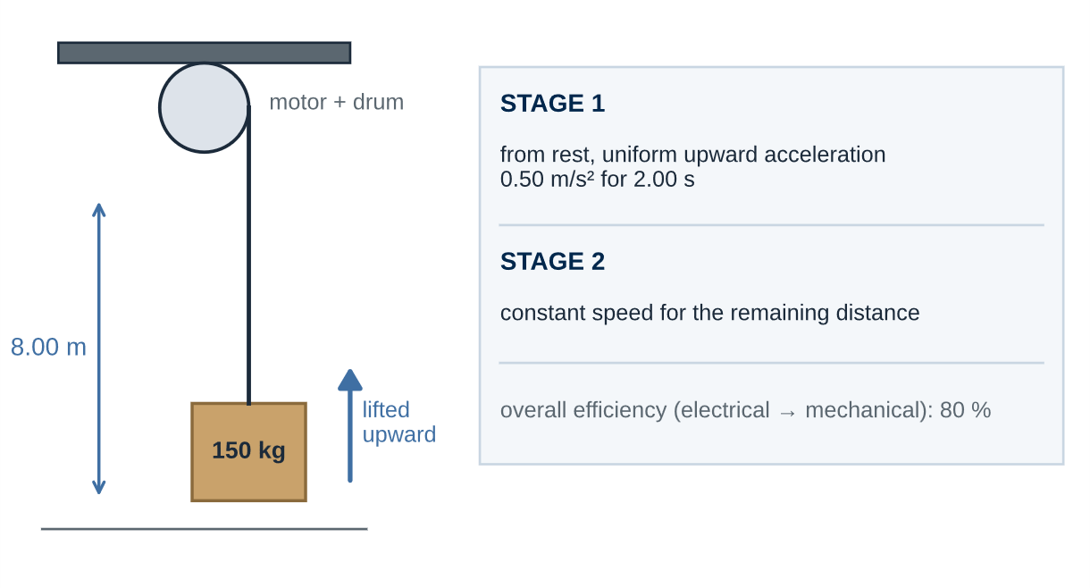
Figure B · Vertical hoist and its two-stage motion. Geometry and given data only.
MODEL ASSUMPTIONS — STATED, AND MEANT
The load is a particle. The cable is vertical, massless and inextensible. Air resistance is neglected. The change from stage 1 to stage 2 is instantaneous. The 80 % overall efficiency applies throughout the lift.

B.1 MODEL — the two stages. (6 points)
1. Draw the free-body diagram of the load. State what is different about the force balance in the two stages.
2. Use kinematics to find the speed at the end of stage 1, the distance covered in each stage, and the duration of each stage.
SKETCH AND ANSWER B.1:

B.2 CALCULATE — forces, work, power, electrical input. (9 points)
1. Determine the cable force during each stage.
2. Determine the mechanical work done by the cable during each stage, and the total.
3. Determine the instantaneous mechanical power delivered by the cable immediately before the acceleration stage ends.
4. Determine the total electrical input energy and the average electrical input power over the whole lift.
ANSWER B.2 (equations, substitutions, results):

B.3 INTERPRET — three different quantities. (5 points)
1. Explain the difference between the instantaneous mechanical power, the average electrical input power and the efficiency. Which of them would you use to size the motor, and which to estimate the energy bill?
2. Explain why B.2.3 specifies the instant immediately before the acceleration stage ends. What happens to the instantaneous mechanical power at that instant?
ANSWER B.3:

B.4 VALIDATE — an energy balance. (5 points)
Show that your total cable work equals the increase in the load's gravitational potential energy plus its final kinetic energy. State what this check confirms and what it cannot confirm.
ANSWER B.4:

PROBLEM C · Vehicle on a Smooth Valley-and-Crest Track (25 points · ≈ 60 min)
Energy finds the speeds. Only the normal-direction force equation finds the reactions — and the limit.
A 600 kg vehicle is idealized as a particle constrained to follow a fixed, smooth track. It starts from rest at A, which is 1.80 m above the lowest point B. The track is concave upward at B, where its radius of curvature is 2.00 m. The track then rises to a convex crest C, 1.20 m above B, where its radius of curvature is 1.50 m. The tangent to the track is horizontal at B and at C.
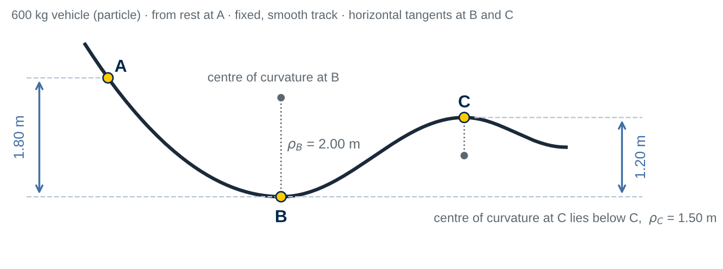
Figure C · Valley-and-crest track profile, with the directions of the centres of curvature at B and C. Not to scale.
MODEL ASSUMPTIONS — STATED, AND MEANT
The vehicle is a particle that follows the track while it remains in contact. The track is fixed and smooth: there is no friction, rolling resistance or air resistance, and no drive or braking force. Uniform gravity.

C.1 MODEL — what is conserved, and which way is normal. (5 points)
1. State the conditions under which the vehicle's mechanical energy is conserved between A, B and C, and explain why the normal reaction does not prevent conservation.
2. Draw the free-body diagram of the vehicle at B and at C. On each, show the direction of û_{n} and explain why it points that way at each point.
SKETCH AND ANSWER C.1:

C.2 CALCULATE — speeds and reactions. (9 points)
1. Use conservation of mechanical energy to find the speeds at B and at C.
2. Use the normal-direction force equation to find the normal reaction at B and at C.
ANSWER C.2 (equations, substitutions, results):

C.3 INTERPRET — what the reactions mean. (5 points)
1. Compare the normal reaction at B with the vehicle's weight and explain physically why they differ.
2. Compare the normal reaction at C with the weight. Does the vehicle remain in contact at the top of the crest? State the condition you used.
ANSWER C.3:

C.4 VALIDATE — the contact limit and its limitations. (6 points)
1. Keeping A, B and ρ_{C} unchanged, find the minimum elevation of the crest above B for which the contact condition at the top of C is satisfied. Does the proposed 1.20 m satisfy it?
2. State the limitations of this result. What does the contact condition at C establish, and what does it not establish?
ANSWER C.4:

PROBLEM D · Spring-Powered Safety Bumper (25 points · ≈ 50 min)
Stored energy, dissipated energy, and an acceleration that energy alone cannot give.
A 5.00 kg cart travels along a horizontal surface at 3.00 m/s and contacts an initially undeformed spring bumper of stiffness k = 800 N/m. The coefficient of kinetic friction between the cart and the surface is μ_{k} = 0.15. The spring is linear and massless.
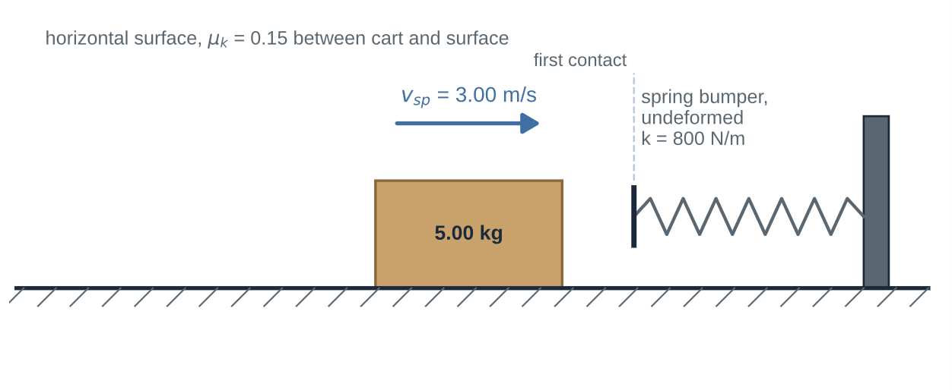
Figure D · Cart approaching the spring bumper. Geometry and given data only.
MODEL ASSUMPTIONS — STATED, AND MEANT
The cart is a particle that slides on the surface, so kinetic friction acts on it throughout the compression. The spring is horizontal and is undeformed at first contact; the cart is not attached to it. Use x for the signed spring deformation and δ > 0 for the compression magnitude, with x = −δ during compression. Take positive in the cart's original direction of travel.

D.1 MODEL — the cart during compression. (5 points)
Draw the free-body diagram of the cart while it is compressing the spring and still moving in its original direction. Show your positive direction and label every force with its source.
SKETCH AND ANSWER D.1:

D.2 CALCULATE — compression, force, acceleration. (9 points)
1. Write the work–energy equation from first contact to maximum compression and solve it for the maximum compression δ_{max}. Report the corresponding signed deformation x.
2. Determine the maximum spring force.
3. Determine the cart's acceleration immediately before it reaches maximum compression, while it is still moving in its original direction. Give its sign and its magnitude.
ANSWER D.2 (equations, substitutions, results):

D.3 INTERPRET — stopped is not balanced. (5 points)
1. The cart's speed is zero at maximum compression. Explain why its acceleration is not zero there.
2. Explain why your D.2.3 result cannot be assumed to hold just after the cart begins to move back, even though the spring force has barely changed.
ANSWER D.3:

D.4 VALIDATE — account for every joule. (6 points)
1. Show that the cart's initial kinetic energy equals the spring energy stored at maximum compression plus the energy dissipated by friction.
2. Explain why constant-acceleration kinematics is inappropriate over the compression interval, and name the method that remains valid.
ANSWER D.4:

SUBMIT · Evidence Checklist and Human Review
Submit ONE completed Word document — this file — containing:
– free-body diagrams with axes and a stated positive direction — A.1, B.1, C.1, D.1;
– hand calculations with equations, substitutions, units and signs — A.2, B.2, C.2, D.2;
– interpretations in your own words — A.3, B.3, C.3, D.3;
– independent validations, each naming the check used — A.4, B.4, C.4, D.4;
– the human review statement below, signed and dated.
Keep every required answer inside this document rather than as separate image or screenshot files. Follow your instructor's submission and file-naming requirements.

HUMAN REVIEW (Problems A–D: 100 points)
“I reviewed the modelling decisions, free-body diagrams, calculations, validation checks and engineering conclusions in this submission and confirm that they represent the work I performed and reviewed.”
Human reviewed and approved: __________________________________
Student name: ______________________________ Date:
AI assists. Humans observe. Humans verify. Humans decide. Humans approve.

Suggested Assessment Rubric — 100 points
Used by the instructor and, where applicable, by an AI grading agent.
Criterion | What full credit looks like | Pts
A · Crate on a rough incline | FBD with N, F_{k}, W and cable; N and F_{k} (A.1: 6). Four works with signs, net work, speed by work–energy (A.2: 9). Meaning of each sign; why N does no work (A.3: 4). Independent force–acceleration check and the constant-acceleration condition (A.4: 6). | 25
B · Hoist | FBD and stage kinematics (B.1: 6). Cable forces, stage works, instantaneous power, electrical energy and average input power (B.2: 9). Power vs average input power vs efficiency; the instant (B.3: 5). Energy-balance validation and its limits (B.4: 5). | 25
C · Valley-and-crest track | Conservation conditions; FBDs with normal directions (C.1: 5). Speeds and both reactions (C.2: 9). Interpretation and local contact check (C.3: 5). Minimum crest elevation, correct design condition, stated limitations (C.4: 6). | 25
D · Spring bumper | FBD during compression (D.1: 5). Work–energy equation, δ_{max} and x, spring force, limiting acceleration with sign (D.2: 9). v_{sp} = 0 ≠ a = 0; friction direction (D.3: 5). Energy accounting and why constant-a kinematics fails (D.4: 6). | 25
TOTAL |  | 100

