ME345 ENGINEERING DYNAMICS · CHAPTER 4 · PARTS 1–7  Chapter 4 Self-Assessment  Work and Energy — Do I Understand This Well Enough to Move On?  Diagnostic · ungraded · organised by lecture Part so you know exactly what to review  12 items · ≈ 40 minutes · work at your own pace · no grade is recorded | 
Taner Onsay, Ph.D. · © 2026 AI First Engineering
AI TUTOR MODE — READ THIS FIRST
This is not a second homework assignment. It is shorter, faster and deliberately diagnostic: its output is not a score but a pattern — the Parts you own and the Parts you need to go back to.
Try each item yourself first. If you get stuck, AI may be used as a tutor, not as an answer machine. Instead of asking for the answer, try: “Do not solve this for me. Ask me one question, or give me one small hint at a time.”
Several items are written so that the plausible answer is the wrong one; getting one of those wrong is more useful than getting it right.

HOW TO USE IT
Work through a Part, then tick one of the four boxes at the end of it. Some items need a short calculation; others need a physical explanation in one or two sentences.
Items are marked by type: small calculation · short explanation · identify the error.
Notation: U work, T kinetic energy, V potential energy (V_{g}, V_{spr}), W weight, v_{sp} speed, x signed spring deformation. Use g = 9.81 m/s².

PART 1 · When Does a Force Do Work?
Work is the force component along the displacement, multiplied by the distance. Direction decides the sign — and sometimes decides that there is no work at all.
1. When does a force do no work? · small calculation · short explanation
A particle moves 4.0 m horizontally to the right. A constant 30 N force acts vertically upward.
Determine the work done by this force and explain why its magnitude alone does not determine the work.
ANSWER 1:

2. Can a force do negative work? · small calculation
A 50 N force acts at 120° to a particle's displacement of 3.0 m.
Determine its work and explain the sign.
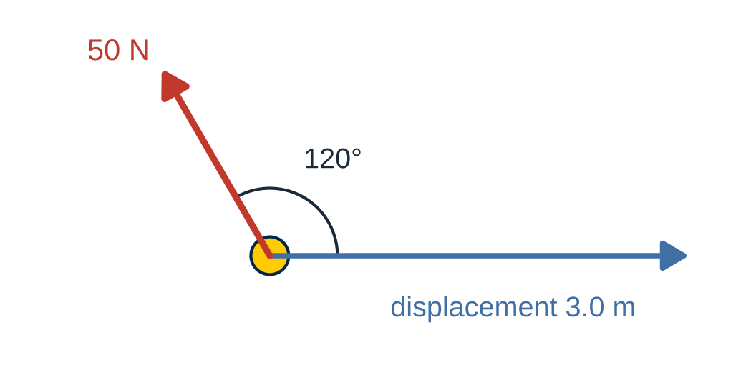
Item 2 · The force and the displacement.
ANSWER 2:

RATE YOURSELF on Part 1 before moving on.
□ I can do this independently. □ I can do this with a small AI hint. □ I need substantial AI help. □ I still need human or instructor help.

PART 2 · How Does Work Change Motion?
Net work changes kinetic energy. Kinetic energy grows with the square of the speed, and that square has consequences.
3. What does net work change? · small calculation
A 4.0 kg cart initially moves at 2.0 m/s. The net work done on it is +24 J.
Determine its final speed.
ANSWER 3:

4. Does mass matter? · short explanation
Two carts, one of mass m and the other 2m, start from rest. The same net work U > 0 is done on each.
Which cart has the greater final speed, and by what factor?
ANSWER 4:

RATE YOURSELF on Part 2 before moving on.
□ I can do this independently. □ I can do this with a small AI hint. □ I need substantial AI help. □ I still need human or instructor help.

PART 3 · Work of Common Forces
Gravity and springs do work you can write down without integrating every time — if you keep track of positions and signs.
5. Gravity and path independence · small calculation · short explanation
A 3.0 kg package moves from a platform at elevation 2.0 m to another at elevation 0.5 m.
Calculate the work done by gravity. Does the answer depend on the path taken?
ANSWER 5:

6. Work of a spring force · small calculation
A spring of stiffness k = 500 N/m changes from 0.10 m compression to 0.04 m compression.
Determine the work done by the spring.
ANSWER 6:

RATE YOURSELF on Part 3 before moving on.
□ I can do this independently. □ I can do this with a small AI hint. □ I need substantial AI help. □ I still need human or instructor help.

PART 4 · How Fast Is Work Done?
The same work, done at different rates.
7. Work versus power · small calculation
Two identical motors each perform 1200 J of mechanical work. Motor A takes 3.0 s; Motor B takes 6.0 s.
Which produces greater average mechanical power? By what factor?
ANSWER 7:

RATE YOURSELF on Part 4 before moving on.
□ I can do this independently. □ I can do this with a small AI hint. □ I need substantial AI help. □ I still need human or instructor help.

PART 5 · Where Is the Energy Stored?
Potential energy depends on a reference; changes in it do not.
8. Does potential energy depend on the datum? · short explanation · small calculation
A 2.0 kg object rises vertically by 3.0 m.
Student A chooses the initial elevation as y = 0. Student B chooses a datum 10 m below the initial elevation.
Will they calculate the same change in gravitational potential energy?
ANSWER 8:

9. Where is spring potential energy smallest? · short explanation
An ideal linear spring has signed deformation x. Compare its potential energy at:
– x = −0.05 m,
– x = 0,
– x = +0.05 m.
ANSWER 9:

RATE YOURSELF on Part 5 before moving on.
□ I can do this independently. □ I can do this with a small AI hint. □ I need substantial AI help. □ I still need human or instructor help.

PART 6 · When Does Mechanical Energy Stay Constant?
Conservation of mechanical energy is a special case, with a condition.
10. Can mechanical energy be conserved when friction acts? · identify the error
A box slides on a rough horizontal surface and slows down.
A student claims that mechanical energy is conserved because the box's gravitational potential energy does not change.
Is the claim correct? Explain using the energy equation.
ANSWER 10:

RATE YOURSELF on Part 6 before moving on.
□ I can do this independently. □ I can do this with a small AI hint. □ I need substantial AI help. □ I still need human or instructor help.

PART 7 · Choosing Between Force–Acceleration and Energy Methods
What the energy equation tells you — and what it cannot.
11. Can energy determine a normal reaction? · identify the error · small calculation
A 2.0 kg slider starts from rest and descends 1.00 m along a smooth fixed track. At the lowest point, the radius of curvature is 2.00 m.
A student calculates the speed using energy and concludes that the normal reaction must equal the weight because the normal reaction does no work.
Is that conclusion correct? Determine the actual normal reaction.
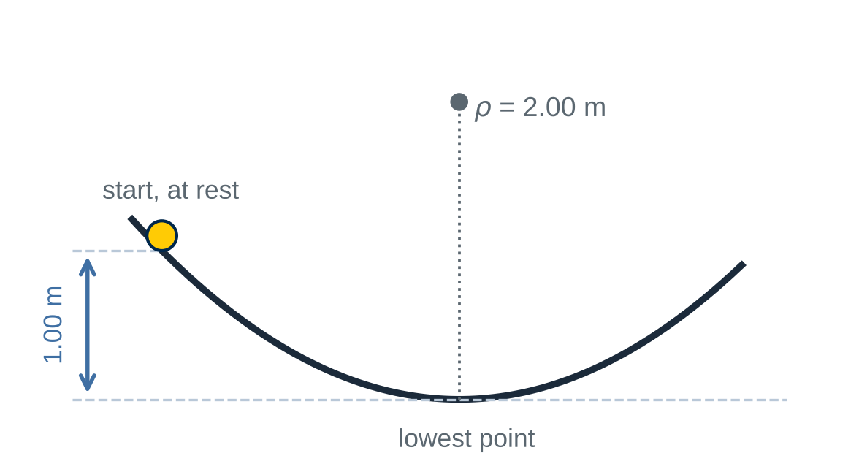
Item 11 · Smooth fixed track; the lowest point is 1.00 m below the start.
ANSWER 11:

12. Does zero speed mean zero acceleration? · identify the error
A cart compresses a spring and momentarily stops at maximum compression. The spring is still compressed.
A student writes:
“Since the speed is zero, acceleration must also be zero.”
Explain why this reasoning is incorrect. Identify the governing equation needed to determine acceleration.
ANSWER 12:

RATE YOURSELF on Part 7 before moving on.
□ I can do this independently. □ I can do this with a small AI hint. □ I need substantial AI help. □ I still need human or instructor help.

READING YOUR RESULTS
The output of this document is a pattern, not a score.
If your ratings look like this | Then do this
mostly “independently” across all seven Parts | You own Chapter 4. Move forward.
“small AI hint” clustered in one Part | That Part is your review target. Retry those items later without AI before you decide you have fixed it.
“substantial AI help” in a Part | Return to that lecture Part and rework its worked example before retrying: Part 1 → items 1–2 · Part 2 → 3–4 · Part 3 → 5–6 · Part 4 → 7 · Part 5 → 8–9 · Part 6 → 10 · Part 7 → 11–12.
any “human or instructor help” | Bring those exact item numbers to class or office hours. That is what they are for.

THE GOAL IS NOT 12 CORRECT ANSWERS.
The goal is to be able to say: “given a machine, I can decide which forces do work, account for where the energy goes, choose the equation that answers the question, and say whether I believe the answer — without outsourcing the judgement.”
AI assists. The engineer observes, models, validates, decides, and approves.

