FUNDAMENTALS OF AI-AUGMENTED ENGINEERING  CHAPTER 8 / HOMEWORK 8  Engineering Homework  Five Systems, One Method — Coupled Linear Models  Formulate It · Solve It · Change It · Break It · Design It · A Solved Matrix Is Not a Validated Model  Suggested Assessment · 20 points  target effort ≈ 180–240 minutes · type all answers and paste the required screenshots directly into this document | 
Taner Onsay, Ph.D. & Sebnem Onsay · © 2026 AI First Engineering ·
AI use is allowed and encouraged — as an Engineering Analyst that may turn your pseudocode into MATLAB (THINK › PSEUDOCODE › AI › CODE). But every prediction must be committed in writing before you compute, every governing equation and every matrix entry must be derived and checked by you, every screenshot must show YOUR OWN MATLAB session running on your computer — not an AI transcript — and every AI claim you record must carry your own ACCEPT / MODIFY / REJECT verdict. Any capable AI assistant is acceptable; none is required. Assessment rewards formulation + verification + validation, not polished prose.

THE ENGINEERING CONTEXT — five systems, one method
Two tanks exchanging a dissolved chemical. A resistor network whose design changes. A rigid beam hanging from three cables. An AI's circuit model that looks perfect. A heat-generating module that must stay cool. Different physics — one engineering move: write ONE conservation or equilibrium statement per unknown, collect the statements into A x = b, solve, then ask two separate questions.
Did the computer solve the equations I wrote? That is VERIFICATION — the numerical residual r = A·x − b answers it. Do the equations I wrote describe the real system? That is VALIDATION — only physics, independent checks and evidence answer it. A solved matrix is not a validated model.
PROBLEM › MODEL › COMPUTE › ANALYZE › VALIDATE › IMPROVE — in every problem.

THE MATLAB PATTERN — provided; the physics is yours
Every problem uses the same five lines. The numbers inside A and b are the engineering — this pattern gives you none of them.
% ProblemN.m — Chapter 8 pattern (fill in from YOUR derivation)
A = [ ... ]; % coefficients — write the units in a comment
b = [ ... ]; % known terms — write the units in a comment
x = A\b % solve by elimination — do not use inv(A)*b
r = A*x - b % numerical residual: checks the arithmetic, not the physics
Time guide: Problem 1 ≈ 25 min · Problem 2 ≈ 30 min · Problem 3 ≈ 25 min · Problem 4 ≈ 20 min · Problem 5 ≈ 30 min · Submit ≈ 5 min. If you are far past 150 minutes, submit what you have with honest notes — do not expand the assignment.

PROBLEM 1 · Two Tanks, One Connected System (≈ 25 min)
A treatment line uses two well-mixed tanks connected in both directions. Feed 1 brings a dissolved chemical into Tank 1; Feed 2 brings clean water into Tank 2; the tanks exchange water through a forward pipe and a return pipe; Tank 2 discharges to the next stage. The process has run long enough to be at steady state. The concentrations in the two tanks are unknown — and each one depends on the other.
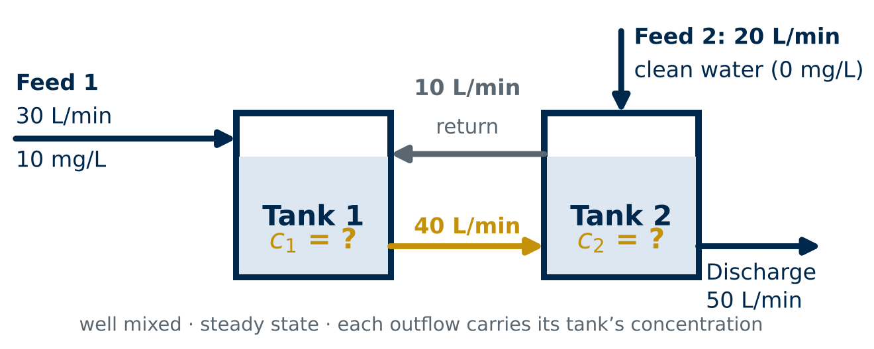
Figure 1: Two well-mixed tanks at steady state. Flow rates and the feed concentration are given; c₁ and c₂ (mg/L) are the unknowns. Each stream leaving a tank carries that tank's concentration.
Stream | Flow rate | Concentration | From → To
Feed 1 | 30 L/min | 10 mg/L | outside → Tank 1
Feed 2 | 20 L/min | 0 mg/L (clean) | outside → Tank 2
Forward transfer | 40 L/min | c₁ | Tank 1 → Tank 2
Return | 10 L/min | c₂ | Tank 2 → Tank 1
Discharge | 50 L/min | c₂ | Tank 2 → outside

1a — Predict First. Before writing any equation, commit — and give one physical reason for each. Wrong is fine; uncommitted is not. Do not edit these later.
P1: c₁ is ABOVE ☐ BELOW ☐ EQUAL TO ☐ the 10 mg/L feed, because ____________________
P2: c₂ is ABOVE ☐ BELOW ☐ EQUAL TO ☐ c₁, because ____________________
1b — Water First. A solute balance is meaningless if the water does not balance. Complete the table and say in one sentence why the water balance must close before any concentration can be trusted.
Control volume | Water in (L/min) | Water out (L/min) | Balanced?
Tank 1 |  |  | YES ☐ NO ☐
Tank 2 |  |  | YES ☐ NO ☐
Whole system |  |  | YES ☐ NO ☐
WHY:
1c — One Balance per Unknown. Define the unknowns with units. Write the steady-state solute balance for each tank in words first (rate in = rate out), then with symbols and numbers. State the units of every term.
ANSWER 1c:

1d — Assemble A x = b. Rearrange your two balances into A x = b with x = [c₁; c₂]. Write A and b, state the units of the entries of A and of b, and explain physically what the SIGN of each off-diagonal coefficient says about how one tank affects the other.
ANSWER 1d:

1e — Solve and Verify the Arithmetic. Solve with the MATLAB pattern and compute the numerical residual. Paste ONE screenshot showing your code and the Command Window output.
PASTE MATLAB CODE + COMMAND WINDOW SCREENSHOT HERE
(click here and paste your screenshot — Ctrl+V / Cmd+V)

1e: c₁ = ________ mg/L c₂ = ________ mg/L r = [ ______ ; ______ ] ______
1f — Verify the Physics: Conservation. A residual checks your equations, not the plant. Check the whole system independently: compute the solute entering with the feeds and the solute leaving with the discharge (mg/min). Does it close? Then reconcile your 1a predictions.
1f: solute in = ________ mg/min solute out = ________ mg/min closes? YES ☐ NO ☐
RECONCILE P1, P2:

1g — Not Every Coupling Is Symmetric. Is your A symmetric? The Chapter 8 circuit matrices were. Explain in two sentences what is physically different about a pipe carrying flow and a resistor carrying current that makes this matrix symmetric or not.
ANSWER 1g:

PROBLEM 2 · The Circuit That Changes (≈ 30 min)
A sensor interface is a two-node resistor network powered by a 6 V regulated supply. The designer first uses R4 = 3 kΩ, then considers replacing it with R4 = 6 kΩ. Before anyone solders anything, the node voltages must be predicted — and the change must be understood, not just computed.
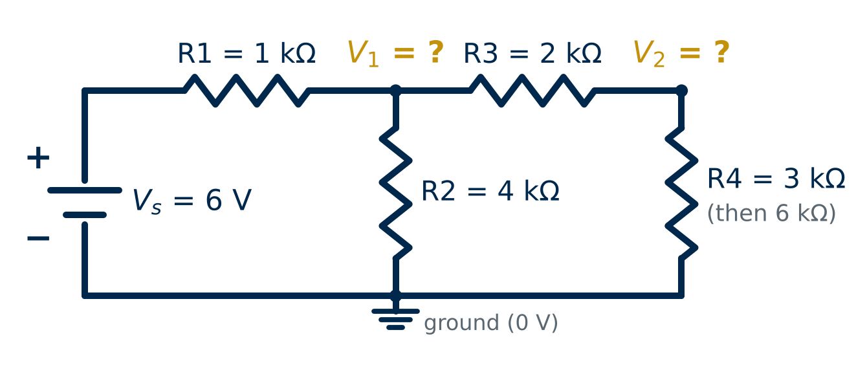
Figure 2: The two-node network. R1 joins the supply to node V₁; R2 joins V₁ to ground; R3 joins V₁ to V₂; R4 joins V₂ to ground. V₁ and V₂ are measured from ground.
Quantity | Symbol | Value | Units
Supply voltage | V_s | 6 | V
Supply → node 1 | R1 | 1 | kΩ
Node 1 → ground | R2 | 4 | kΩ
Node 1 → node 2 | R3 | 2 | kΩ
Node 2 → ground | R4 | 3, then 6 | kΩ
Units that work together: V · kΩ · mS (= 1/kΩ) · mA. Convention: at each unknown node, the currents defined as LEAVING the node sum to zero.
2a — KCL at Both Nodes. Write Kirchhoff's Current Law at V₁ and at V₂, one current per resistor, using the leaving convention. Use conductances G = 1/R in mS.
ANSWER 2a:

2b — The Matrix and Its Checks. Collect your equations into A x = b with x = [V₁; V₂] for R4 = 3 kΩ. Then check two properties of A against the circuit: is it symmetric, and does each diagonal entry equal the sum of the conductances touching that node? Say what each check would catch.
ANSWER 2b:

2c — Solve by Hand, Then by MATLAB. Solve the 2 × 2 system by hand with Gauss–Jordan elimination — show each row operation (exact fractions or 4 significant figures). Then confirm with A\b and report the residual.
HAND WORK 2c:

2c: hand V₁ = ________ V V₂ = ________ V MATLAB V₁ = ________ V V₂ = ________ V r = ________
2d — Predict the Change. R4 is about to become 6 kΩ. Before computing: which entries of A and b change? Will V₂ rise or fall? Will V₁ move at all — and which node changes more? Commit with one physical reason.
P3: entries that change: ________ V₂ RISES ☐ FALLS ☐ V₁ RISES ☐ FALLS ☐ UNCHANGED ☐ larger change at V₁ ☐ V₂ ☐
REASON P3:
2e — Recompute and Compare. Rebuild the model for R4 = 6 kΩ, solve, and complete the table. Was P3 right?
Quantity | R4 = 3 kΩ | R4 = 6 kΩ | Change
V₁ (V)
V₂ (V)
Current through R4 (mA)
Current through R1 (mA)

2f — Explain the Physics. R4 does not touch node 1, yet V₁ changed. Using the currents in your table, explain why — and why V₂ changed more than V₁. Two to four sentences; name the coupling element.
ANSWER 2f:

2g — Sensitivity Is Not Uncertainty. Changing R4 from 3 to 6 kΩ is a design decision. A purchased 3 kΩ resistor is only guaranteed to ±1 %. Use your model to find how far V₂ moves when R4 = 3 kΩ increases by 1 %. Then explain the difference between this PARAMETER SENSITIVITY and the MEASUREMENT UNCERTAINTY of a meter that reads V₂ — which one does your model compute, and which one does it not?
ANSWER 2g:

2h — Evidence. Paste ONE screenshot showing your MATLAB code and output for 2c, 2e and 2g.
PASTE MATLAB CODE + COMMAND WINDOW SCREENSHOT HERE
(click here and paste your screenshot — Ctrl+V / Cmd+V)

PROBLEM 3 · Three Supports, Three Unknown Forces (≈ 25 min)
A rigid, horizontal beam is hung from a ceiling by three vertical cables at x = 0, 2 and 5 m. A 900 N piece of equipment is fixed to the beam at x = 7/3 m. The beam's own weight is neglected. The installer needs the tension in every cable to choose cable sizes.
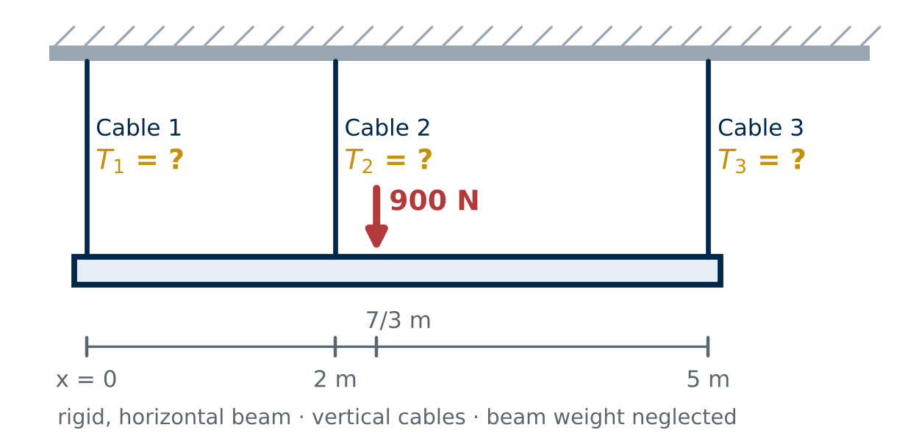
Figure 3: Rigid beam on three vertical cables (x = 0, 2, 5 m) with a 900 N downward load at x = 7/3 m. T₁, T₂, T₃ (N) are the unknown cable tensions.
3a — Count Before You Compute. Draw a free-body diagram of the beam (paste a photo or sketch, or describe it in words). How many unknown forces are there, and how many independent equilibrium equations does statics give for parallel vertical forces in a plane? What does that mismatch mean?
ANSWER 3a:

3b — The Third Condition. The cables are installed and tensioned so that Cable 2 carries exactly twice the tension of Cable 1: T₂ = 2·T₁. Is this an equilibrium equation? Explain where a condition like this comes from physically and why the problem needs it.
ANSWER 3b:

3c — Build the 3 × 3 System. Write the vertical force balance, the moment balance about x = 0 (state your sign convention), and the load-sharing condition. Assemble A x = b with x = [T₁; T₂; T₃] and give the units of each row.
ANSWER 3c:

3d — Solve and Verify the Arithmetic. Solve with MATLAB and compute the residual.
3d: T₁ = ________ N T₂ = ________ N
T₃ = ________ N max |r| = ________
Since the matrix rows have different physical units: force, moment, and the additional force constraint. Consequently, max(|r|) combines unlike units and should not be interpreted as a single physical error magnitude.
3e — Verify Independently. Do not reuse the equations you solved. Check (i) the vertical force sum, (ii) the moment balance about a DIFFERENT point — x = 5 m — and (iii) that every tension is physically possible for a cable. Show the numbers.
ANSWER 3e:

3f — When the Matrix Says No. A teammate replaces T₂ = 2·T₁ with a third equilibrium equation: the moment balance about x = 5 m. Write that 3 × 3 system, run A\b, and record exactly what MATLAB reports. MATLAB may return a warning and a nonunique numerical result for the singular system; the exact output can depend on MATLAB version. Do not imply a particular output is universal. Explain physically why this system cannot determine the tensions.
ANSWER 3f:

3g — Evidence. Paste ONE screenshot showing your MATLAB code and output for 3d and 3f.
PASTE MATLAB CODE + COMMAND WINDOW SCREENSHOT HERE
(click here and paste your screenshot — Ctrl+V / Cmd+V)

PROBLEM 4 · A Perfect Residual, an Incorrect Circuit (≈ 20 min)
An AI assistant was asked to model the Problem 2 circuit with R4 = 3 kΩ. It returned the memo below. Its arithmetic is flawless — run it yourself if you doubt it. Something upstream of the arithmetic is not.
AI MODEL MEMO — verbatim
“Nodal model for the 6 V, two-node network (R1 = 1, R2 = 4, R3 = 2, R4 = 3 kΩ), in mS, V and mA:
A = [ 1.5 −0.5 ; −0.5 5/6 ] b = [ 6 ; 0 ]
MATLAB returns V = A\b = [ 5.0000 ; 3.0000 ] V with residual r = A·V − b = [ 0 ; 0 ] mA. The model is verified to machine precision; the node voltages are certified.”

4a — Reproduce the AI's Run. Solve the AI's system yourself (by hand or in MATLAB) and compute its residual. Do you get the same numbers?
4a: V₁ = ________ V V₂ = ________ V r(AI model) = [ ________ ; ________ ] mA
4b — Cross-Examine with the Physics. Put the AI's voltages into YOUR correct Problem 2 model: compute r = A_correct · V_AI − b. What is the physical meaning of each entry of this residual, in mA?
4b: r(correct model) = [ ________ ; ________ ] mA
MEANING:

4c — Find the Missing Component. Which entry of the AI's A is wrong, which component did the AI omit, and how does the SIZE of the 4b residual confirm your diagnosis? Show the one-line calculation.
ANSWER 4c:

4d — Physical Reasonableness. Without any matrix: if V₁ = 5 V and V₂ = 3 V, how much current flows through R1, through R3 and through R2? Does the current balance at node 1? Compare with your Problem 2 answer.
ANSWER 4d:

4e — Verification Is Not Validation. In three or four sentences: why did a zero residual fail to detect this error, what exactly did the AI verify, and what did it never test? Name TWO checks — outside the solve — that would have caught it.
ANSWER 4e:

4f — Verdict on the Memo. One check, one or two sentences.
ACCEPT ☐ MODIFY ☐ REJECT ☐
WHY:

PROBLEM 5 · Design a Thermal Network (≈ 30 min)
A power module (node 1) generates 60 W. Heat leaves node 1 to the ambient air through a conductance G₁ and flows to a temperature-sensitive sensor housing (node 2) through G₁₂. The housing loses heat to ambient through a heat sink of conductance G₂. The heat sink is bought from a catalog: G₂ = 1, 2, 3 or 4 W/K — larger is heavier and more expensive. Requirement: the housing must stay at or below 30 °C. Choose the smallest heat sink that meets it.
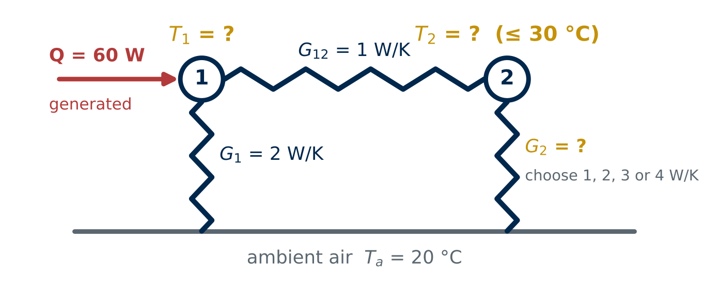
Figure 5: Steady-state thermal network. Heat flow through a conductance G (W/K) equals G times the temperature difference across it. T₁ and T₂ (°C) are unknown; G₂ is the design choice.
Quantity | Symbol | Value | Units
Ambient temperature | T_a | 20 | °C
Heat generated at node 1 | Q | 60 | W
Node 1 → ambient | G₁ | 2 | W/K
Node 1 → node 2 | G₁₂ | 1 | W/K
Node 2 → ambient (heat sink) | G₂ | 1, 2, 3 or 4 | W/K
Housing limit | T₂, max | 30 | °C
Same matrix, different physics: temperature ↔ voltage · heat flow (W) ↔ current · thermal conductance (W/K) ↔ electrical conductance. A difference of 1 K equals a difference of 1 °C.
5a — Predict First. Commit before computing: as G₂ increases, T₂ falls. Does T₁ fall too — by more or less than T₂? Which catalog value do you expect to be the smallest that meets 30 °C?
P4: T₁ falls MORE ☐ LESS ☐ NOT AT ALL ☐ than T₂ smallest passing G₂ ≈ ________ W/K
REASON P4:
5b — Energy Balance at Each Node. Write the steady-state energy balance at node 1 and at node 2 (heat leaving = heat generated), one term per conductance, with units.
ANSWER 5b:

5c — Assemble A x = b. Write A and b with x = [T₁; T₂] for a general G₂, with units. Which entries depend on the design choice? Note that ambient-temperature contributions must appear in the right-hand side. Compare the structure of A with your Problem 2 matrix.
ANSWER 5c:

5d — Solve Every Candidate. Write a short MATLAB loop over the four catalog values (THINK › PSEUDOCODE first — an AI may help with the loop syntax). Complete the table and paste ONE screenshot of code and output.
G₂ (W/K) | T₁ (°C) | T₂ (°C) | T₂ ≤ 30 °C? | max |r| (W)
1 |  |  | YES ☐ NO ☐
2 |  |  | YES ☐ NO ☐
3 |  |  | YES ☐ NO ☐
4 |  |  | YES ☐ NO ☐

PASTE MATLAB CODE + COMMAND WINDOW SCREENSHOT HERE
(click here and paste your screenshot — Ctrl+V / Cmd+V)

5e — Choose and Justify. State the heat sink you select, its temperature margin to 30 °C, and why a smaller one fails. Reconcile P4.
ANSWER 5e:

5f — Verify Energy Conservation. For your selected design, compute the heat leaving to ambient through G₁ and through G₂. Do they add up to the 60 W generated? What would it mean if they did not, even with a tiny residual?
5f: through G₁ = ________ W through G₂ = ________ W total = ________ W (should be 60 W)
5g — How Robust Is the Choice? Catalog conductances are nominal. If the delivered heat sink is 10 % below its catalog G₂, does your design still meet the requirement? Then name TWO assumptions of this model that the computation cannot validate.
ANSWER 5g:

A SOLVED MATRIX IS NOT A VALIDATED MODEL.
Five systems — tanks, a circuit, a beam, an AI's model, a heat sink — and every one solved by the same line, A\b. In every one the residual was tiny, and in one of them the model was wrong. The computer answers the question you wrote; only conservation checks, independent equilibrium checks, physical reasonableness and, eventually, measurement tell you whether you wrote the right question. Carry the distinction into Chapter 9 and beyond: verification belongs to the computation, validation belongs to the engineer.

SUBMIT · Evidence Checklist & Human Review (≈ 5 min)
Submit ONE completed Word document — this file — containing all of the following:
☐ 1a predictions P1, P2 — unedited · 1b water table · 1c balances · 1d A, b with units and signs · 1e screenshot and values · 1f conservation and reconciliation · 1g symmetry
☐ 2a KCL · 2b matrix + checks · 2c hand Gauss–Jordan + MATLAB · 2d prediction P3 · 2e table · 2f physics · 2g sensitivity vs uncertainty · 2h screenshot
☐ 3a FBD and count · 3b the third condition · 3c system with units · 3d tensions · 3e independent checks · 3f the singular system · 3g screenshot
☐ 4a reproduced run · 4b cross-model residual and meaning · 4c missing component · 4d reasonableness · 4e verification vs validation · 4f verdict
☐ 5a prediction P4 · 5b energy balances · 5c A, b · 5d candidate table + screenshot · 5e selection · 5f energy check · 5g robustness and assumptions
☐ Human review statement signed and dated (below)

SUBMIT ONE COMPLETED HOMEWORK DOCUMENT
Keep all required evidence in this document rather than as separate MATLAB or image files. Separate .m files are welcome as optional attachments, but the document must stand on its own. If this homework is being used as part of a course, follow your instructor's submission and file-naming requirements.

HUMAN REVIEW
“I reviewed the predictions, derivations, matrices, code, screenshots and written responses in this submission and confirm that they represent the work I performed, that I can derive every entry of every matrix, and that I can say exactly what each residual does and does not establish.”
Human reviewed and approved: __________________________
Student name: __________________________ Date: ____________

Suggested Assessment Rubric — 20 points
Used by the instructor and, where applicable, by an AI grading agent. All required evidence must appear inside this document — the grader will not open separate MATLAB or image files. A submission whose matrices are solved correctly, but whose reasoning never separates verification from validation, cannot earn a high score.
Criterion | What full credit looks like | Pts
Problem 1 — Two tanks (1a–1g) | Predictions committed with reasons; water balance closed for both tanks and the system; one solute balance per tank with units; A (L/min) and b (mg/min) correct with the off-diagonal signs explained; MATLAB solution and residual; system conservation closed; asymmetry explained physically. | 4
Problem 2 — The circuit that changes (2a–2h) | KCL with the leaving convention; A, b correct in mS, mA with the symmetry and diagonal checks; hand Gauss–Jordan shown and matching MATLAB; prediction committed; both cases tabulated; coupling through R3 explained with currents; sensitivity computed and distinguished from measurement uncertainty. | 4
Problem 3 — Three cables (3a–3g) | Unknowns vs equations counted; the load-sharing condition identified as an additional physical condition, not equilibrium; 3 × 3 system with units; tensions correct; independent checks (ΣF, moment about x = 5 m, positive tensions); singular system reported and explained as dependent equations. | 4
Problem 4 — Perfect residual, wrong circuit (4a–4f) | AI run reproduced; cross-model residual computed and interpreted as an unbalanced node current; R2 identified as the omitted conductance with the residual's size as evidence; physical reasonableness argued; verification vs validation stated precisely; verdict justified. | 4
Problem 5 — Thermal design (5a–5g) | Prediction committed; nodal energy balances with units; A, b for a general G₂; all four candidates solved; smallest passing heat sink selected with margin; energy conservation verified; robustness to a 10 % shortfall assessed; two model assumptions named. | 4
 | TOTAL | 20

