
AI FIRST ENGINEERING LLC
Taner Onsay, Ph.D. & Sebnem Onsay
© 2026 AI First Engineering LLC. All rights reserved. Educational use with attribution is permitted; commercial reproduction, redistribution, adaptation, or resale requires written permission.
FUNDAMENTALS OF AI-AUGMENTED ENGINEERING
ENGINEERING COMPUTATIONAL PROJECT 1

CAN WE PREDICT THE SHOT?
From Early Motion → Committed Prediction → Physical Validation
UNIFIED PROJECT MANUAL · v8.3 STUDENT RELEASE
THE QUESTION
Can we use a little bit of the past to predict the future?
You will see only the beginning of three real basketball shots. From that early-flight measurement you will predict the part you are not allowed to see, commit to the prediction, and only then find out how well it did.

CENTRAL ENGINEERING QUESTION
Can an ideal projectile-motion model, built from only a short early-flight measurement of a real human basketball shot, predict the remaining physical trajectory?

AI ASSISTS → HUMAN VERIFIES → ENGINEER DECIDES
YOUR PROJECT DATA | ENTER
Team ID | ______________________________
Shot 1 ID | ______________________________
Shot 2 ID | ______________________________
Shot 3 ID | ______________________________

Your instructor will provide the assigned Shot IDs and announce the COMMIT Gate deadline, submission procedure, and availability of the FULL validation data.

FROM CHAPTER 7 TO PROJECT 1
In Chapter 7 you could see everything. In Project 1 you cannot.
In Chapter 7 you had the complete trajectory of one shot — every frame from release to rim. You fitted models to it, interpreted the coefficients physically, questioned what R² could and could not tell you, investigated why model and measurement disagreed, and asked whether one experiment was enough evidence.
Project 1 takes most of that data away. For each of three shots you receive only the beginning of the flight (PARTIAL). From it you measure, fit, and extract the release state — then use physics to predict the part of the flight you have not seen, and commit to that prediction before the rest is revealed.
Only after the COMMIT Gate is the withheld flight (FULL) released. Then you find out how well the beginning predicted the rest — and decide, across three experiments, what the evidence actually supports. Chapter 7 taught the methods. Project 1 asks you to apply them.
MEASURE | FIT | EXTRACT  RELEASE STATE | PREDICT  THE UNSEEN | COMMIT | REVEAL | VALIDATE | ACCUMULATE  3 SHOTS | DECIDE

BEFORE YOU START — COMMIT TO A FIRST ANSWER (not graded, not submitted)
In your own notes, answer: What would it take for you to trust a prediction of the part of a shot you have never seen? Also guess how far off the prediction will be at the hoop plane — millimetres, centimetres, or decimetres. You will return to this in Step 7.

How to use this manual
Follow the STEPS in order. Each one opens with where you are and why, then gives the equations, what to do, and a checkpoint that lists what to deliver and how to know you are finished.
THE PROJECT ROUTE
PROBLEM → MODEL → COMPUTE → ANALYZE → VALIDATE → IMPROVE → DECIDE → REPORT

STEP | NAME | FINISH LINE
0 | Understand the Problem | Know the question, model boundary, deliverables, and data architecture.
1 | Verify the Computation | Show that your numerical root-finding implementation produces a trustworthy answer.
2 | Explore the Design | Find and interpret the two possible release-angle solutions; perform the Courtside Check.
3 | Understand the Experiment | Know how the physical test data were produced and what was measured versus assumed.
4 | Measure the Early Motion | Set up Tracker correctly; define release and t = 0; obtain early-flight data.
5 | Fit, Cross-Check, Predict & Commit | Fit in Tracker/Excel/Python, extract release conditions, predict all three shots, and freeze them.
6 | Validate Against the Physical Test | Use FULL data to test the frozen predictions over the withheld free-flight trajectory.
7 | Improve, Decide & Report | Use evidence and AI critically; recommend two improvements; make and defend the engineering decision.

Box key: PREDICT — commit to an answer in your notes before you look (not graded). A MOMENT TO NOTICE — something important has just changed. RULE — part of the locked method. CHECKPOINT — deliverables and finish line.

Final submission package
- Self-standing Engineering Report (PDF).
- Completed Project Workbook (XLSX) using the supplied template.
- Completed guided Python program (PY).
- Tracker project files are not submitted, but save them until the project has been fully graded.
STEP 0

UNDERSTAND THE PROBLEM
What exactly will you predict — and what will you not be allowed to see?
WHERE AM I? Start. No software yet. | WHY? Every later number must answer the same, precisely defined question.

0.1 Project definition
Use a short early-flight portion of three real human basketball shots to estimate release conditions. Before seeing the remaining flight, use an ideal projectile model to predict each remaining trajectory and its hoop-plane crossing. Commit those predictions. Only afterward are the FULL videos used to measure the withheld motion and validate the predictions. The withheld information is the quantitative remaining trajectory — not whether the ball went in.

0.2 Ideal physical model
- Planar motion viewed from the side.
- After release, horizontal acceleration is zero. Vertical acceleration is −g, with g = 9.81 m/s².
- Aerodynamic drag, ball spin/Magnus effects, lateral motion, rim/backboard/net contact, and rebound are not modeled.
- The model is validated only during clean free flight.
x_{p}(t) = x_{r} + v_{x0} t y_{p}(t) = h_{r} + v_{y0} t − ½ g t²
MODEL BOUNDARY
Do not use fitted vertical acceleration as gravity. a_{y,fit} is a measurement/fit health check. Every committed prediction uses g = 9.81 m/s².

0.3 Nominal hoop-opening reference
(D_{hoop} − D_{ball}) / 2 = (0.457 − 0.239) / 2 = 0.109 m
The 0.109 m radial clearance is a geometric reference for the Courtside Check and for reading hoop-plane results. It is NOT a make/miss classifier; the project does not model 3D ball–rim contact, spin, lateral error, or rebounds.

0.4 Data architecture
Dataset | Available | Purpose
PARTIAL | from the start | Early free-flight motion used to estimate release conditions and create the prediction.
COMMIT Gate | you submit it | Freezes release conditions and predicted trajectories before validation data are available.
FULL | only after the Gate | Contains the withheld remaining physical trajectory, used only after commitment for validation.

IMPORTANT
PARTIAL data are estimation data. FULL data are validation data. The withheld information is the remaining quantitative trajectory — not a make/miss surprise.

Do this
- Record your Team ID and three assigned Shot IDs on the cover.
- Identify at least two effects the model intentionally excludes.
- Be able to explain the difference between estimation data (PARTIAL) and validation data (FULL), and state the central question in your own words.
STEP 0 CHECKPOINT · DELIVER · FINISHED WHEN
Deliver: nothing yet — this STEP is understanding.
☐ Three Shot IDs recorded. ☐ Model assumptions understood; two excluded effects named. ☐ PARTIAL versus FULL understood. ☐ Central question stated in your own words.

STEP 1

VERIFY THE COMPUTATION
Before you trust a tool, make it answer a question you already know.
WHERE AM I? Before design and prediction. | WHY? A converged answer is not automatically a correct one. Check the solver against an exact answer.

For the design study only, use your team-assigned numerical values (Project Workbook, 00_TEAM_ASSIGNMENT: your row gives the team-assigned release angle for Step 1 and the team-assigned release speed for Step 2). Do not choose your own values. All teams share the common design-study inputs below. In Steps 1–2, h_{r}, L, θ_{r} and v_{r} are design-study inputs in the release-origin formulation (x_{r} = 0, rim center at (L, H); Appendix A.1) — not the release conditions you will later measure from your own videos.
Design-study input | Value / source | Used in
H, g | 3.048 m, 9.81 m/s² (fixed project constants) | Steps 1–2
θ_{r} (team-assigned release angle) | your row of 00_TEAM_ASSIGNMENT | Step 1
v_{r} (team-assigned release speed) | your row of 00_TEAM_ASSIGNMENT | Step 2 and Courtside Check
Release height h_{r} | 2.10 m (common, all teams) | Steps 1–2
Horizontal distance L | 4.30 m (common, all teams) | Steps 1–2
Speed-search bracket [v_{low}, v_{high}] | 6.00–9.00 m/s (common, all teams) | Step 1
Angle-search range | 30°–70° (common, all teams) | Step 2

Record every input in 02_NUMERICAL_METHODS before solving.
f_{v}(v) = h_{r} + L tan θ_{r} − H − g L² / (2 v² cos² θ_{r}) = 0
f′_{v}(v) = g L² / (v³ cos² θ_{r})
Analytical check (exact answer):
v = √[ g L² / ( 2 cos² θ_{r} ( h_{r} + L tan θ_{r} − H ) ) ]

Do this
- Use your team-assigned release angle θ_{r}, the common inputs h_{r} = 2.10 m and L = 4.30 m, and the speed-search bracket 6.00–9.00 m/s.
- Solve f_{v}(v) = 0 using bisection. Preserve enough iteration evidence to show convergence.
- Solve the same equation using Newton-Raphson.
- Compute the analytical speed using the closed-form equation.
- Compare all three answers and evaluate the residual f_{v}(v) at the numerical solution.
- Explain briefly why agreement among independent solution paths increases confidence in the computational implementation.
Python note: angles are reported in degrees, but Python trigonometric functions use radians. Convert at the point of use (e.g. theta_rad = np.radians(theta_deg)). No separate degree/radian exercise is required.
STEP 1 CHECKPOINT · DELIVER · FINISHED WHEN
Deliver: bisection (result + representative convergence evidence), Newton-Raphson (result + convergence evidence), analytical result, and a verification comparison with residual and concise conclusion — in 02_NUMERICAL_METHODS Section A; selected evidence goes to Report Appendix A.
☐ Bisection, Newton, and analytical results compared. ☐ Residual checked. ☐ Computation verified, not merely converged.

STEP 2

EXPLORE THE DESIGN
One speed, two answers — and a solver that shows you only one.
WHERE AM I? Solver verified; now used as a design tool. | WHY? A solver can converge to a correct answer without revealing the full solution structure.

PREDICT FIRST
For a fixed release speed, how many release angles will reach the hoop center — none, one, two, or infinitely many? Write your answer and reason before searching.

f_{θ}(θ) = h_{r} + L tan θ − H − g L² / (2 v² cos² θ) = 0
f′_{θ}(θ) = sec² θ [ L − (g L² / v²) tan θ ]

Do this
- Use your team-assigned release speed v_{r}.
- Evaluate f_{θ} over the broad prescribed angle range (nominally 30°–70°) and locate BOTH sign changes.
- Bracket and solve both roots using bisection.
- Run Newton-Raphson from different starting angles and record which root each starting value approaches.
- Plot/compare the two trajectories and compare their descending entry angles (θ_{entry}: Appendix A.1).
- Explain why convergence to a root does not by itself establish that the solution is the preferred physical release.
- At the selected design angle, perform the Courtside Check at v_{r} − 0.10, v_{r}, and v_{r} + 0.10 m/s. For each speed, find the descending crossing of y = H and compute e_{x} = x_{cross} − L (same procedure as Section 5.4 and Appendix A.3, with x_{r} = 0 and x_{H} = L).
Courtside Check · release-speed case | e_{x} at hoop plane (m) | Change from nominal (m)
v_{r} − 0.10
v_{r} |  | 0
v_{r} + 0.10

In one or two sentences: could a ±0.10 m/s change matter to a human player trying to score? Compare the hoop-plane movement with the 0.109 m reference. This is a sensitivity illustration, not a make/miss prediction. (Why two roots exist: Appendix A.2.)
STEP 2 CHECKPOINT · DELIVER · FINISHED WHEN
Deliver: two-root and Courtside Check evidence in 02_NUMERICAL_METHODS Sections B–C; selected evidence to Report Appendix A.
☐ Two roots found and compared. ☐ Newton starting-value behavior examined. ☐ Trajectories/entry angles compared. ☐ Courtside Check completed. ☐ No make/miss classifier used.

STEP 3

UNDERSTAND THE EXPERIMENT
Data are evidence — not unquestionable ground truth.
WHERE AM I? Before you measure. | WHY? Test–prediction correlation is only meaningful when the test configuration is documented. You did not record these videos, but you must understand how they were produced.

3.1 Common test configuration
Item | Project test configuration
Human test | Real free-throw shots recorded from the side.
Rim-center height, H | 10.00 ft = 3.048 m (known physical value).
Free-throw reference to rim center | 13.75 ft = 4.191 m measured physical reference used for Tracker calibration.
Hoop / ball diameter | 0.457 m / 0.239 m.
Camera | Fixed tripod; approximately perpendicular to the shot plane; about 4.5 ft above floor and about 7.62 m from the shot plane.
Video | iPhone slow motion, 120 fps, 1920×1080; fixed camera.
Release definition | First frame in which the ball has completely left the fingertips.

The camera shows the shooter, release, apex, and basket in a stable side view. The videos are treated as a planar approximation; residual perspective effects are part of the test/measurement limitations.
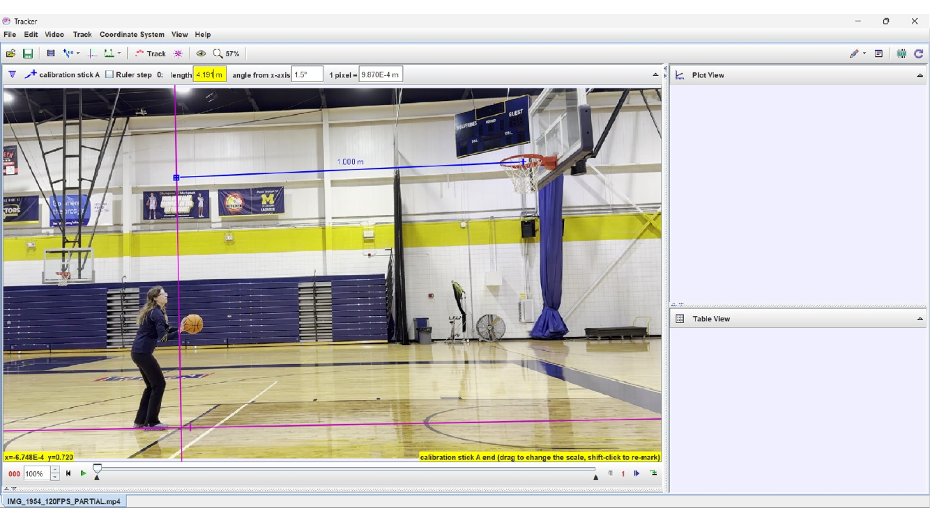
Representative physical test view used to produce the basketball-shot dataset.

3.2 What is measured and what is known
- H = 3.048 m is a known physical rim-center height and is used in the model. Tracker's displayed hoop height is only a sanity check against H; do not invent a separate H_{exp}.
- The experimental coordinate system is not forced to place x = 0 at release. The fitted release coordinates are x_{r} = B_{x} and h_{r} = C_{y}.
- The hoop-center horizontal coordinate is x_{H}; the release-to-hoop distance is L = x_{H} − x_{r}.
- Hoop-plane error: e_{x} = x_{p}(t_{H}) − x_{H} at the descending crossing y_{p}(t_{H}) = H.
PARTIAL AND FULL ARE ONE RECORDING
PARTIAL is the SAME 120-fps video as FULL, with only the END trimmed off; the beginning, frame sequence, camera view, and release event are preserved. FULL restores the withheld remainder of that same shot. This continuity is what allows the same coordinate/calibration setup and release-frame reference to carry into validation.

STEP 3 CHECKPOINT · DELIVER · FINISHED WHEN
Deliver: nothing yet — this STEP feeds Report Section 4 (Physical Test Setup & Data).
☐ Test geometry and acquisition understood. ☐ Physical constants, fitted quantities, and measured coordinates distinguished. ☐ Why FULL is validation data understood.

STEP 4

MEASURE THE EARLY MOTION
The shot becomes data — but only its beginning.
WHERE AM I? Turning each PARTIAL video into (t, x, y). | WHY? Every later number inherits this setup, and you must reuse it unchanged after the reveal. Fitting cannot repair a tilted axis, a misplaced calibration end, or the wrong release frame.

Follow the prescribed Tracker sequence for each of your three shots; do not invent a different coordinate setup.

4.1 Tracker setup sequence
ALIGN | TRANSLATE | CALIBRATE | FINE-TUNE | DEFINE RELEASE / t = 0 | TRACK

- Open the assigned PARTIAL video in Tracker and freeze the video before the shot begins.
- Move the coordinate origin first to the corner of the free-throw zone/reference line shown in the project image. The y-axis represents the physical free-throw line. The painted floor geometry establishes the court direction; the horizontal structural/wall reference near rim height is a visual aid for positioning the calibration stick. These are reference aids, not separate coordinate systems.
- Rotate the coordinate system by dragging the x-axis until it aligns with the edge of the free-throw zone. A correction of only 2–3° can matter over the long distance to the basket.
- After alignment, translate the origin — WITHOUT rotating the axes again — to the floor location directly in front of the player's foot before the shot begins.
- Add the calibration stick and set its physical length to 4.191 m.
- Place the RIGHT end of the calibration stick at the center of the hoop circle/visible ellipse.
- Place the LEFT end on the y-axis. Use the cream-colored horizontal wall frame/background reference to help maintain the intended perspective alignment.
- Zoom into both ends and fine-tune their positions.
- After this point, do not rotate the coordinate axes again.
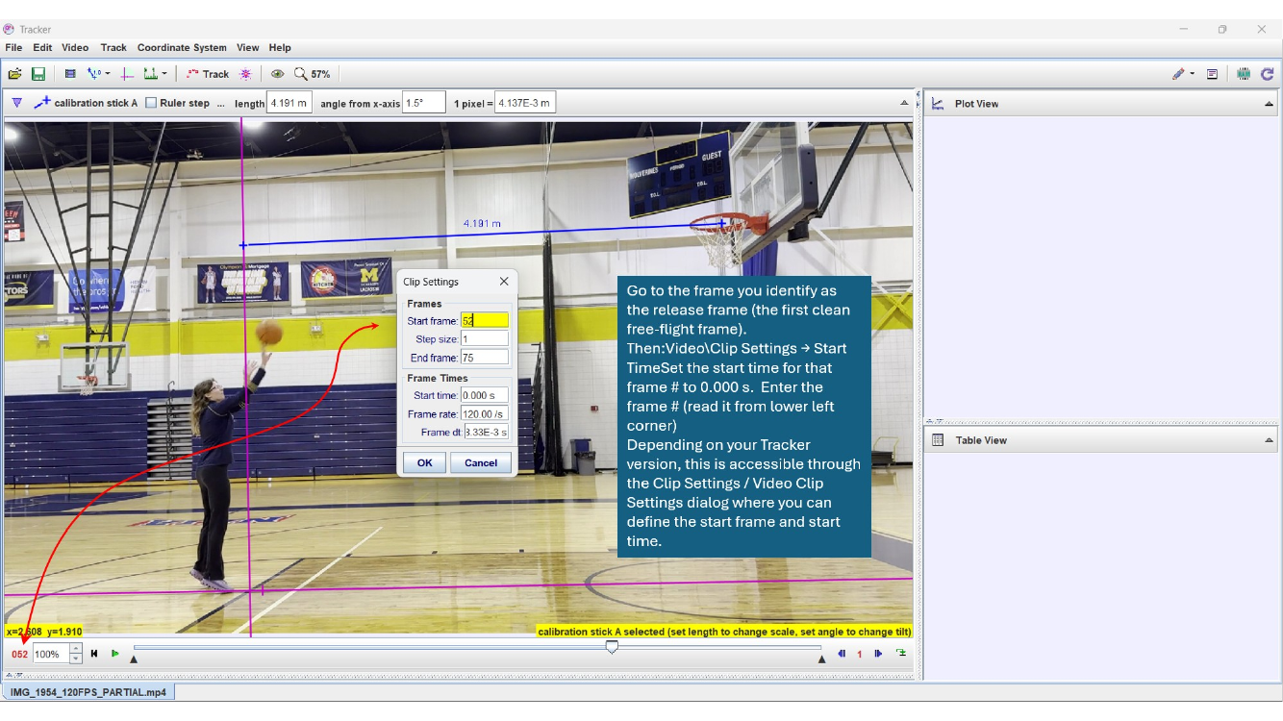
Tracker coordinate-system setup: establish physical direction before final calibration.
WHY THE ORDER MATTERS
Axis alignment establishes physical direction. Calibration establishes image-to-distance scale. Translating an already aligned coordinate system is allowed; rotating it after calibration changes the physical interpretation of the data.

4.1A Calibration reference comparison — measurement matters
Two known distances, one video. Calibration A uses the elevated hoop-level reference (blue, 4.191 m). Calibration B uses two identifiable court-floor corners (red). The floor distance will be measured and supplied by the instructor: 5.745 m.
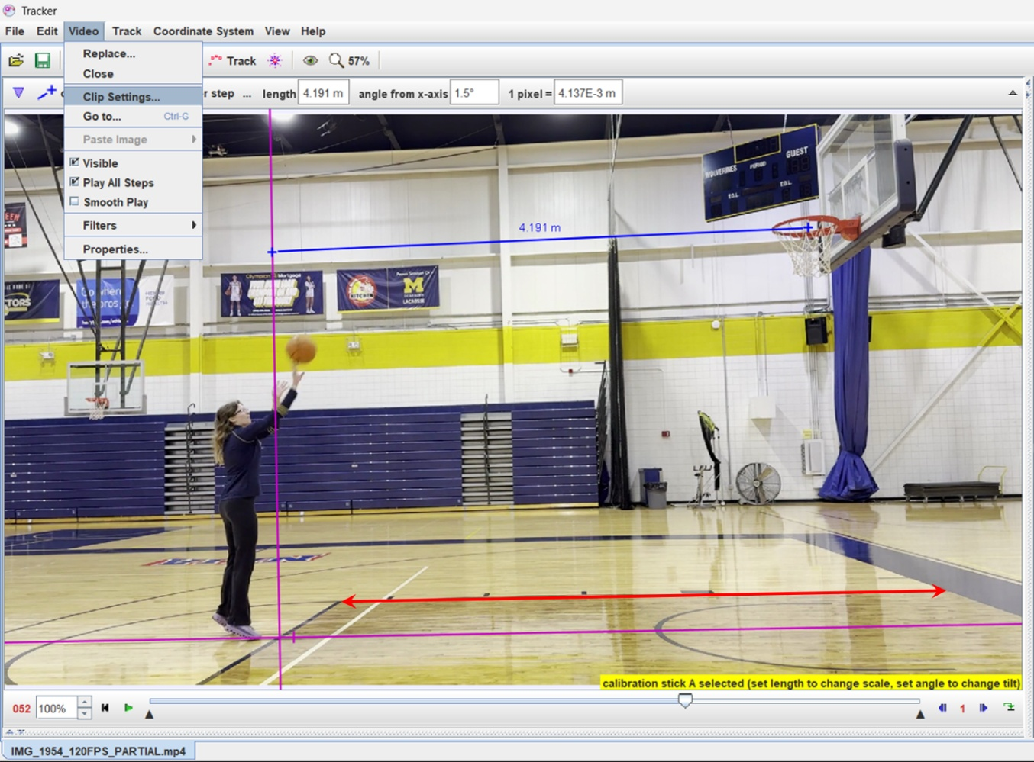
5.745m
Figure: Blue = elevated reference (Calibration A); red = measurable court-floor reference (Calibration B). Use the actual endpoints, not the approximate length of the drawn arrow.
Task — controlled calibration comparison
For one assigned shot, save the original Tracker setup. Record the results with A, then change ONLY the calibration-stick endpoints and entered length to B. Keep the origin, axis orientation, release frame, tracked ball positions, and fitting interval unchanged. Refit the same points; do not retrack the ball.
Quantity | A: elevated (blue) | B: floor (red)
Reference length (m) | 4.191 m | 5.745 m
Scale (m/pixel) | ________ | ________
Release speed (m/s) | ________ | ________
Release angle (°) | ________ | ________
Predicted hoop crossing y (m) | ________ | ________
Calculate % difference in release speed = |vB − vA| / |vA| × 100%. Explain whether the change affects the predicted hoop outcome. Which reference do you trust more, and why? Discuss endpoint visibility, physical length uncertainty, and perspective; do not assume that a floor reference is automatically superior.
Keep Calibration A for the required three-shot prediction/validation workflow. This comparison is a separate measurement-sensitivity task; do not replace the committed baseline results with Calibration B.

4.2 Define the release frame and set t = 0
- Advance the video frame-by-frame until you find the FIRST frame in which the basketball has completely left the shooter's fingertips.
- Check the previous frame. The ball should still be touching the hand/fingertips there.
- Select the first fully released frame as the RELEASE FRAME.
- In Tracker, set this frame as the beginning/start frame of the analysis clip using the clip settings.
- Set/verify the time at this release frame as t = 0.000 s.
- Confirm the video rate is 120 frames/s, so Δt = 1/120 = 0.00833 s.
- Return to the release frame and verify t = 0.000 s before tracking.
RECORD THE RELEASE FRAME · DO NOT USE A HAND-CONTACT FRAME
Record the release-frame number for each of your three PARTIAL videos in the Project Workbook and on the COMMIT Gate BEFORE FULL data are released. It is part of the frozen measurement setup.
Do not choose a frame in which the ball is still touching the hand. The projectile model begins with the first clean free-flight frame — and with t = 0 there, the fitted coefficients are the release state directly (recall C_{y} on the wrong clock in Chapter 7).

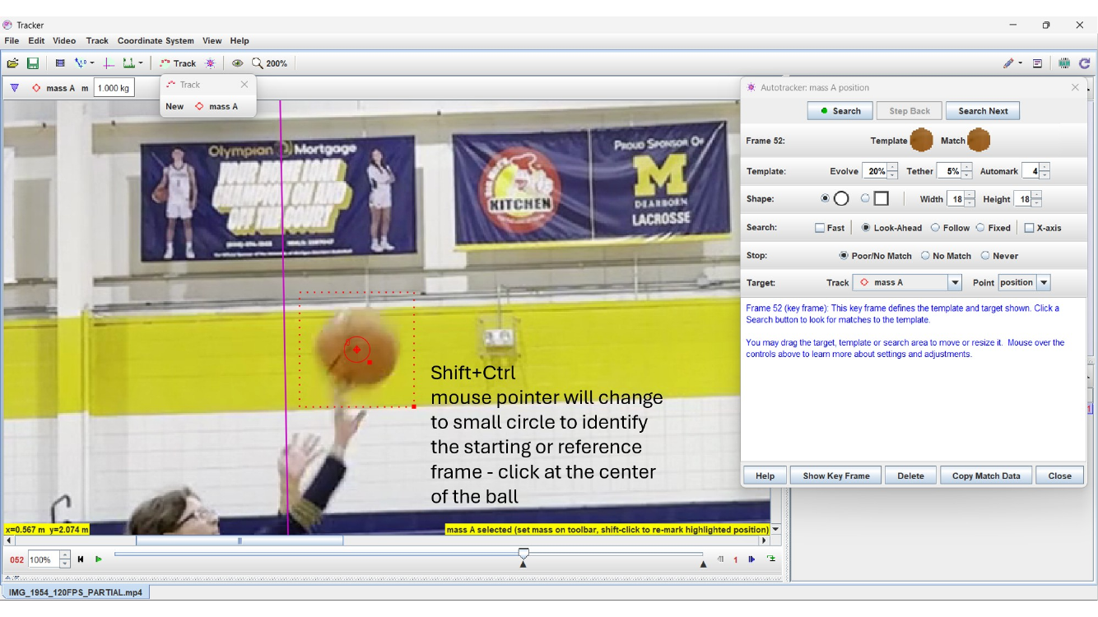
Release-frame setup: use the first clean free-flight frame and define it as t = 0.

4.3 Track the early flight
- Create a point-mass track for the ball center.
- Use AutoTracker where reliable; inspect the tracked marker and correct any obvious mistracking.
- Track all usable consecutive early-flight frames contained in PARTIAL. Do not target a fixed number of points.
- Preserve the Tracker project for your own work even though it will not be submitted.
- Export/copy the early-flight t, x, y data to the supplied Excel Project Workbook (03–05_SHOT#_FIT).
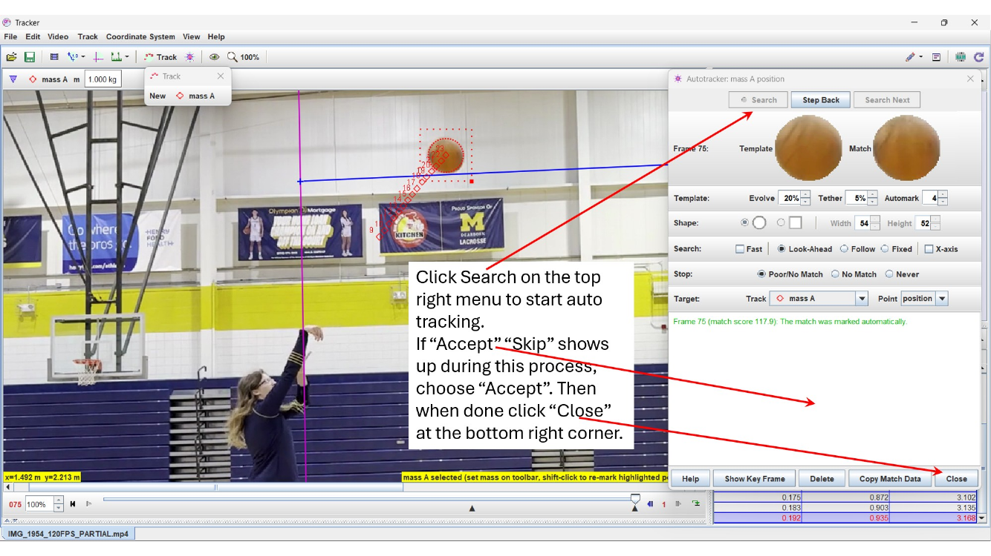
Representative AutoTracker workflow. Inspect the marker rather than assuming automated tracking is correct.
SAVE THE SETUP — YOU WILL REUSE IT AFTER THE REVEAL
SAVE the PARTIAL Tracker project for each shot. After FULL release, make a validation copy of that project and replace/load the corresponding FULL video so the established axes, origin, calibration, tracks, and release-frame reference are reused. Verify the recorded release-frame number and t = 0 before continuing. If your Tracker installation/workflow cannot preserve the setup when FULL is loaded, use the alternate route: reopen FULL and reproduce the frozen setup from your recorded Gate/Workbook values before tracking the withheld interval.

4.4 Read the hoop-center coordinate, x_{H}
In the same established coordinate system, read the horizontal coordinate of the hoop center — where you placed the right end of the calibration stick — and record it as x_{H} in the shot's FIT sheet. x_{H} is measured before the reveal and frozen at the Gate. Do not reset x = 0 at release.
STEP 4 CHECKPOINT · DELIVER · FINISHED WHEN
Deliver: for each shot — early-flight t, x, y in the FIT sheet; release-frame number and x_{H} recorded; Tracker project saved locally.
☐ Axes aligned before calibration. ☐ Origin translated without re-rotation. ☐ 4.191 m calibration applied and fine-tuned. ☐ First clean free-flight frame identified and recorded. ☐ t = 0 verified. ☐ All usable PARTIAL points tracked. ☐ x_{H} read. ☐ Data in Excel.

STEP 5

FIT, CROSS-CHECK, PREDICT & COMMIT
The model goes where the measurements have not.
WHERE AM I? Early-flight data in hand for three shots. | WHY? Make one honest, frozen claim about data you have not yet seen.

Fit the SAME early-flight data in three environments: Tracker MEASURES, Excel INSPECTS & CROSS-CHECKS, Python AUTOMATES & EXTENDS. Agreement verifies the processing workflow; it does not validate the physical model.

5.1 Fit and extract the release state
x(t) = A_{x} t + B_{x} y(t) = A_{y} t² + B_{y} t + C_{y}
Fitted coefficient | Physical meaning at release (t = 0) | Symbol
B_{x} | horizontal release position | x_{r} = B_{x}
C_{y} | release height | h_{r} = C_{y}
A_{x} | horizontal velocity (constant in the model) | v_{x0} = A_{x}
B_{y} | vertical velocity at release | v_{y0} = B_{y}
2A_{y} | fitted vertical acceleration — health check only | a_{y,fit} = 2A_{y}

v_{r} = √( v_{x0}² + v_{y0}² ) θ_{r} = atan2( v_{y0}, v_{x0} )
Environment | What to do
TRACKER — MEASURE | Use the Data Tool/fit capability: first-order fit for x(t), second-order fit for y(t). Record the coefficients and available fit-quality information.
EXCEL — INSPECT & CROSS-CHECK | Paste the same t, x, y data into the shot's FIT sheet. Create XY scatter plots; add a linear trendline to x(t) and a polynomial order-2 trendline to y(t). Display equation and R²; label axes and units professionally.
PYTHON — AUTOMATE & EXTEND | Save the early-flight data as a clean CSV and run the supplied guided program, which reads the file by filename (do not hard-code the data). Set SHOT_ID and X_H, leave VALIDATION_FILE = None (COMMIT mode), complete STUDENT TASKS 1–7, and run once per shot. File reading, plotting, R², checks, and output are supplied (Appendix B.2).

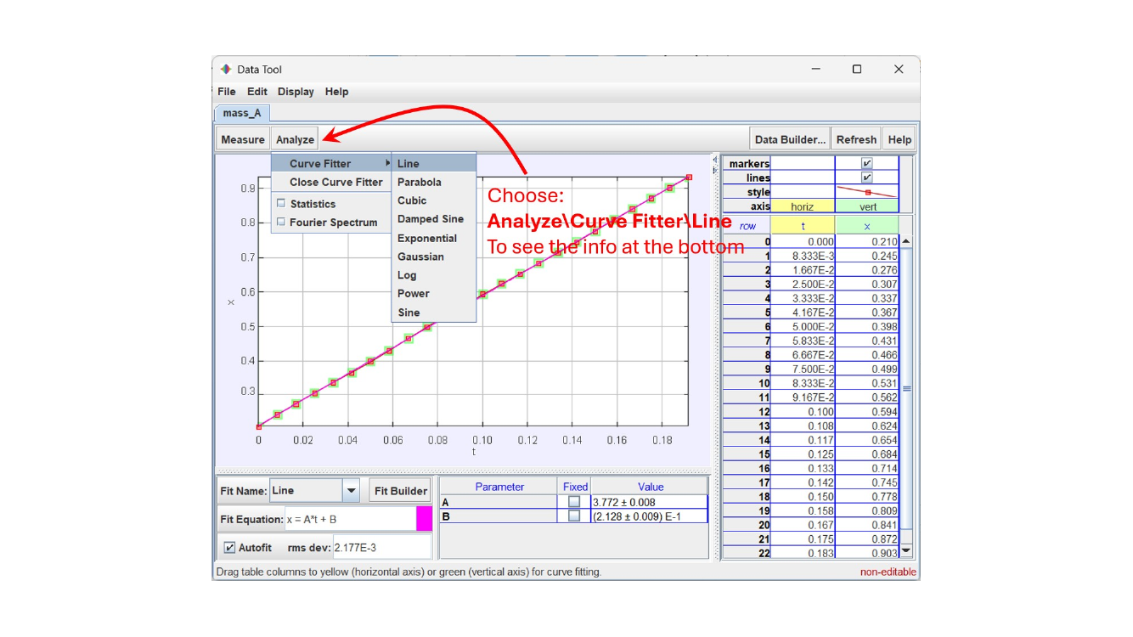
Representative Tracker fit view. Fit x(t) linearly and y(t) quadratically.
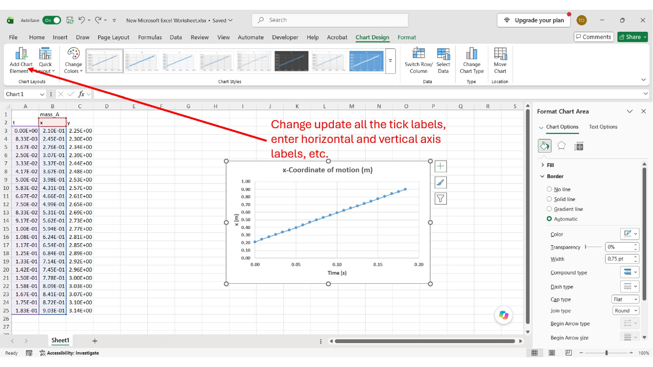
Representative Excel trendline workflow. Your workbook must contain your own data, equations, R² values, labels, and units.
CLEAN DATA ROUTE · TIME-ORIGIN GUARD
TRACKER → EXCEL → clean CSV → PYTHON
Excel is the organized numerical record; the CSV is the machine-readable transfer file. A clean CSV has exactly one header row, then numeric rows in three columns — time, x, y (s, m, m). Remove any extra label rows Tracker or Excel adds above the column names (e.g. a track-name row such as mass_A). Name it as the program expects, e.g. SHOT_ID_early.csv.
The program will NOT silently replace t with t − t[0]. It verifies that the first measurement is at t ≈ 0; if the check fails, return to Tracker and correct the release-frame/time setup.

5.2 Cross-check the three environments
Process ALL THREE shots in Tracker, Excel, and Python. Results should agree closely enough to demonstrate consistent processing. Do not force values to match and do not use an arbitrary percentage tolerance; investigate meaningful disagreement. R² and three-environment agreement verify the fit and the processing — not the prediction. Answer these questions ONCE, for Shot 1 (Shots 2–3 need the numerical cross-check only):
- Do Tracker, Excel, and Python produce essentially the same fitted coefficients and release conditions?
- If small differences exist, are they consistent with displayed precision or implementation differences, or do they indicate something that should be investigated?
- What does the fitted vertical acceleration a_{y,fit} suggest about the quality of the tracking, calibration, and coordinate setup?
- What does R² tell you about the curve fit, and what does it NOT tell you about the predictive validity of the projectile model?
- Based on the three-environment comparison, are you comfortable using the fitted Shot 1 release conditions for the committed prediction? Defend your answer with evidence.

5.3 Fit-health check
Compare a_{y,fit} = 2A_{y} with −9.81 m/s² as evidence about tracking, calibration, coordinate alignment, and fitting. Do NOT replace g = 9.81 m/s² in the prediction with your fitted acceleration. Look at all three shots' values side by side — this is your first cross-shot evidence, before any reveal. What does it suggest, and what can it not tell you?

5.4 Create the committed prediction
x_{p}(t) = x_{r} + v_{x0} t y_{p}(t) = h_{r} + v_{y0} t − ½ (9.81) t²
For each shot, predict the trajectory over the remaining flight in the established Tracker coordinate system. The hoop center is (x_{H}, H), H = 3.048 m. Solve y_{p}(t_{H}) = H, take the later positive root (the descending crossing), and compute:
e_{x,pred} = x_{p}(t_{H}) − x_{H}
e_{x,pred} < 0: the model crosses the hoop-height plane short of the hoop center; e_{x,pred} > 0: beyond it (Appendix A.3).
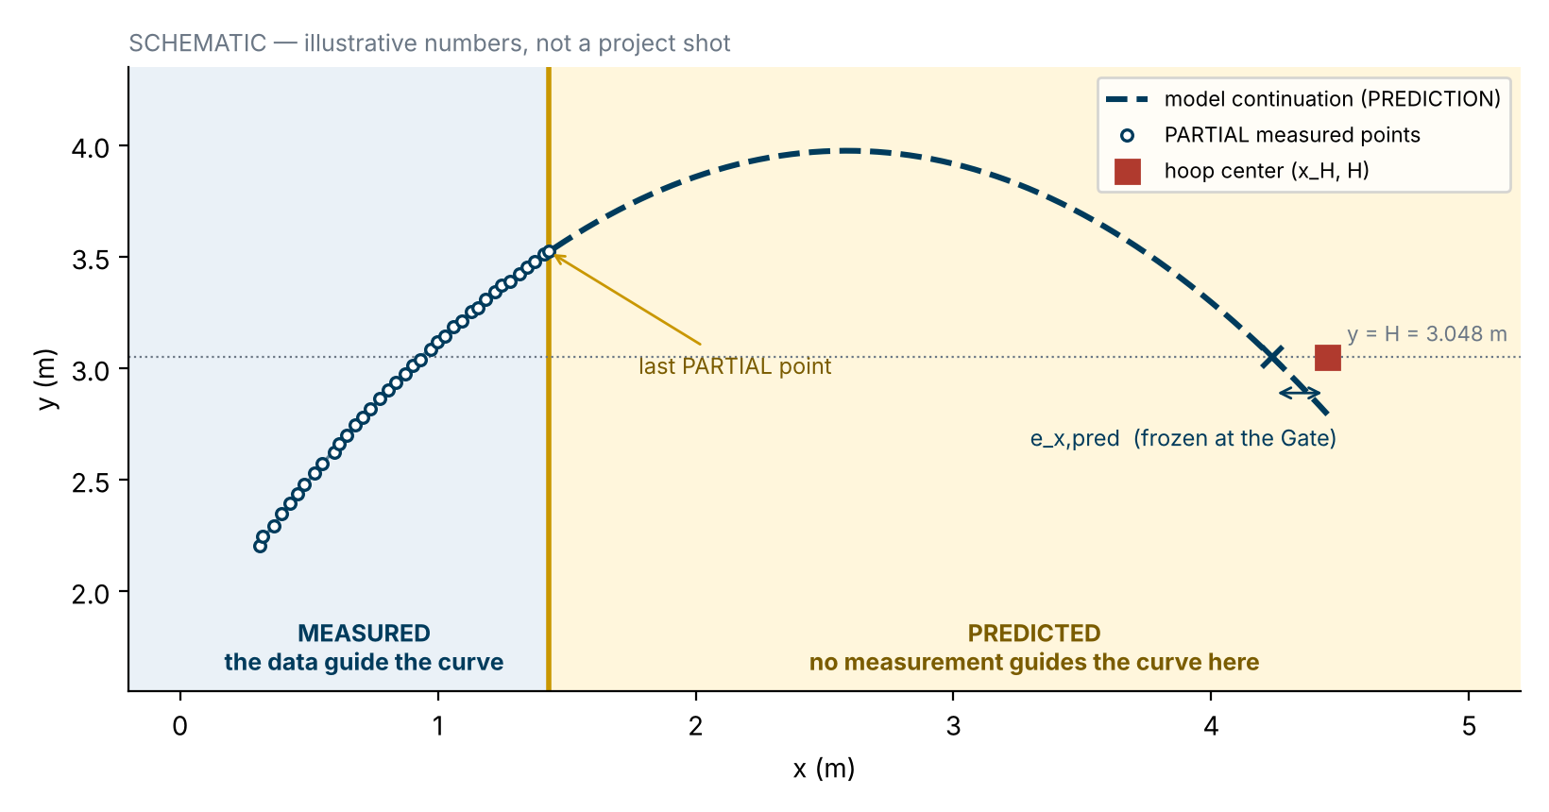
Schematic only — illustrative numbers, not a project shot.
STOP. LOOK AT WHAT YOU JUST DID.
Beyond the final PARTIAL measurement, the model is no longer describing observed data. It is predicting motion that has not yet been revealed.

BEFORE YOU COMMIT (not graded, not submitted)
In your notes: which shot do you trust least, and why? Where along the withheld flight do you expect the largest disagreement? Short of, beyond, or close to e_{x,pred}? After the reveal you will have a record of what you actually expected.

5.5 COMMIT Gate
YOU HAVE SEEN EVERYTHING YOU ARE ALLOWED TO SEE
Freeze the release state. Freeze the predicted trajectory. Freeze the hoop-plane prediction.
The prediction must be frozen before the withheld evidence exists for you. After the Gate, new data are no longer fitting data — they are evidence.
A prediction adjusted after seeing FULL is no longer an independent prediction.

Complete the supplied COMMIT Gate Test Card for all three shots using only PARTIAL data. Target approximately 2 pages; use 3 only if needed and do not exceed 4. It is a prediction record, not a mini-report.
Freeze for each shot | Required
Measurement setup | Release-frame number (first frame fully clear of fingertips, t = 0.000 s)
Release state | x_{r}, h_{r}, v_{x0}, v_{y0}, v_{r}, θ_{r}
Fit-health record | a_{y,fit}
Target geometry | x_{H} and H = 3.048 m
Prediction | Complete predicted x–y trajectory/plot and e_{x,pred}

COMMIT DECLARATION
These release conditions and predicted trajectories were determined using only PARTIAL early-flight data. They are frozen predictions and must not be altered after FULL validation data become available. Any later-discovered mistake or limitation will be preserved and explained in the engineering assessment. Your instructor will announce the Gate deadline, submission procedure, and FULL-data availability.

Where the freeze lives | What to keep
Gate Test Card | The submitted record of release state, x_{H}, e_{x,pred}, and the three prediction plots. Keep a copy.
Project Workbook | The same frozen values, copied into each VALIDATION sheet's “frozen prediction inputs” block after the reveal.
Python | COMMIT mode writes SHOT_ID_COMMITTED_STATE.csv — a working file, not a required submission. COMMIT mode will not overwrite an existing committed state (REPLACE_COMMITTED_STATE = True is only for a deliberate re-run before the COMMIT Gate and before FULL-data release; the program refuses it once validation files exist). VALIDATION mode predicts only from the committed state; it re-reads SHOT_ID_early.csv (keep it and Tasks 1–5 complete) to plot PARTIAL and run an integrity check that warns if PARTIAL or X_H changed since the Gate. If the file is lost, enter your Gate/Workbook values in FROZEN_FALLBACK — never values obtained by refitting after the reveal.

STEP 5 CHECKPOINT · DELIVER · FINISHED WHEN
Deliver: COMMIT Gate Test Card for all three shots (≈ 2 pages, ≤ 4) as your instructor directs; FIT sheets complete; Shot 1 interpretation drafted for Report Section 6.2.
☐ All three shots processed in Tracker, Excel, and Python. ☐ Shot 1 interpretation completed. ☐ g = 9.81 m/s² in every prediction. ☐ Three predictions with e_{x,pred}. ☐ Gate submitted. ☐ Frozen values preserved (Gate copy, Workbook, committed-state file).

STEP 6

VALIDATE AGAINST THE PHYSICAL TEST
The future becomes data.
WHERE AM I? Predictions frozen; FULL released. | WHY? This is independent validation: the withheld flight was never used to build the prediction. Measure how well it did — do not repair it.

THE REVEAL
What was previously an unseen future has now become experimental evidence.
You are testing the prediction, not improving the fit. Do not refit, adjust the release state, or move x_{H}. The question is not whether the ball scored; it is how well a model built from the beginning of the motion predicted the part it had never seen.

6.1 Carry the frozen setup into FULL
Open your validation copy of the PARTIAL Tracker project with the FULL video loaded, so the established axes, origin, calibration, and release-frame reference are reused. Verify the recorded release-frame number and t = 0 before tracking. FULL uses the same release-based time axis as PARTIAL: t = 0 stays at the original release frame. Do not reset the clock at the first withheld frame — validation times continue after the last PARTIAL time. If the setup cannot be preserved, use the alternate route in Section 4.3.

6.2 Define the validation interval
Validation begins with the first withheld frame immediately following the PARTIAL interval and continues through the last clean free-flight frame before the ball interacts with the rim, net, backboard, or another object. Use ALL usable measured points in this interval; do not thin the data.
PHYSICAL REGIME RULE
Do not automatically stop at the hoop plane. Stop when the physics changes. Validate the ideal model only over clean free flight; if clean free flight continues beyond the hoop plane, keep those points. Do not remove points to improve agreement.

6.3 Compare at matching times
Track the usable withheld interval with the same calibration, axes, coordinate system, and time origin. At every measured validation time t_{i}, evaluate the frozen prediction at that same time:
d_{i} = √[ (x_{m,i} − x_{p,i})² + (y_{m,i} − y_{p,i})² ]
E_{traj} = √[ (1/N) Σ d_{i}² ]
E_{traj} is the RMS spatial disagreement over the withheld free-flight trajectory; report it in meters and centimeters. Because d_{i} compares positions at the same instant, it reflects both where the ball went and when it got there. In Python, create the validation CSV (one header row; time, x, y) containing only the usable withheld interval, set VALIDATION_FILE, complete STUDENT TASKS 8–9, and run with SHOT_ID_early.csv and SHOT_ID_COMMITTED_STATE.csv in the same folder. The program stops if the validation file overlaps PARTIAL or restarts the clock.

6.4 Hoop-plane comparison
Determine the predicted and measured descending hoop-height crossings in the same coordinate definition. e_{x,pred} is the frozen Gate value. The measured crossing x_{cross,meas} is obtained by linear interpolation only when two clean measured free-flight points bracket y = H on the descending branch; then e_{x,meas} = x_{cross,meas} − x_{H}.
Δe_{x} = e_{x,meas} − e_{x,pred}
Interpret the sign and magnitude of Δe_{x} as a target-region comparison. Do not convert it into a make/miss classifier.
IF CONTACT COMES FIRST
If contact occurs before clean measured points bracket hoop height, record e_{x,meas} and Δe_{x} as N/A. Do not extrapolate measured motion. E_{traj} remains valid over the available withheld clean free-flight interval and must still be reported.

6.5 Figure and record
For each shot, plot the early measured points, the FROZEN predicted trajectory, and the withheld measured FULL trajectory on one x–y figure; the comparison must be visible without reading a table. (Python also plots d_{i} against time.) Store every validation row — t_{i}, measured and predicted coordinates, d_{i} — in the shot's VALIDATION sheet; the report summarizes rather than printing hundreds of rows.
Shot | N_{val} | E_{traj} (m / cm) | e_{x,pred} (m) | e_{x,meas} (m) | Δe_{x} (m)
1
2
3

6.6 Three experiments — accumulating evidence
Read the three shots in order, and let each change what you are allowed to claim. Analyze each shot as its own experiment and compare results (E_{traj}, Δe_{x}, a_{y,fit}, how d_{i} evolves) — never average trajectories point by point. No confidence intervals or uncertainty bands. Your answers feed Report Sections 7.2 and 8; they are not separate deliverables.
 | The question | Write down
SHOT 1 | What does this evidence show? | One sentence you can defend from Shot 1 alone — and one you cannot yet claim. Compare Δe_{x} with your Courtside Check result and the 0.109 m reference (context, not make/miss).
SHOT 2 | Does the evidence repeat? | Which Shot 1 sentence survives, and which does not?
SHOT 3 | Is a pattern emerging? | What repeats, what changes, any consistent bias, any shot that behaves differently — and does it make you question measurement quality?

6.7 Put the prediction on trial
Where prediction and measurement disagree, weigh at least three competing explanations. Do not pick a culprit first; build each case from your own evidence.
Suspect | The question
MODEL | Is the ideal projectile model missing relevant physics?
DATA / TEST | Could tracking, calibration, perspective, release-frame identification, or other experimental factors contribute?
COMPARISON | Are prediction and experiment compared in the same coordinate system, scale, time origin, and physical quantity?

If you discover a mistake made before the Gate, keep the committed result and explain the mistake in your engineering assessment.
STEP 6 CHECKPOINT · DELIVER · FINISHED WHEN
Deliver: completed 06–08_SHOT#_VALIDATION sheets and 01_SUMMARY validation rows; a predicted-vs-measured trajectory figure for each shot.
☐ All usable withheld free-flight points used; stopped when the physics changed. ☐ No post-Gate prediction repair. ☐ E_{traj} for all three shots. ☐ Hoop-plane comparison completed (or N/A). ☐ Figures created. ☐ Complete record in Excel. ☐ Three shots compared collectively.

STEP 7

IMPROVE, DECIDE & REPORT
A claim sized to the evidence.
WHERE AM I? Three frozen predictions, three reveals. | WHY? Turn results into engineering judgment. AI may help interrogate evidence and draft prose; the decision is yours.

AI ASSISTS | HUMAN VERIFIES | ENGINEER DECIDES

7.1 AI Engineering Review
After validating all three shots, give AI your actual numbers and plots. Do not ask only, “Was my model good?”
SUGGESTED AI PROMPT
I developed and physically validated an ideal projectile-motion model for three basketball shots. For each shot, the model used only early-flight (PARTIAL) measurements to estimate the release state. The remaining trajectory was withheld until after my predictions were committed at a COMMIT Gate; I then compared the frozen predictions with the withheld (FULL) measurements without refitting.
I will provide, for all three shots: my fitted release conditions, a_y,fit and fit-quality information, predicted and measured trajectory plots, how d_i evolves over the validation interval, E_traj, predicted and measured hoop-plane locations and Δe_x (or N/A where contact came first), and my own observations from measurement and analysis.
Act as an engineering design-review partner. (1) Compare the three tests collectively: overall predicted-versus-measured agreement, how disagreement evolves over the flight, the significance of E_traj for each shot, and hoop-plane disagreement Δe_x. (2) Identify what repeats across the three shots and what does not — including any consistent bias and any shot that behaves differently. (3) Assess whether fitted acceleration and fit evidence suggest measurement, calibration, or coordinate issues. (4) For the disagreements, consider three competing explanations — MODEL (missing physics or assumptions), DATA/TEST (tracking, calibration, perspective, release-frame identification, other experimental factors), and COMPARISON (same coordinate system, scale, time origin, and physical quantity) — and state what in my evidence supports or weakens each. (5) Distinguish conclusions strongly supported by my evidence from speculation, and state what three tests still cannot establish. (6) Generate 8–10 possible evidence-linked improvements if the study were repeated, classify each as TEST/MEASUREMENT, COMPUTATIONAL METHOD, or PHYSICAL MODEL, and rank-order them by expected engineering payoff, explaining the ranking. Do not make my final selection for me.
Do not invent missing data or assume causes that my evidence does not establish. Ask questions if additional information is needed. Challenge my interpretation where appropriate.

7.2 Human engineering judgment
Review the complete AI-ranked list using what the AI does not fully know: practical feasibility; implementation difficulty; laboratory logistics; equipment and time; what you personally observed during measurement and analysis; payoff relative to effort; possible unintended consequences.
SELECT EXACTLY TWO IMPROVEMENTS
You may agree with the AI's ranking or override it. Agreement still requires independent engineering justification from your own evidence. If you override AI, explain the practical, experimental, computational, logistical, or engineering consideration that changed the priority. The goal is not to agree or disagree with AI — it is to make the better engineering decision.
Also identify one AI observation you agree with (and the project evidence that supports it) and one you disagree with, would qualify, or cannot verify (and why). Use the discussion to improve your reasoning — not to replace it.

7.3 Recommend TWO improvements
Improvement can target the test, the comparison, the computation, or the model. Tie each to specific project evidence and classify it as TEST/MEASUREMENT, COMPUTATIONAL METHOD, or PHYSICAL MODEL:
Required element | What it means
OBSERVATION | The specific parameter, test result, procedure, equipment behavior, equation, or assumption that motivated the recommendation.
SPECIFIC IMPROVEMENT | Exactly what you would change in the next engineering iteration.
EXPECTED EFFECT | What result or limitation the change is expected to improve or clarify.

No generic improvements: “use better equipment,” “collect more data,” or “use a more accurate model” is insufficient unless you identify the specific evidence, equipment/procedure/assumption, and expected effect.

7.4 Is three enough?
CHAPTER 7 ASKED WHETHER ONE EXPERIMENT WAS ENOUGH. YOU NOW HAVE THREE. IS THREE ENOUGH?
- Does the evidence repeat across the three shots?
- Is a pattern emerging — or does one shot behave differently?
- Which conclusions does your evidence now support — and which remain unsupported?
Use only the evidence you already have — no statistics, new calculations, or additional experiments. Three shots are more evidence than one; they do not establish universal validity. Your answer is the foundation of the verdict below.

7.5 Make the engineering decision
Choose one decision for the complete predictive workflow. There is no prescribed E_{traj} threshold. Defend it with multiple forms of evidence: trajectory agreement, evolution of disagreement, hoop-plane Δe_{x}, consistency across shots, fit-health evidence, and known model limitations. Judge adequacy for this purpose: predicting the remaining free-flight trajectory and hoop-plane crossing from early-flight data, under this test setup. A useful shape for the conclusion: The evidence supports … The evidence does not yet support … To support a stronger claim we would need …
Decision | In plain words
ACCEPT | The evidence supports using this workflow for its stated purpose without significant qualification.
ACCEPT WITH LIMITATIONS | The evidence supports using it — within limits that you name and justify.
REJECT–REVISE | The evidence does not support using it until something specific is revised.

NO FORMAL UNCERTAINTY ANALYSIS
Project 1 uses sensitivity, disagreement, measurement-quality evidence, and model limitations. Do not invent numerical uncertainty bounds or confidence intervals. Formal uncertainty analysis belongs in a separate activity.

7.6 Write the self-standing engineering report
A reader should not need this manual to understand the problem, test configuration, computational approach, predictions, validation evidence, recommendations, or decision. Use the supplied Engineering Report Template (its section prompts include suggested AI prompts for the Project Definition and Executive Summary):
Report section | What the reader must learn
1 · Project Definition | What engineering problem was addressed; what was observed, predicted, withheld, and validated.
2 · Executive Summary | Written last: purpose, approach, key quantitative findings, limitations, final decision.
3 · Engineering Approach | Model, assumptions, numerical verification/design study, measurement → fit → prediction → validation workflow.
4 · Physical Test Setup & Data | How the shots were recorded; geometry/calibration/time origin; PARTIAL/FULL architecture; Shot IDs.
5 · Results — Design & Computation | Solver verification, two-root behavior, Courtside Check.
6 · Results — Release Conditions & Committed Predictions | Three-tool fits and frozen predictions; Shot 1 cross-platform interpretation once.
7 · Test–Prediction Correlation & Validation | Full-trajectory comparison, E_{traj}, Δe_{x}, cross-shot interpretation.
8 · Engineering Assessment & Improvements | AI Engineering Review, human evaluation, two evidence-supported improvements.
9 · Conclusions & Engineering Decision | ACCEPT / ACCEPT WITH LIMITATIONS / REJECT–REVISE, defended quantitatively.

Appendix | Required purpose / evidence
A · Numerical Methods & Computational Verification | Solver setup, representative convergence evidence, bisection/Newton/analytical verification, two-root evidence, Courtside Check.
B · Experimental Measurement & Curve Fitting | Shot 1: representative Tracker, Excel, and Python fitting evidence + cross-platform comparison. Shots 2–3: concise numerical results.
C · Committed Prediction & Validation Details | Committed prediction evidence, validation method, representative point-by-point calculations, detailed results. Full frame-by-frame data stay in the workbook.
D · AI Assistance & Engineering Verification | Where AI materially assisted; one AI observation verified; one rejected/qualified/unverified; one example of AI-assisted prose/code revised; how ownership was maintained.

AI-ASSISTED WRITING · APPENDIX FILTER
STUDENT PROVIDES VERIFIED EVIDENCE → AI DRAFTS/CRITIQUES → STUDENT CHECKS EVERY CLAIM AND NUMBER → STUDENT REVISES → ENGINEER OWNS THE REPORT. Do not paste the AI conversation; summarize and evaluate its useful content.
Every appendix item must answer: “What engineering result does this evidence support?” No repeated menus, routine software screenshots, unexplained raw output, or images included only to prove software was opened.

7.7 Return to your first answer
Reread what you wrote before Step 0 next to your three values of E_{traj} and Δe_{x}.
Would less of the past have been enough?
How would you find out — and what would the next experiment need to change to make your claim stronger?

STEP 7 CHECKPOINT · DELIVER · FINISHED WHEN
Deliver: Engineering Report (PDF), Project Workbook (XLSX), completed Python program (PY).
☐ AI review used actual evidence from all three shots. ☐ One AI observation verified, one challenged/qualified. ☐ Exactly two improvements: OBSERVATION → IMPROVEMENT → EXPECTED EFFECT, independently justified. ☐ Decision defended without an arbitrary threshold. ☐ Report self-standing; appendices purposeful. ☐ PDF + XLSX + PY ready.

APPENDIX A — TECHNICAL REFERENCE
Reference material supports the STEPS; nothing essential to completing a STEP should require guessing from this appendix.

A.1 Projectile equations
x(t) = x_{r} + v_{x0} t y(t) = h_{r} + v_{y0} t − ½ g t²
v_{x0} = v_{r} cos θ_{r} v_{y0} = v_{r} sin θ_{r}
θ_{entry} = atan( |v_{y0} − g t_{H}| / v_{x0} ) (descending entry angle at the hoop plane)
For the design-study release-origin formulation (Steps 1–2), x_{r} = 0 and the rim center is (L, H). For experimental work, preserve the Tracker coordinate system: release is (x_{r}, h_{r}), hoop center is (x_{H}, H), and L = x_{H} − x_{r}.

A.2 Analytical structure of the two-angle problem
For a fixed speed, let u = tan θ and A = gL²/(2v²). The hoop-center condition can be written as a quadratic:
A u² − L u + (A + Δh) = 0, Δh = H − h_{r}
D = L² − 4A(A + Δh)
When D > 0, two real angle roots exist. You do not need to derive this quadratic during the main workflow; it explains why the broad numerical search reveals two solutions.

A.3 Hoop-plane definitions
e_{x} = x_{cross} − x_{H}
e_{x} < 0 means the model crosses the hoop-height plane short of the hoop center; e_{x} > 0 means beyond the center. The nominal 0.109 m opening reference is geometric context only. The predicted crossing uses the later (descending) positive root of y_{p}(t_{H}) = H; the measured crossing is linearly interpolated only when two clean measured descending points bracket H; if contact occurs first it is N/A and is never extrapolated.

A.4 Validation metrics
d_{i} = √[ (x_{m,i} − x_{p,i})² + (y_{m,i} − y_{p,i})² ]
E_{traj} = √[ (1/N) Σ d_{i}² ]
Δe_{x} = e_{x,meas} − e_{x,pred}

A.5 One notation, every tool
The letters are the same in Chapter 7, Tracker, Excel, Python, the Workbook, the Gate, and the Report — so you never have to translate.
Quantity | Symbol | Python name | Units
Linear fit, x(t) | A_{x}, B_{x} | A_x, B_x | m/s, m
Quadratic fit, y(t) | A_{y}, B_{y}, C_{y} | A_y, B_y, C_y | m/s², m/s, m
Release state | x_{r}, h_{r}, v_{x0}, v_{y0} | x_r, h_r, v_x0, v_y0 | m, m, m/s, m/s
Release speed / angle | v_{r}, θ_{r} | v_r, theta_r | m/s, deg
Fit-health check | a_{y,fit} = 2A_{y} | a_y_fit | m/s²
Hoop center | (x_{H}, H) | X_H, H | m
Hoop-plane result | e_{x,pred}, e_{x,meas}, Δe_{x} | e_x_pred, e_x_meas, delta_e_x | m
Validation | d_{i}, E_{traj} | d_i, E_traj | m

APPENDIX B — PROJECT WORKBOOK & PYTHON ARTIFACT

B.1 Supplied Excel Project Workbook
Use the supplied workbook rather than creating a different sheet architecture. It provides organization and formatting, not finished engineering formulas.
Sheet | Purpose
00_READ_ME | Team/Shot IDs, release-frame numbers, and workflow reminders.
00_TEAM_ASSIGNMENT | Team-specific Shot IDs, Step 1 assigned angle, and Step 2 assigned speed. Use only your team row.
01_SUMMARY | Final three-shot release conditions and validation metrics.
02_NUMERICAL_METHODS | Step 1 verification, Step 2 two-root investigation, Courtside Check.
03_SHOT1_FIT | Shot 1 early data, Excel fits, coefficients, release conditions, x_{H}, cross-check.
04_SHOT2_FIT | Shot 2 equivalent.
05_SHOT3_FIT | Shot 3 equivalent.
06_SHOT1_VALIDATION | Frozen prediction inputs, complete withheld measured/predicted data, d_{i}, E_{traj}, hoop-plane results.
07_SHOT2_VALIDATION | Shot 2 equivalent.
08_SHOT3_VALIDATION | Shot 3 equivalent.

Students create the required Excel formulas, scatter plots, and trendlines. The workbook is the complete organized numerical record submitted for assessment.

B.2 Supplied guided Python program
The Python artifact is end-to-end: file input → fitting → release conditions → prediction → COMMIT → validation → d_{i} → E_{traj} → hoop-plane comparison → plots. Infrastructure is supplied; a small number of engineering equations are left as clearly marked student tasks.
Program section | What you do | Mode
Settings (top of file) | Set SHOT_ID, X_H; leave VALIDATION_FILE = None until FULL is released. | both
STUDENT TASKS 1–5 | Release state from the fitted coefficients, and release-speed magnitude. | COMMIT
STUDENT TASKS 6–7 | x_{p}(t) and y_{p}(t) using the frozen release state and g = 9.81 m/s². | COMMIT
STUDENT TASKS 8–9 | Pointwise disagreement d_{i} and RMS disagreement E_{traj}. | VALIDATION

- Reads experimental data from file by filename (SHOT_ID_early.csv, later SHOT_ID_validation.csv; clean CSV with one header row and columns time, x, y); do not hard-code the complete dataset.
- Checks that the first early-flight time is t ≈ 0 and stops with a clear message if not. It never replaces t with t − t[0].
- Fits x(t) linearly and y(t) quadratically and reports coefficients/R².
- Calculates release conditions and a_{y,fit} (reported as a health check only).
- Generates the frozen ideal-projectile prediction using g = 9.81 m/s² and the descending hoop-height crossing.
- COMMIT mode (VALIDATION_FILE = None): saves SHOT_ID_COMMITTED_STATE.csv, writes the fit and committed-prediction figures, and stops. It refuses to overwrite an existing committed state unless REPLACE_COMMITTED_STATE = True, which is permitted only before the COMMIT Gate and FULL-data release and is refused once validation files exist. It never authorizes revising a committed prediction after the reveal.
- VALIDATION mode: predicts only from the committed state (or the manual FROZEN_FALLBACK values from your Gate/Workbook). It re-reads SHOT_ID_early.csv to plot PARTIAL and to check that PARTIAL and X_H have not changed since the Gate (warning if they have; frozen values are still used). It stops if the validation file overlaps PARTIAL or restarts the clock, then evaluates the frozen prediction at the measured validation times, calculates d_{i}, E_{traj}, and the hoop-plane comparison (N/A if no clean measured crossing), and writes the validation figures without overwriting the Gate-time figures.
Figure written by the program | Use
SHOT_ID_fit_results.png | Early-flight fits — Appendix B evidence.
SHOT_ID_committed_prediction.png | Frozen predicted trajectory — the Gate plot.
SHOT_ID_validation_trajectory.png | Predicted vs measured — the required validation figure.
SHOT_ID_validation_disagreement.png | d_{i} against time — how the disagreement evolves.

AI AND CODE
AI may help explain, complete, or debug the supplied program. You remain responsible for understanding the engineering meaning of the calculations and verifying the results against the Excel workbook.

APPENDIX C — VIDEO PRODUCTION DETAILS
REFERENCE / INSTRUCTOR DOCUMENTATION
Students use the provided video files and are NOT required to reproduce these video-production steps. This appendix documents data provenance for future reuse and technical traceability.

The project video library originated as iPhone slow-motion MOV recordings. The camera remained fixed on a tripod, approximately perpendicular to the shot plane, and recordings were preserved before derivative processing.

C.1 File-production chain
Stage | Purpose
00_ORIGINAL_MOV | Preserve original recordings.
01_MP4_120FPS | Tracker-compatible H.264 MP4 derivatives at 120 fps.
02_CLEAN_FULL | Clean FULL validation clips.
03_PARTIAL_PREDICTION | Early-flight PARTIAL clips used for estimation and commitment.

C.2 Reference FFmpeg conversion
ffmpeg -i "IMG_1954.MOV" -an -vf "fps=120" -c:v libx264 -preset slow -crf 15 -pix_fmt yuv420p "IMG_1954_TRACKER_120FPS.mp4"

Production QA verified the deployment clips as H.264, 120 fps, 1920×1080. PARTIAL derivatives preserve the early motion needed for release-condition estimation; CLEAN_FULL derivatives preserve the remaining free-flight trajectory used for validation.

C.3 Data-provenance principle
Original recordings are preserved. Derived files are named systematically and screened before deployment. The separation between PARTIAL and FULL files supports a prediction-before-validation workflow; it is not intended to hide the visible make/miss outcome.

ONE-PAGE PROJECT CHECKLIST
Stage | Before you move on
STEP 0 | Central question, model boundary, three Shot IDs understood.
STEP 1 | Bisection/Newton/analytical verification + residual complete.
STEP 2 | Two roots + Newton-start behavior + Courtside Check complete.
STEP 3 | Test geometry, data provenance, PARTIAL/FULL roles understood.
STEP 4 | ALIGN → TRANSLATE → CALIBRATE → FINE-TUNE → RELEASE/t = 0 → TRACK for all shots; release-frame numbers and x_{H} recorded.
STEP 5 | Tracker/Excel/Python cross-check for all 3; Shot 1 interpretation; g = 9.81 in every prediction; frozen predictions submitted at Gate.
— GATE — | After this line, new data are evidence, not fitting data.
STEP 6 | All usable withheld free-flight points validated; E_{traj} and Δe_{x} (or N/A) for all 3; plots complete; three shots compared collectively.
STEP 7 | AI review + human challenge; exactly two specific improvements; verdict; self-standing report and purposeful appendices.

FINAL SUBMISSION
☐ Engineering Report PDF ☐ Project Workbook XLSX ☐ Guided Python Program PY
☐ Tracker projects saved locally for your own protection (not submitted)

FITS ≠ VALIDATED. A PREDICTION IS A CLAIM MADE BEFORE THE ANSWER EXISTS.
AI ASSISTS → HUMAN VERIFIES → ENGINEER DECIDES
End of Project Manual

